2012 Family Arabian Nominations

Shalimar "Pascha"   
Nominated by Alexandria (Alex) Shveyda

YOUR NAME: Alex Shveyda

HORSE'S NAME: Shalimar Pascha   
 HORSE'S AGE: 18   
 HORSE'S GENDER: Mare   
  
I'm not just nominating a horse, I'm nominating my best friend. She is and always will be the best thing that has ever happened to me. Not only has she touched my heart but she has touched everyone's around her. The way her eyes lit up and how she whinnied whenever I walked past her was one of the many things that made me realize how strong our bond was. Not only did she make me into the rider I am today, she made me into the person I am. She was my biggest inspiration. She was so strong.  
  
Pascha was my very first horse. We grew and learned together. Getting her was the best day of my life.....loosing her was the worse. Pascha not only taught me how to ride she gave many children and adults their first ride! She gave many young children their first "showing" experience. She took care of them - kept them safe. She participated at the Horse Expo in the paint a horse booth sometimes being painted 4 times a day.  
  
When she would not behave - we put her in training and she came home behaving beautifully.  
When she colicked - we sent her to surgery and she recovered fully in record time.  
When she colicked again - we gave her medications and sat with through the night and she recovered. When she was diagnosed with a neurological disorder in November of 2011, we did everything we could to make her comfortable.  
.....and in August of 2012 she told us she was tired and ready to find peace and we let her go.  
  
I love her.....I miss her.....and I thank her for making me who I am today!

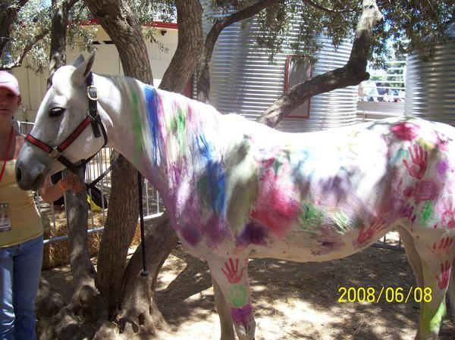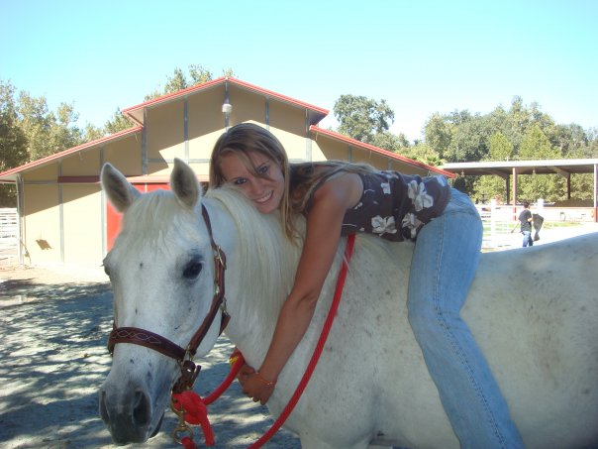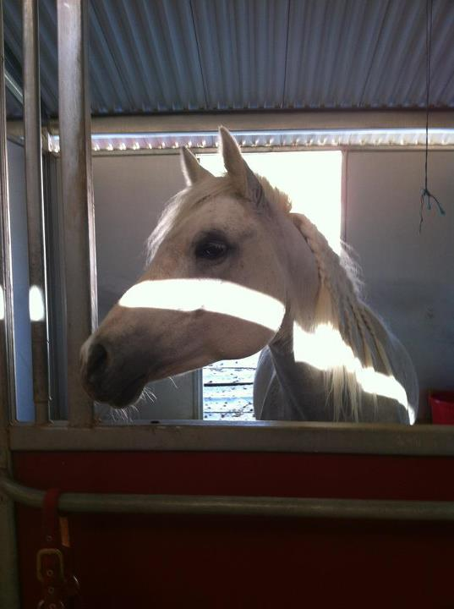

Joy is being submitted for consideration by Jamie Seals and Rachel Thompson (Rachel is the owner)  
JS Rejoice is her official name but she goes by "Joy"  
1999 Bay Mare

We are nominating JS Rejoice “Joy” for DAHA Family Arabians of Year but Joy is much more than that; Joy is a multi-family Arabian and is loved by many. Here is her story…..

Joy was born in Arizona in 1999 where she lived until she joined a family in Northern California in 2006. Joy won HA/AA Hunter Pleasure Walk Trot 10 and Under with this family in 2006, 2007, 2008 and 2009. What a good girl! In 2010 Joy joined the Thompson Family here in the Bay Area; she was immediately loved by both of her girls – Rachel and Claire. Rachel and Claire rode Joy in shows as well as “horsing around” with friends and trail riding. Joy taught both Claire and Rachel to be stellar riders with her calm, sweet and accommodating nature. In 2010 Joy and her girls competed in 23 Hunter Pleasure show classes which included a Top 3 and a Top 5 at the Region 3 Championship in Reno. In 2011 Joy and her girls competed in 15 Hunter Pleasure show classes including a Top 3 and Top 5 at Region 3 Championship show in Reno and Championship at the Canadian Nationals. What a summer! What a horse!

The next year, Joy met another little girl – Jamie Seals. Jamie was around the barn and riding other horses for fun and at shows but in the spring of 2012 their mutual trainer brought them together thinking they would be a good team. And they were …actually they were better than good, they were great. Jamie had never really settled on one horse previously so it took some time for her to get used to riding Joy but they settled in pretty quick with each other, and they started winning at shows. Joy was patient and quiet with Jamie. Jamie practiced and practiced, cared for and loves Joy. Jamie and Joy won 4 local Championships in Hunter Pleasure Walk/Trot 10 and Under as well as winning a Regional Championship and a Top Ten at Youth Nationals in July. Jamie and Joy rode and participated in over 15 Hunter Pleasure classes altogether through this last summer and also clocked countless hours riding for fun.

Jamie has moved on to a horse of her own but will always carry Joy in her heart and be grateful for the time they had together. Throughout this winter, Rachel Thompson and her trainer have been working with Joy to get her ready for the 2013 show season in a new discipline – Western Pleasure. Joy and Rachel are taking on this challenge as they have done before – with determination, a kind spirit and a can-do attitude. There is no doubt that this winning combination will bring them much success in the 2013 show season and beyond.

I also want to mention that while at Region 3 Championships in Reno this last summer, the Thompsons were approached by another family asking if their daughter could ride Joy in a Western Pleasure classes – their daughter’s horse had coliced the night before and had been rush to the Vet Hospital. They agreed to let this girl ride Joy – in a discipline she had not competed in previously – and came away with a Reserve Champion. Another great accomplishment and another girl fell in love with our Joy that day.

As you can see, Joy is a pretty special mare. She has lovingly carried our three girls – Rachel, Claire and Jamie - through countless shows, blue ribbons, Championships and the ever important occasional trail ride. She has been patient when she needs to be, competitive when the situation calls for it but always, always loving. Clearly Joy is a Multi-Family Arabian – and for those of us who love her, that is the case every single year!

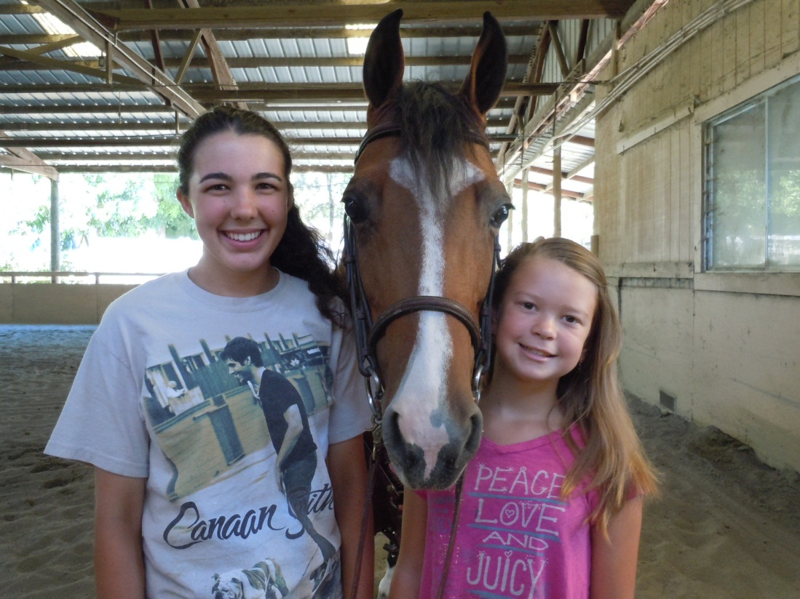

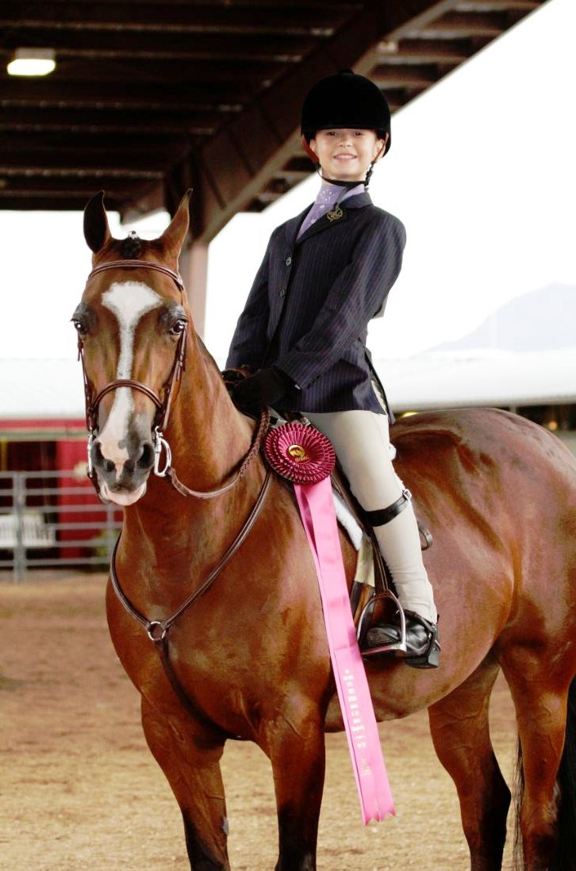

Name: Indigo Express AAHR*AA07718

Anglo-Arabian Registered

Foaled: May 12, 1990

Sire: Whidbey Express AHR0219205

Dam: Port O Time JC 7810006

A Family Arabian for many families.

By Nancy Dupont, Castle Rock Arabians

Looking for a lesson horse, I purchased Whinny sight unseen in the spring of 2005. I was looking for a big horse for my riding lesson program and happened to like Anglo Arabians.  The owner explained she used to be an endurance horse but after retiring her to pasture, she made too much noise (Hence, her nickname was Whinny!) and they decided to sell her.

Heather Herman delivered Whinny to me.  When she backed out of the trailer she lived up to her nickname.  Her “Whinny” went up and down the musical scale in loud assertive notes.  My first impression was “Wow! Loud, and not too pretty!   I had paid so much for a horse I thought would be an elegant, tall Arabian/Thoroughbred type--with the look of Eagles. Yes, she was *tall*—but built like a tank, designed for front line combat. With her imposing bulk and all her roaring, I wasn’t sure what to do with her.

Based on her unpopularity at her former home, I dismissed the thought of trying to return her. Then, after a couple of days, something clicked with the big gray horse and me.  I decided to give it a chance and watched her take “best” to higher level!

She had a way of instructing me how she should be treated in order to gain her respect and cooperation.

First she refused to occupy a closed stall and insisted on being in pasture. She acted terrible--calling out and kicking the stall door daily until you listened to her demands.  Finally, we complied and moved her.  She lived well and healthy in pasture and corral conditions that would make a show horse shudder.  She never wore a tail bag and her tail was just fine. Never shaved nor blanketed.

She loved the trail and more kids found out that she would pack them for miles. She was the kid’s choice to ride in the Explorer’s Camp.  This is a ride that starts at Castle Rock Arabians in Walnut Creek, over Mt. Diablo and to the Concord-Mt. Diablo Trail Ride grounds in Clayton. It included our usual participation in the Clayton 4th of July parade.

We learned that Whinny, the “50 mile trail horse” hated parades.  We learned that just as we entered the parade line up.  Whinny, along with the child on board was spinning around like a top. One mom, Zhana McCullough volunteered to ride Whinny to relieve the child of her parade duties.  Zhana doesn’t complain much when she’s on horseback but Whinny didn’t quit her spinning just because there was a new rider. It went on for a block before we decided the parade was not a Whinny-thing.

In her younger days, she covered so many miles of trail she could, as they say: “fall asleep trotting.”  Perhaps that many miles would take the fire out of a normal horse but you just had to tune up the music to wake her up. She would not tolerate music from car radios, reviewing stands, IPods, I phones, or any other computer driven annoyance.  In respect of Whinny’s desire for quiet, we all rode quietly and used only our voice as a natural aide.

What Whinny liked was packing lightweight kids and timid beginner adults around on her back.  No, she did not like bits and fought bitterly against one touching her mouth.  So we complied, no bit. We used just a halter.  Then she would “fall asleep” at the trot and as she trotted around the arena, a child safely learned to sit and post the trot.

We learned to treat Whinny how she wanted to be treated.  After that, she looked at us with that patient expression, her dark eyes calmly saying: “Now that is better!” What took you so long to understand?  Now I can get my part of the lesson done, and you just stand in the middle and talk.”

Even a 2 year old could lead her or ride her.  She consumed more carrots from visiting students and stood patiently while the birthday kids painted her body with face paint and then washed her off.

Of all the horses in our equine family, Whinny was photographed more than any. She was photographed by hundreds of parents watching their child’s first ride, first trot and first love. She will be remembered as fulfilling our Mission Statement: “Connecting children to horses.” What better tribute to the Arabian and Half Arabian breed can be made than that?

Our Whinny crossed over the Rainbow Bridge last night at 12:00 a.m. November 23, 2011. She was 21 years old and at CRA for 8 years.

When I get to heaven she will surely be there as calm and patient as ever. I will kiss her again as I did last night and remind her of how much she meant to all of us.

Her big dark eyes showed little pain that night as her mortal body was shutting down. Our good doctor Cory Soltau had given her medicine to take away the bitter sting of suffering and let her pass quietly in peace.  She died twelve hours after first coming down with colic. Many hands tried to help that day.  Mikayla rushed to report to anyone who would help that Whinny needed us.

Leigha Perry gave her Banamine.  Gaba, Brittany and Rachel took turns walking her and watching and we thought after the shot, she was getting better.  Leigha kept a record of her every move to show Dr Soltau who came at 3 pm and administered an aggressive treatment to hopefully pull her through.  If she was going to recover, this would be the final hope.

Panta kept a night watch on her, giving her small handfuls of wet hay as prescribed. But after several hours, when the medicine wore off, Panta came to tell us she was worse than before. Cliff and Panta walked her for an hour and more hoping to relieve her distress.  I put in an urgent call to Dr. Soltau to come quickly.  Dr. Soltau arrived at midnight--minutes after I called him!

Her body sweaty and trembling, her heart racing, she stood quietly submitting to what she knew were kind hands touching her. Her passing was peaceful, with dignity as it befits her station as a queen.

We have pictures, testimonials and memories to serve as a tribute to the gift that she gave us.  The gift I love best is to hear what the children say when they tell the story of Whinney.

Testimonials from friends of Whinny:

Hi Nancy,  
Winney's passing is so sad.  Kristen was very depressed last night when she read your e-mail.  I'm so sorry. If I am asked to be one of the reader/voters, she has my vote for 2011 Family Arabian.

Nancy, I have cried so many times today about Whinny its crazy.  She truly is amazing....Tracey Seals

I am writing this through tears. Kelly and I both are so sorry to hear that Whinney has passed. She was a kind and gentle soul and we will miss her very much. She was the first horse we both rode at Castle Rock and the experience of riding such a forgiving creature left us wanting more.

I recently asked that a friend of Kelly's ride Whinny at a birthday party. The girl was scared and uncertain, but Whinny took good care of her and she had a wonderful experience. She was truly a remarkable horse.

You have our deepest condolences, prayers and love,

Katherine & Kelly

Just for the record, I'd say the mare was loved by more than a few adults, too - I know I appreciated her work ethic and calm nature, and nurturing of my and others' students more than I can properly express.

As I have often commented, these five and six-figure show horses are certainly something, but the horses that are worth their weight in gold are the true school horses, with their patience and their tolerance. Without them, most of the ribbon and rose - toting riders would never have gotten where they are today. Love, Vicky

Nancy and all Castle Rock Family,

I too read this through tears.  As the former "Camp Mom" for many years at Castle Rock I grieve with you.  Whinny was one of a kind and the many, many memories I have of her with the "wee ones" one her back are fond and bitter sweet.  I will always hold dear the memories of Whinny, the many campers who experienced a wonderful horse for the first time (my grandkids for one) and the patience she showed for the horse painting and more all the love she was shown each day, mine included.

I fondly remember the wonderful and loving moments spent there and Whinny was part of many of those memories. Rest in peace Whinney.  With Love and Friendship,  Kathy V.

|  |  |  |
| --- | --- | --- |
| |  |  | | --- | --- | | |  | | --- | | Nancy, I am so sad to hear about dear, sweet Whinny. I hated to hear the awful news and Ema will be terribly upset. She's been asking me to see Whinny every weekend since the last time we were there. She loves Whinny, she wanted to go see her even if not to ride. I will miss her too!  My love to you all there. I will let Ema know the next time we come there about sweet whinny.  Hugs, Donna Chapman   She was such an amazing horse.  I don't think we had another lesson horse that was as versatile as her. Every instructor and every lesson, both child and adult, thought she was perfect.   Rebecca McCullough | | |
|  |

