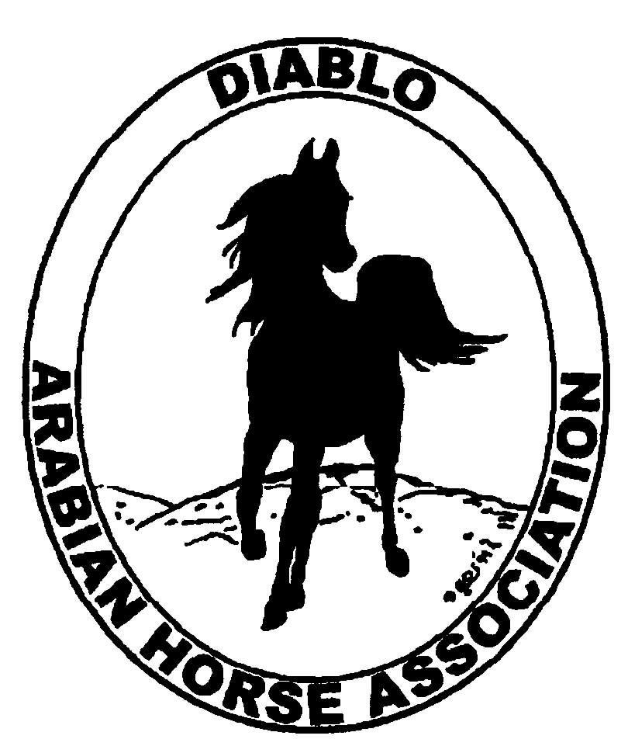

DIABLO ARABIAN HORSE ASSOCIATION
MINUTES—JANUARY 2012 Board Meeting
10 January 2012

Board Members Present: Committee Members: Delegates/Guests

1. Amy Edwards 1 Dorothy Burt
2. Pat Hendershot 2. Evelyn Call
3. Jill Mitchell 3. Debbie Compilli
4. Cindy Silvani
5. Cory Soltau
6. Mitch Sperte
7. Colleen Swift
8. Anne Wheeler

President Cory Soltau called the meeting to order at 7:04 P.M. The minutes of the December board meeting were reviewed. Pat Hendershot made a motion to approve the minutes, and Jill Mitchell seconded. Motion carried.

Correspondence: None

Treasurer’s Report: Amy Edwards presented the Treasurer’s Report as of January 10, 2012. Total Assets and Liabilities equaled $65,448.69. She also distributed a Transaction Detail Report for December 1, 2011 through January 10, 2012 which included Total Income of $5,286.00 and Total Expenses of [$3,366.78] for a net balance of $1919.22. Two bills were presented to Amy for review and approval for payment by the Board. Pat Hendershot motioned to pay the bills, and Cindy Silvani seconded. Motion carried.

COMMITTEE REPORTS

Awards/High Point: Debbie Compilli has received banquet reservations for 80 people but has not received payment yet to cover all of them. She plans to do a “walk-through” of the hall next week but has encountered difficulty communicating with staff at the venue because of personnel changes. Hall access for decorating is available only at 4 P.M. Debbie reported that the menu has been finalized and that a vegetarian entree will be available in addition to pork. Debbie said that approximately 125 people usually attend the Banquet. Cory Soltau volunteered to assist Jessica Mattson with emceeing duties. Sherry Pedder was absent but sent word that she has secured all of the High Point Awards and is ready to go.

Calendar Review: Cory Soltau asked that each committee chair submit an itemized budget at the annual budget meeting to be held at his home Tuesday, January 24th at 7 P.M. In light of the current worldwide economic crisis, he asked that budgets be prepared with an eye toward budget cutting wherever possible as well as maximizing benefits of club activities to members. The Region 3 meeting will be Friday, February 3rd. The Horse Faire at Heather Farms in Walnut Creek will be April 7th and will be held in conjunction with the annual Easter Egg Hunt.

Breed Awareness/Family Outreach/Public Relations: Debbie Compilli reported that there are three entries for the Family Arabian of the Year Award and that she has already received an entry for next year’s award program. Tracey Seals has sent eblasts to publicize the program and coordinates transmissions with Meghan Johnson. Anne Wheeler answered questions about last year’s Horse Expo, at which neither DAHA nor Region 3 had an effective presence. Jill Mitchell reported on the opportunity afforded for breed awareness by the Heather Farms Horse Affaire. The Horse Demonstration portion of the program provides an opportunity to showcase the versatile Arabian along with other breeds and in various disciplines. Although Heather Farms is in a fairly affluent area, parking is difficult and there is no stabling. It is strictly a trailer-in and -out venue. Jill Mitchell has secured three booths for DAHA and one both for Jill Mitchell Training Stables. Spaces cost $25 each for exhibitors and $40 each for vendors. We will need to bring a generator as now power is available. Cory Soltau initiated a brief discussion of possible giveaways such as AHA Arabian horse coloring sheets (Coke Swift noted that the club still has unopened crayon packets that can be used), a magnet with an Arabian horse, a list of resources for riding lessons and so forth. Anne Wheeler suggested a map with pins or dots identifying breeders, trainers, instructors, and the like. Evelyn Call recommended a flyer with photos of Arabians and riders/handlers in various disciplines to showcase Arabian versatility (another breed awareness opportunity). Jill Mitchell reminded everyone of the popularity of children having their photos taken on an Arabian. Amy Edwards will check on the cost of giving a key ring to children. Jill Mitchell liked the idea of giving a shirt to each child to color/decorate and take home. Cory then asked that Jill chair a Horse Faire Committee, and Evelyn Call. Mitch Sperte, Coke Swift, Cory Soltau, and Anne Wheeler agreed to serve on the committee. Last, Anne Wheeler reported that she has volunteers for booth shifts at Golden Gate Fields (! 10:30 A.M. – 1:30 P.M. and 1:30 P.M. – 4:30 P.M.). She will label the tip jar to indicate that tip monies will be donated to the Horsemen’s Relief Fund.

Horse Shows: Coke Swift updated and emailed spreadsheets on income and expenses for the Spring and Fall Shows. She briefly discussed various debits that were attributed to the Fall Show to show a lower net loss for the cancelled Spring Show. She also attributed to the Fall Show the cost of awards that could be used at the Fall Show. Amy Edwards noted that the time has come to cease debit adjustments between the shows and to move forward. The cancellation of the Spring Show because of the EHV-1 problem was hopefully an anomaly. Cory Soltau asked for a list of Horse Show Committee members; Mitch Sperte recommended that every member of the BOD be on the committee. Cory plans to go to Brookside to negotiate lower costs for the club’s use of the venue. Evelyn Call asked about insurance coverage for the cancellation of events. Bids for the position of Show Secretary will be discussed at the Horse Show Committee meeting. Cory noted that the club should have received three bids; however, none was received from Nancy Goertzen. Anne Wheeler suggested that the Premium Book include a caveat that only 66% of fees would be refunded in the event of a possible cancellation of any show. DAHA needs to cover expenses and avoid incurring extraordinary costs in the event of cancellations for unforeseen problems such as the EHV-1 outbreak. Jill Mitchell motioned to pay Coke Swift for mileage and show fees, and Anne Wheeler seconded. Motion carried.

Membership: Evelyn Call reported that DAHA’s member status as of 2 January 2012 is as follows.

Adults (1-Year) - 92
Adults (3-Year) - 27
Adults (Life) - 6

TOTAL VOTING ADULTS - 125

Adults – Associate - 6
Youth - 34

TOTAL MEMBERS - 165

Newsletter/Web Site: Meghan Johnson was absent but emailed a report. She disseminated the newsletter December 13, 2012, and it was emailed by Tracey Seals shortly thereafter. Meghan also mailed it to the 9 or so members without access to email. She updated the web site as of January 34, 2012 and added the Golden Gate Fields information to it. She also added a web page for BOD meeting minutes to the club web site and uploaded all meeting minutes from May 2011 through December 2011. She has not included quarterly complements of minutes to the Newsletter as that would make it too long. Last, she updated the DAHA Contacts list with information on the new 2012 BOD. She asked that Tracey Seals eblast members about the GGF event, the need to RSVP for the Banquet, and a request for silent auction items.

Trail Rides: Jill Mitchell had nothing new to report. Cory Soltau will discuss with Tom Brumleve the possibility of a trail ride to Diablo Ranch. The $500 donation to Save Mt. Diablo for the Endurance Ride will need to be reviewed to determine if the club can afford that donation in 2012. Jill said that Region 3 will probably not donate anything, although she intends to submit a request in any case.

Volunteer Awards: No report—Cindy Volz was absent. AHA unfortunately sent the AHA Volunteer award directly to the recipient rather than to President Pat Hendershot or to Cindy so that she could announce the individual’s name at the Banquet. The recipient will receive a DAHA jacket which will be name-embroidered at a later date.

Youth: Jill Mitchell reported that she is still awaiting the AHA ruling on age limits, which, if passed, will go into effect December 2012 for the following show season. She mentioned the need to elect a new Region 3 Youth Director. Jill reported that DAHA offers some youth activities at the Spring Show. She announced that Mitchell’s Marauders won the Youth Team Judging Award from a field of 53 candidate teams.

Old Business: Tips from the Golden Gate Fields event will be donated to the Horsemen’s Distress Fund.

New Business: Jill Sherman has agreed to host a summer barbeque social at Sherman Ranch. Cory Soltau is working with the Shermans and other horse people to afford DAHA members some additional social opportunities.

Delegates and Alternates were elected as follows:

Delegates: 1. Cory Soltau
- Pat Hendershot
- Mitch Sperte

Alternates: 1. Cindy Silvani
2. Evelyn Call
3. Jill Mitchell
4. Cindy Volz

Cindy Silvani motioned to adjourn the meeting, and Amy Edwards seconded. Motion carried. The meeting was adjourned at 9:15 P.M.

Respectfully submitted,

Cindy Silvani
Secretary

