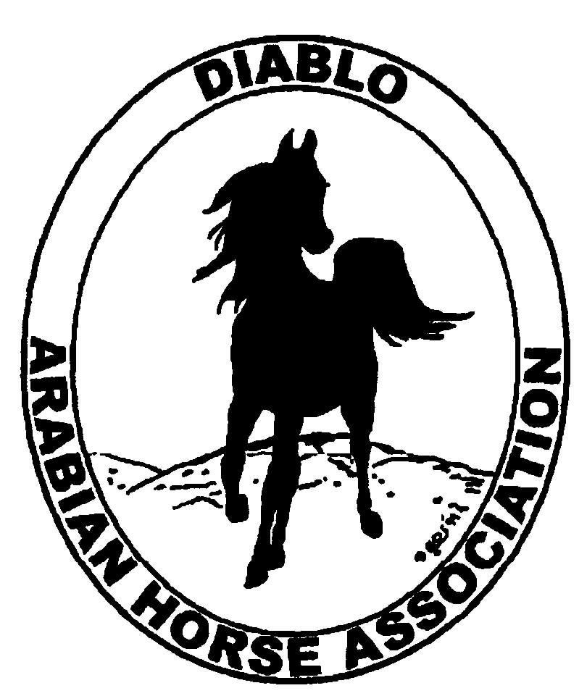

DIABLO ARABIAN HORSE ASSOCIATION
MINUTES—JANUARY 2013 Board Meeting
8 January 2013

Board Members Present: Committee Members: Delegates/Guests

1. Evelyn Call 1. Debbie Compilli 1. Pat Hendershot
2. Amy Edwards 2. Cindy Silvani
3. Jill Mitchell
4. Ed Oto
5. Cory Soltau
6. Mitch Sperte
7. Colleen Swift
8. Anne Wheeler

President Cory Soltau called the meeting to order at 7:13 P.M. The minutes of the December board meeting were reviewed. Colleen Swift made a motion to approve the minutes, and Mitch Sperte seconded. Motion carried.

Correspondence: Anne Wheeler forwarded donations with cover letters to Horse’s Honor, the U.C. Davis Equine Research program, and the Horsemen’s Distress Fund. Anne also received a call from Susan Bavaria of AHA requesting photographs for the Breed Awareness section of DAHA’s Club Excellence Award submission to accompany the article Susan is writing.

Treasurer’s Report: Donna Bolla was absent but emailed the Treasurer’s Report as of December 31, 2012. Total Equity and Liabilities equaled $78,274.84. The Profit and Loss Operating statement for April through December 2012 included Total Income of $5,893.40 and Total Expenses of $11,434.17 for a net income of [$5,540.77]. Donna included a Profit and Loss Operating Budget Performance report to help with preparation of the 2013 DAHA Budget. She sent Check Detail for the month of December 2012 and a Reconciliation Summary and Detail of the club’s Chase Operating account for the period ending December 31, 2012. Last, Donna included copies of the Chase bank statement. Donna corrected the calendar to reflect the Treasurer’s presentation of the Annual Report at the April board meeting following the close of the club’s fiscal year 31 March 2013 rather than at the January board meeting. President Cory Soltau decided that the Budget meeting should take place annually in January as in years past.

Calendar Review: There will be a Budget meeting followed immediately by a Horse Show Committee meeting Wednesday, 23 January 2013 at 6 P.M. at the home of Cory Soltau. Cindy Silvani will email a meeting announcement together with a budget worksheet template to give meeting attendees a starting point to develop a suitable budget worksheet.

COMMITTEE REPORTS

Awards Banquet: Debbie Compilli presented her 2013 budget, which reflected some decreases including a significant cost reduction for the facility, for the annual Awards Banquet. She also included the menu. Debbie canvassed the BOD for their decision about the photographer, who wants to charge $350 to film the Banquet, Amy Edwards prepares the video presentation for each Banquet.—she needs additional photos. Ed Oto offered to take photos gratis. He can upload pictures to SnapFish, which allows anyone to pay for selected photos. Ed will submit photos to Amy for “A Year in Review.” He suggested producing a 2014 DAHA calendar at a cost of $10 each at Costco. Debbie then asked for donations for the Silent Auction and Raffle. Cory Soltau is still working to secure Victoria Oto and Camille Waechtner to be the keynote speakers at the Banquet.

Breed Awareness/Public Relations/Horse Faire: Anne Wheeler reminded everyone that DAHA’s Golden Gate Fields date is January 20, 2013 (the Martin Luther King holiday weekend). Volunteers should plan to arrive at 10 A.M. and to stay until 4 P.M. At Anne’s request for the BOD’s consideration, Coke Swift motioned that the club extend its membership for $40 in the Equestrian Center of Walnut Creek, and Evelyn Call seconded. MC. For the March 30th Horse Faire, Anne asked about selecting a site for and the size of the DAHA tent. The BOD wants to be situated near the farm animals, e.g., ducks and chickens, because they draw the public’s attention. Jill Mitchell pointed out that the Horse Faire is scheduled the same weekend as the Santa Rosa show. The club can determine how much of a presence it wants and can claim any discipline first. The video at last year’s Horse Faire did not work—people did not see it. The concept of “touching the horse” works well. We need to make information more inviting and attractive to encourage people to pick it up. Horse coloring and Ibn Whitey were good draws. Anne would like to move quickly on the Native Costume/Arabian Racing Day at the Alameda County Fair. Evelyn Call reported that no decision has yet been made. Cory Soltau and Dorothy Burt will meet with ARAC representatives. Anne created a mock-up of a flyer for Arabian Racing to disseminate at Golden Gate Fields as it would be the perfect target audience location. Evelyn will check the date of the Sheikh’s and Sheikha’s races and let Anne know.

Directory: Cindy Silvani reported that the DAHA Directory (for members only) is ready to go to the printer. Pat Hendershot would like it to be mailed to the entire membership and offered to help prepare the mailing.

Family Outreach: Debbie Compilli has received three entries, and the panel of judges has made its decision. The award will be announced at the Banquet. After a brief discussion, it was decided that there would be an “In Memoriam” presentation after the conclusion of the Family Arabian program.

High Point Program: No report--Tracey Seals was absent. Cory Soltau will contract Tracey Seals for a status report on the High Point booklet, the standings, and on ordering the awards. Cory will also contact Sherry Pedder for her input.

Horse Shows: Coke Swift reported that the Horse Show meeting last week was very productive. Coke needs to know what is happening with the schedule of classes. Jill Mitchell will work with Mitch Sperte to finalize it, especially the TBA classes. Mitch thinks that the schedule looks good; he would like to have some driving classes. The next Horse Show committee meeting will be Wednesday, 23 January 2013 at the home of Cory Soltau, immediately following the Budget meeting which will begin at 6 P.M.

Membership: Evelyn Call presented the DAHA Membership Report. She noted that her data do not necessarily include names submitted by 31 December 2012 because of lag time in AHA processing. Numbers are up approximately one-third over last year; expenses remained virtually the same. Member status as of 2 January 2013 is as follows.

Adults (1-Year) - 115
Adults (3-Year) - 27
Adults (Life) - 6

TOTAL VOTING ADULTS - 148
Associate Members - 0

Youth - 33

TOTAL MEMBERS - 181

Income

AHA Memberships $195.00
Broughton Membership 55.00
Hendershot HC-Membership 90.00

TOTAL INCOME $340.00

Expenses

AHA Memberships $105.00

Newsletter/Web Site: Meghan Johnson was absent but emailed the following report. She disseminated the December Newsletter the second week of the month. Meghan assisted Tracey with an e-blast with the Newsletter and a reminder about the Membership Banquet, with an additional reminder to be sent this week. The web site is up-to-date as of 7 January 2013, including the Events section; Meghan added seasonal photos and updated/added the 2013 BOD to the contact page. She updated the philanthropy page per the December meeting minutes. She will begin to work on the March Newsletter soon.

Racing: Cory Soltau will contact Dorothy Burt about meeting with the ARAC representatives and will coordinate production of an announcement with Anne Wheeler.

Trail Rides: Nothing to report

Volunteer Awards: Cindy Volz was absent but informed Debbie Compilli that everything is in order.

Youth: No report—Leigha Perry was absent.

Old Business: Cory Soltau shared various marketing and promotional pieces from past years and said that he would like to do this type of advertising and promotion again. He proposed a farm tour to which he would like to invite 4H and other local groups, focusing on beginners and those new to the Arabian breed. He suggested asking local farms to do the legwork to get the public to attend. He has discussed a three-farm tour (not as a sales tool but as a promotional vehicle) with Amy Edwards and Jill Mitchell, perhaps for August and would like children to be involved. The Sherman family will host a barbeque, and the Reinstein Ranch plans an evening bonfire. Each venue would conduct a raffle. Pat Hendershot mentioned that ArabHorse.com is a resource for ideas and organizational suggestions. The target audience for the concept is new, non-horse/non-Arabian owners. We must be prepared to answer questions such as where to take riding lessons or where to buy or lease a horse. In addition, a rescue-animal charity, whose mailing list could be used to reach non-horse owners, should be identified as the event beneficiary.

New Business: Delegates and Alternates to the 2013 AHA Annual Convention in Lexington, KY were selected as follows:

Delegates: Cory Soltau
Pat Hendershot
Anne Wheeler
Jill Mitchell

Alternates: Evelyn Call
Mitch Sperte

Anne Wheeler then motioned to adjourn the meeting, and Coke Swift seconded. Motion carried. The meeting was adjourned at 9:10 P.M.

Respectfully submitted,

Cindy Silvani
Secretary

