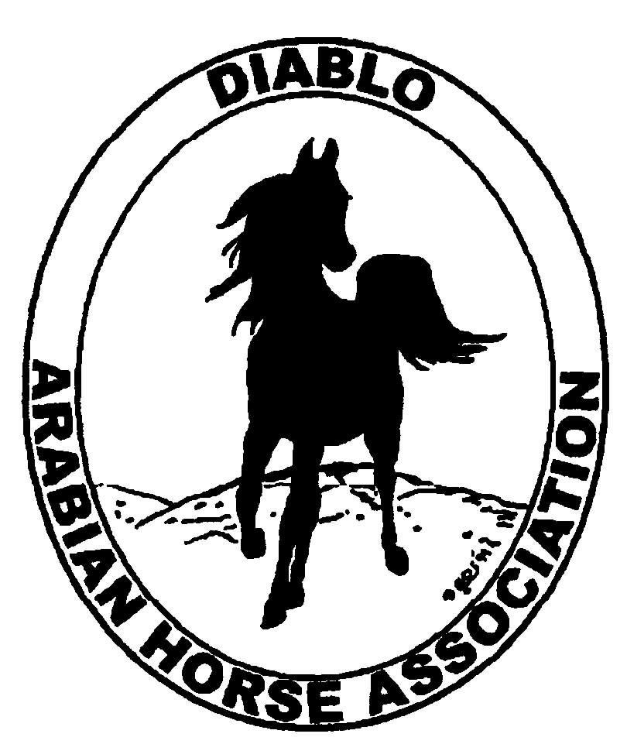

DIABLO ARABIAN HORSE ASSOCIATION
MINUTES—FEBRUARY 2012 Board Meeting
7 February 2012

Board Members Present: Committee Members: Delegates/Guests

1. Pat Hendershot 1 Evelyn Call
2. Cindy Silvani 2. Debbie Compilli
3. Cory Soltau 3. Tracey Seals
4. Mitch Sperte
5. Colleen Swift
6. Cindy Volz
7. Anne Wheeler

President Cory Soltau called the meeting to order at 7:20 P.M. The minutes of the January board meeting were reviewed. After corrections were noted, Pat Hendershot made a motion to approve the minutes, and Coke Swift seconded. Motion carried.

Correspondence: Dorothy Burt presented a thank-you note to DAHA for the horse-embossed platter presented to her as an outgoing board member.

Treasurer’s Report: Amy Edwards was absent but emailed the Balance Sheet, Transaction Report, Profit and Loss Statement, and Cash Flow Statement as of February 7, 2012. Total Assets and Liabilities equaled $66,779.18. She also distributed a Transaction Detail Report for January 1, 2012 through February 7, 2012 which included Total Income of $13,276.12 and Total Expenses of [$11,225.38] for a net balance of $2,050.74. Mitch Sperte motioned to table the Treasurer’s Report, as Amy Edwards and Coke Swift both need to be present, until the next Budget meeting, scheduled for Monday, February 13th at 6 P.M. at Cory’s home. Cindy Volz seconded. Motion carried.

Calendar Review: The board could not vote on the annual budget as it was not yet ready. Cory Soltau is still awaiting some Horse Show data as well as some committee budget reports. He will convene a Horse Show Budget meeting Thursday, February 9th. The DAHA Budget meeting will take place at his home Monday, February 13th at 6 P.M. Evelyn Call announced the Sheiks’ Race June 23rd at the Alameda County Fairgrounds. Tracey Seals will ask Meghan Johnson to send an eblast, to include photographs, in May to all Region 3 members. Evelyn Call will ask the local Chamber of Commerce to publicize the Sheiks’ Race and will provide pictures of native costume riders from last year’s race. It will be the only West Coast venue for this race series. Anne Wheeler recommended the next DAHA/Golden Gate Fields Day as an opportune time and place to publicize the Arabian Sheiks’ Race series. The club can put up banners at the track, and Cory Soltau will contact AHA to source racing promotional materials.

COMMITTEE REPORTS

Awards/High Point: Debbie Compilli presented the closing statement on the recent Winter Membership Banquet. Debbie has already inquired about a new venue for next year and is soliciting bids. She said that Heather Farms and Shadelands in Walnut Creek cost less than the Lafayette Veterans Hall and are large enough to accommodate our club. The cost, inclusive of kitchen use, would be approximately $525 as compared to the Lafayette site at approximately $1,850 (for a Sunday event). A Saturday event would cost slightly more. Proposed dates are Saturday, January 26, 2013 or Sunday, January 27th. Debbie is also soliciting catering bids.

Breed Awareness/Public Relations/Horse Faire: Anne Wheeler received a check for $94 for tips earned by the club at Golden Gate Fields. Anne reported that she attended a meeting Monday evening on the Horse Faire. The club has secured a great location, front and center, with booth space for DAHA as well as for Jill Mitchell Training Stables. Mitch Sperte expressed interest in renting a space. Cory Soltau said that he has a large pop-up structure that the club can use. We will also need to bring a generator as there is no electrical power. Anne further encouraged other individuals/breeding/training establishments to download forms to apply to the Equestrian Center of Walnut Creek. Anne would like to see as many applications external to DAHA as possible, so that the collective Arabian presence is not viewed as a single entity (DAHA). At Cory Soltau’s request, Tracey Seals agreed to assume responsibility for the Public Relations subcommittee and will contact local and equestrian media outlets and chambers of commerce. Cory will brainstorm with Tracey. He will also contact Sidney Simpson about writing publicity pieces for the club as Sidney has expressed interest in anything she can do on the computer as her health permits.

High Point Program: Tracey Seals presented the new High Point booklet for 2012, which had already been distributed at the Winter Banquet last month. Tracey received mailing labels from Evelyn Call and will mail booklets to DAHA members this week. Meghan Johnson will upload the High Point booklet to the DAHA web site.

Horse Shows: Coke Swift reported that all of the judges have been secured. The judge from Louisville, Susan Posner, has obtained a reasonably priced air fare. There will be one local judge, one from the Northwest, and one from the Southern California area. Coke needs to disseminate the Premium Book; she would like to schedule a Horse Show Committee meeting soon. Leigha Perry, Amy Edwards, and Jill Mitchell recommended changing Junior Western Pleasure, Hunter Pleasure, and Country/English Pleasure Championships to Sunday. Equitation and Open Championships would be held Saturday. Coke will check on pricing for a 5’ X 8” Premium Book as well as on the current 8 ½” X 11” 4-color format currently used; the latter has been partially subsidized by Brookside Equestrian Center. Coke will investigate quickly as the book needs to go to press by this coming weekend. She will report her findings to Cory Soltau, and together they will decide which format to use.

Membership: Evelyn Call reported that DAHA’s member status as of 31 January 2012 is as follows.

Adults (1-Year) - 99
Adults (3-Year) - 28
Adults (Life) - 6

TOTAL VOTING ADULTS - 133

Adults – Associate - 4
Youth - 38

TOTAL MEMBERS - 175

Evelyn noted that more members are electing the 3-year membership option, which results in the club’s retaining members longer.

Newsletter/Web Site: Meghan Johnson was absent but emailed a report. She updated the club web site with the High Point booklet, events, classified ads, and the Family Arabian information. She also added Coke Swift and Tracey Seals as the contacts on the Horse Show web page. Meghan contacted Region 3 IT Director Rik Harnden about adding a link from the DAHA Horse Show web page to the listing on the Region 3 Horse Show page. She recommended that Coke Swift contact AHA about linking the DAHA Horse Show web page to the AHA Horse Show page. She purchased and mailed a card to Sidney Simpson on behalf of the club. Last, Meghan requested ideas for the March Newsletter or web site.

Trail Rides: No report--Jill Mitchell was absent

Volunteer Awards: Cindy Volz was unable to attend the Banquet and inquired about the award presentations, which were excellent. She noted that this is the inaugural year for the Friends of DAHA award, which was also well received (it will be awarded on an ad hoc basis). Unfortunately, the embroidery on the award jacket was not ready by the time of the Banquet. Evelyn Call suggested that Hall of Fame and AHA Volunteer awards be solicited. Cindy reminded the group that the AHA Volunteer Award deadline is July 31st. The deadline for the Hall of Fame award (also given on an ad hoc basis to a person or a horse) is December 31st. Mitch Sperte suggested creating a banner with the names of all Hall of Fame winners. Evelyn Call reminded everyone that they are all engraved on the trophy, which is on display annually at the Banquet. Anne Wheeler and Meghan Johnson chair the subcommittee for DAHA’s AHA Club of the Year award submission.

Youth: No report--Jill Mitchell was absent.

Old Business: None

New Business: None

Cindy Volz motioned to adjourn the meeting, and Coke Swift seconded. Motion carried. The meeting was adjourned at 9:05 P.M.

Respectfully submitted,

Cindy Silvani
Secretary

