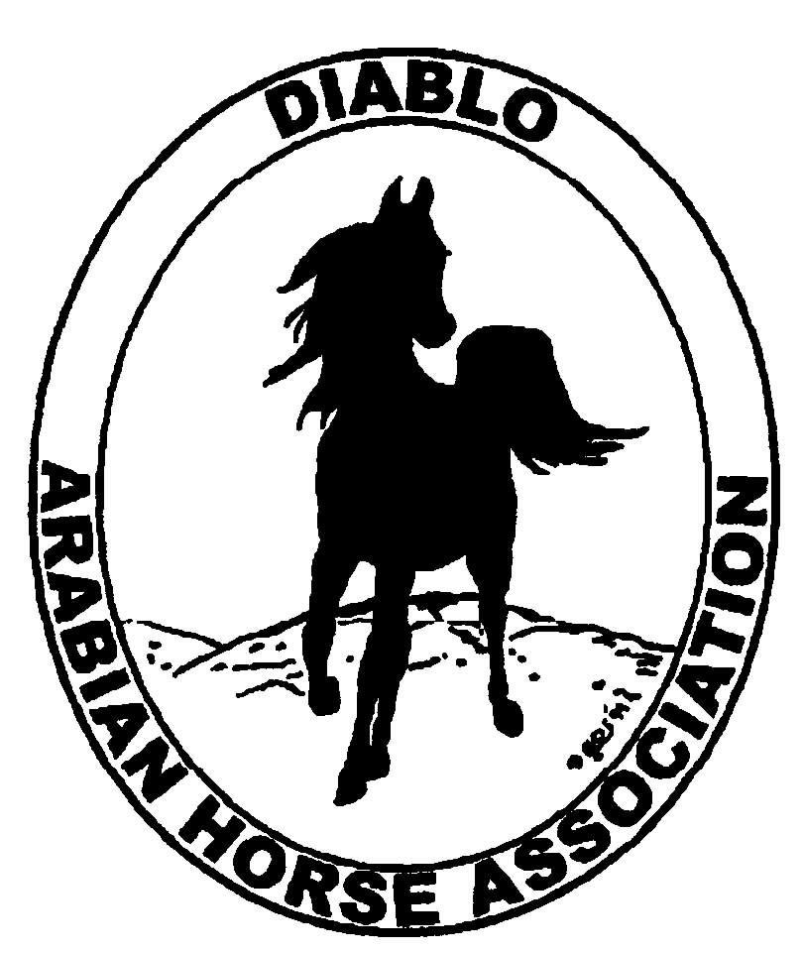

DIABLO ARABIAN HORSE ASSOCIATION
MINUTES—FEBRUARY 2013 Board Meeting
5 February 2013

Board Members Present: Committee Members: Delegates/Guests

1. Evelyn Call 1. Cindy Volz 1. Pat Hendershot
2. Amy Edwards 2. Cindy Silvani
3. Jill Mitchell
4. Ed Oto
5. Cory Soltau
6. Mitch Sperte
7. Tracey Seals
8. Colleen Swift
9. Anne Wheeler

President Cory Soltau called the meeting to order at 7:02 P.M. The minutes of the January board meeting were reviewed. Evelyn Call made a motion to approve the minutes, and Coke Swift seconded. Motion carried.

Correspondence: Debbie Fuentes of AHA asked for information about DAHA for a Club Excellence Award profile she is writing. Founded in 1969 by Carl and Pat Hendershot, Bud and Lorraine Soltau, and Lee and Bette Vinson, Diablo was incorporated as a 501 (c) (3) organization in 1974. Debbie asked about club-sponsored events such as horse shows, youth programs, and other DAHA activities. The club is planning two one-day horse shows open to the community. Evelyn Call will complete and return the survey form to Debbie Fuentes.

Treasurer’s Report: Donna Bolla was absent but emailed the Treasurer’s Report as of January 31, 2013. Total Equity and Liabilities equaled $83,593.51. The Profit and Loss Operating statement for April 2012 through January 2013 included Total Income of $13,395.30 and Total Expenses of $13,333.83 for a net income of $61.47. Donna included an updated Profit and Loss Operating Budget Performance. She sent Check Detail for the month of January 2013. Last, Donna included the Horse Show Profit and Loss Show Account report for April 2012 through January 2013.

COMMITTEE REPORTS

Awards Banquet: No report--Debbie Compilli was absent. Debbie does not yet have all the expenses. Reaction to the Banquet was generally favorable—attendees enjoyed the event. Shadelands proved to be a great improvement on the Lafayette facility—it was easier to maneuver; we were allowed in one-half hour earlier; and the Shadelands staff helped set up. Mitch Sperte made two suggestions: change the date to Saturday and have a DJ and entertainment after the awards presentation. Debbie would need to find out if the club would be allowed to stay later and what the cost of a DJ would be. Jill Mitchell mentioned the need to have a clean-up crew. Debbie submitted a preliminary budget. Cory Soltau will ask Debbie if she is willing to continue as Banquet Chair. Cory will ask Debbie to reserve the Shadelands facility for the next Banquet.

Breed Awareness/Public Relations/Horse Faire: Anne Wheeler reported that the Golden Gate Fields event was successful, although tips amounted to only $60.90 (the track reported that attendance was the lowest ever). Anne motioned that the tip donation be rounded to $100, and Mitch Sperte seconded. Motion carried. Anne mentioned Region 3’s participation in the June Horse Expo, again to be managed by Margie Pope. Everyone agreed that the presentation needs a great deal of improvement. Horse Expo management requires all Arabian involvement to be under Margie Pope’s supervision. Anne then discussed the March 30th Horse Faire (same date as the Golden Gate show). She needs flyers about the Sheikh/Sheikha’s races. Group consensus was to move the DAHA booth to a more favorable, well-trafficked area. Jill Mitchell, Coke Swift, and Anne Wheeler will work on the Horse Faire together. Ed Oto suggested contacting all area training stables to find out if they want to be represented in the DAHA booth. Anne reminded everyone to bring their blue DAHA shirts back for updating with the most recent Club Excellence award date.

Family Outreach: No report--Debbie Compilli was absent.

High Point Program: Tracey Seals said that the High Point program will be revamped. The High Point committee, which comprises Tracey, Jill Mitchell, Mitch Sperte, Ed Oto, Dorothy Burt, Amy Edwards, and representatives from Earthquake Arabians, will meet Wednesday, February 27th. Tracey will send an eblast announcing the beginning of High Point 2013. Presentation of awards at this year’s Membership Banquet was greatly improved and more concise.

Horse Shows: Coke Swift shared the flyer announcing the DAHA Spring Show that will be sent to Region 3 members; Amy Edwards will request Region 3 mailing labels from Sharon Richards, and Coke is trying to get mailing lists from other regions. Coke budgeted $400 for the production of the flyer. She still needs to buy postage. Mitch Sperte said that his contact in New Orleans, a krewe member and parade Grand Marshal, will send Mardi Gras material and trinkets to include in show promotion. Cory Soltau asked about the Fall Show; show dates are 9/26 – 9/29/13. Coke is working on the list of judges. Jill Mitchell will talk to students at Fresno about getting course credit for volunteering. Jill also reported that there will be two one-day shows (one will be at Roberta Reinstein’s ranch).

Membership: Evelyn Call presented the DAHA Membership Report. She noted that numbers are up by 12 over last year’s figures to date. Member status as of 2 February 2013 is as follows.

Adults (1-Year) - 114
Adults (3-Year) - 24
Adults (Life) - 6

TOTAL VOTING ADULTS - 144
Associate Members - 0

TOTAL MEMBERS - 178

Income

AHA Memberships $205.00
L. Domeier Membership 20.00 Life member/local club
D. Lanzini Membership 20.00 Life member/local club
C. Silvani Membership 60.00 Life member/local club – 3 yrs.

TOTAL INCOME $305.00

Expenses

TOTAL EXPENSES -0-

Newsletter/Web Site: Meghan Johnson was absent but emailed the following report. The web site is up-to-date as of 5 February 2013. Meghan would like to upload some of Ed Oto’s Banquet photos to the web site and upcoming newsletter. She was informed of a successful horse sale that resulted from an ad on the web site and in the newsletter. She added the winner of the Family Arabian award to the web site and will incorporate the other nominee applications as well. She would like someone to email her a brief description of the Banquet as she was unable to attend. Anne Wheeler sent her a description of the Golden Gate Fields event. Meghan received some ads for the March newsletter. She needs 2013 High Point material from Tracey Seals to post to the web site.

Racing: No report--Dorothy Burt was absent. Evelyn Call reported that she and Dorothy will attend the upcoming ARAC meeting. Dorothy is working on getting costume riders.

Trail Rides: Jill Mitchell said that the weather is still too unsettled to schedule a ride. Cory Soltau will talk to the Brumleves about hosting a ride.

Volunteer Awards: Cindy Volz needs input and suggestions for the Friends of DAHA award. The deadline for submissions for the AHA Volunteer award is July 31st.

Youth: No report—Leigha Perry was absent. Cory Soltau received a note from Leigha Perry with suggestions for recruiting youths from various stables for both horse and non-horse related activities, with an eye toward the ever-present liability issue. Jill Mitchell suggested a booth at the Alamo Art Fair, the Walnut Festival, and Lafayette Art Fair. Cory Soltau asked about the Danville Independence Day parade. He will contact Leigha about it, and Ed Oto volunteered to work on it.

Old Business: Cory Soltau mentioned D & O insurance; he has received quotes from a couple of vendors. The cost will be approximately $1,000 per year.

New Business: None

Anne Wheeler then motioned to adjourn the meeting, and Coke Swift seconded. Motion carried. The meeting was adjourned at 8:50 P.M.

Respectfully submitted,

Cindy Silvani
Secretary

