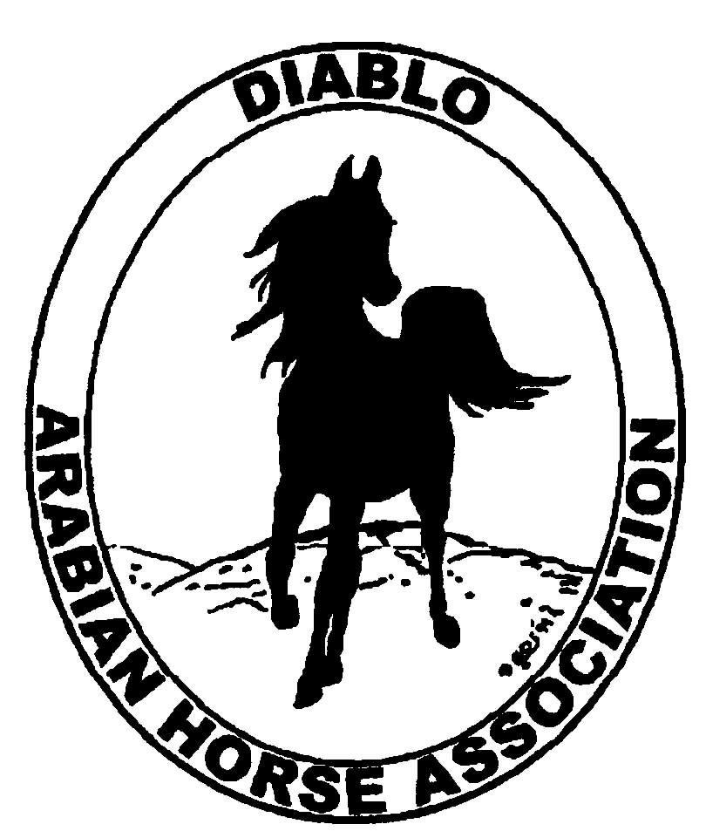

DIABLO ARABIAN HORSE ASSOCIATION
MINUTES—MARCH 2012 Board Meeting
6 March 2012

Board Members Present: Committee Members: Delegates/Guests

1. Amy Edwards 1 Evelyn Call
2. Jill Mitchell 2. Meghan Johnson
3. Cindy Silvani
4. Cory Soltau
5. Mitch Sperte
6. Colleen Swift
7. Cindy Volz
8. Anne Wheeler

President Cory Soltau called the meeting to order at 7:07 P.M. The minutes of the February board meeting were reviewed. Coke Swift made a motion to approve the minutes, and Cindy Volz seconded. Motion carried.

Correspondence: None

Treasurer’s Report: Amy Edwards emailed as well as distributed hard copies of the Balance Sheet and Transaction Report as of March 1, 2012 as well as a club budget for 2012. Total Assets and Liabilities equaled $66,004.57. The Transaction Detail Report for February 1, 2012 through February 28, 2012 included Total Income of $2,225.00 and Total Expenses of [$5,845.03] for a net balance of [$3,620.03]. Amy reported that there were no bills during the reporting period. Mitch Sperte motioned to send a check for $100 to Horses’ Honor as agreed earlier (tips received for the club’s having run the snack bar at Golden Gate Fields) and Cindy Volz seconded. Motion carried. Anne Wheeler will write a letter to accompany the check to be sent to Horses’ Honor. Cindy Volz then motioned to accept the 2012 Budget and Mitch Sperte seconded. Motion carried. After a discussion of the club’s financials, Amy Edwards formally resigned her position as DAHA Treasurer, for personal reasons, effective with the April 2012 filing of the club’s annual tax return.

Calendar Review: The Golden Gate Horse Show is upcoming at month-end. The Burbank Show, a combined Region 1 and Region 2 event, will he held next weekend.

COMMITTEE REPORTS

Awards Banquet: Debbie Compilli was absent but emailed a report. She solicited three bids for catering, received two, and awarded the contract to Classic Catering which submitted the lower bid.

Breed Awareness/Public Relations/Horse Faire: Anne Wheeler would like to have a banner (with the club name, logo, and web site address) made to publicize the club and its participation in the Sheik’s Race at the Alameda County Fair this summer. The banner could also be displayed at the Horse Faire and the Spring Show or at any event in which DAHA participates. Evelyn Call suggested having two banners made one on vinyl to publicize the club and another on ales expensive substrate to publicize the Sheik’s Race. She was quoted a price of approximately $50 for a 2’ X 3’ banner; a larger format would cost about $160 with a one-week turnaround time. In addition, Evelyn has designed and will get a quote on printing a club brochure to publicize DAHA’s activities and Arabian events in the Tri-Valley area. Jill Mitchell reported that an ad in the Horse Faire PR material will cost about $40; she volunteered to find out where it will be printed and how it will be disseminated. Jill also suggested having ensembles representing the various Arabian equestrian pursuits available for children to wear when having photographs taken at the Faire. Jill also mentioned face painting and salting the Easter Egg Hunt with “DAHA eggs” directing people to the booth. Cory Soltau recommended taking out two full-page ads in the Horse Faire program, which is to be distributed to an expected attendance of 2,000 people. Anne Wheeler then reported that each 501 (C) 3 organization participating is expected to donate a raffle prize. Cory approved the club’s getting the maximum three electrical outlets for the booth and then suggested a Horse Faire budget of $700 to cover expenses. Mitch Sperte made a motion to approve the $700 line item, and Coke Swift seconded. Motion carried. Cory then recommended that a DAHA PR contact be listed on the proposed brochure. Jill Mitchell will transport Ibn Whitey to the Horse Faire.

High Point Program: Tracey Seals was absent but had emailed a budget that was corrected to reflect expenses of [$4,207.00] and income of $4,212.00 for calendar 2012. She also reported that the High point booklet would be mailed March 8, 2012 to all DAHA members. She posted the “DAHA—Club of the Year” article on FaceBook.

Horse Shows: Coke Swift reported that the premium book is at the printer. She talked to the owner of Brookside Equestrian Center about securing a lodging quotation. He agreed to negotiate the most favorable rates with local hotels. Coke and members of the Judges’ Selection committee (Debbie Compilli, Pat Hendershot, Jill Mitchell, Cory Soltau, Mitch Sperte, Coke Swift, and Cindy Volz) agreed to meet at the home of Cory Soltau Tuesday, March 13 at 7 P.M.

Membership: Evelyn Call reported that DAHA’s member status as of 29 February 2012 is as follows.

Adults (1-Year) - 93
Adults (3-Year) - 25
Adults (Life) - 6

TOTAL VOTING ADULTS - 124

Adults – Associate - 4
Youth - 33

TOTAL MEMBERS - 161

Evelyn noted that no income or expenses were recorded during the month of February, nor were any new members reported by AHA during that month. Evelyn did receive $300 in renewal income yesterday, which will be reflected in her report for March 2012. Cory Soltau distributed DAHA Membership Application forms for the BOD to share with any prospective members.

Newsletter/Web Site: Meghan Johnson completed both the Newsletter and Web Site updates last week, including a letter from 2012 President Cory Soltau.

Racing: Evelyn Call reported that Dorothy Burt is working on this year’s slate of Arabian Costume Riders for the demonstration at the upcoming Sheik’s Race. Cory Soltau will work with Evelyn to publicize the event in local media outlets.

Trail Rides: Jill Mitchell is looking into a ride either at Camanche Lake near the Central Valley town of Ione or Pelican Inn on the coast. Camanche offers great campsites, barbeque facilities, and even pizza delivery. Cory Soltau recommended that Jill contact the Concord/Mt. Diablo Trail Ride Association about a possible ride on the mountain.

Volunteer Awards: Cindy Volz has received two nominations for the DAHA Hall of Fame; she requested nominations for the Volunteer Awards.

Youth: Jill Mitchell announced that Leigha Perry has volunteered to get involved with the club’s youth activities. Jill is planning some new and exciting events for youth at the Region 3 show.

Old Business: None

New Business: None

Cindy Volz motioned to adjourn the meeting, and Coke Swift seconded. Motion carried. The meeting was adjourned at 9:02 P.M.

Respectfully submitted,

Cindy Silvani
Secretary

