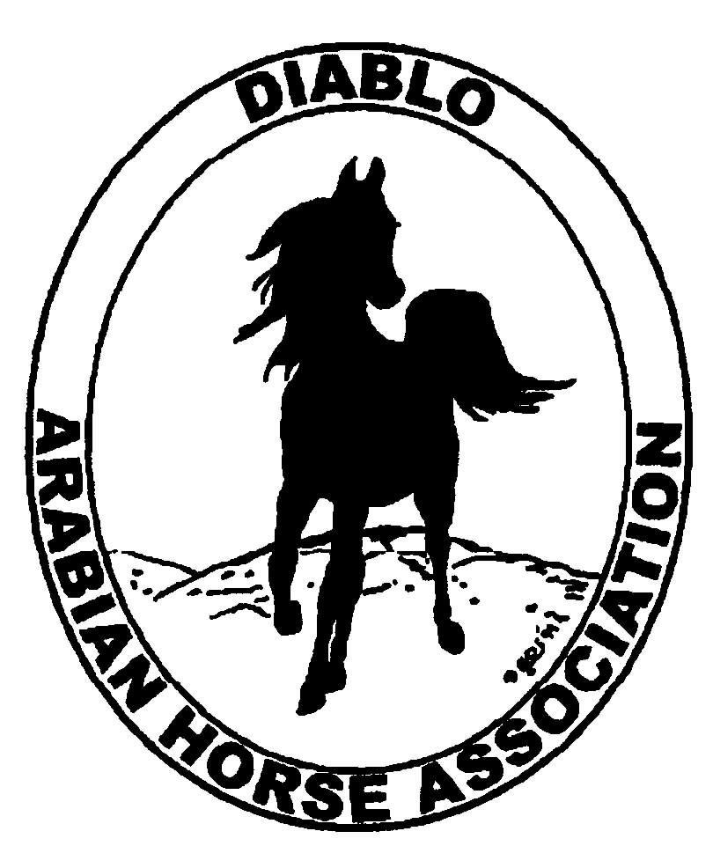

DIABLO ARABIAN HORSE ASSOCIATION
MINUTES—MARCH 2013 Board Meeting
5 March 2013

Board Members Present: Committee Members: Delegates/Guests

1. Evelyn Call 1. Dorothy Burt 1. Pat Hendershot
2. Jill Mitchell 2. Leigha Perry 2. Cindy Silvani
3. Ed Oto
4. Cory Soltau
5. Mitch Sperte
6. Colleen Swift
7. Anne Wheeler

President Cory Soltau called the meeting to order at 7:00 P.M. The minutes of the February board meeting were reviewed. Evelyn Call made a motion to approve the minutes, and Jill Mitchell seconded. Motion carried.

Correspondence: Cory Soltau received confirmation that the D & O insurance is now effective. He received a message from Mike Tracy about Mike’s wish to help with the Family Arabian Award program. Mike would like to expand on what was done with the program this past year and at the annual Membership Banquet. Mike said that at the least, stories submitted should be presented at the Banquet.

Treasurer’s Report: Donna Bolla was absent but emailed the Treasurer’s Report as of February 28, 2013. Total Equity and Liabilities equaled $83,190.00. The Profit and Loss Operating statement for April 2012 through February 2013 included Total Income of $15,597.30 and Total Expenses of $15,827.34 for a net of [$230.04]. Donna included an updated Profit and Loss Operating Budget Performance. She sent Check Detail for the month of February 2013. Last, Donna included the Horse Show Profit and Loss report for April 2012 through February 2013.

COMMITTEE REPORTS

Awards Banquet: No report--Debbie Compilli was absent.

Breed Awareness/Public Relations/Horse Faire: Anne Wheeler, Coke Swift, and Leigha Perry met regarding the Horse Faire. In keeping with the current industry focus on youth and based on last year’s attendance, they have decided to focus on activities for children, such as coloring, horse painting ($5 each), and Easter eggs (no candy). Coke plans to assemble promotional packets with coloring sheets and colored pencils in bags with flyers to hand out to the public. She will take a small tent and will rent two spaces only. Leigha plans to have Youth supervise painting. Evelyn Call has made up some certificates for the free membership drawing. Heather from Summit will bring Ibn Whitey, and Coke will see that he is properly attired in Native Costume. Jill Mitchell will look into the possibility of having a few Arabians in the demonstration arena. Anne will order a Black Stallion Breyer model and book for the raffle prize. Cory will investigate ordering additional books as well as the My Little Black Pony books for younger children at a cost of $4 per book. Anne then shared the flyer she created for the Horse Faire.

Directory: Pat Hendershot mailed the Membership Directories (except to those present at the DOD meeting. Evelyn Call will use the remainder to send to new members and to take to the Spring Show.

Family Outreach: No report--Debbie Compilli was absent.

High Point Program: No report--Tracey Seals was absent. Ed Oto said that the committee, including Tracey Seals, Jill Mitchell, Mitch Sperte, Dorothy Burt, Cory Soltau, Amy Edwards (is ill), and Ed will meet Wednesday, March 6th.

Horse Shows: Coke Swift said that she had overlooked the omission of the Premium Book preparation from Melanie’s contract; Coke is doing the Premium Book herself. Coke still needs Dressage, Reining, and Trail judges. Candidates include Deb Whitley, Cindy Reich, and the new “r” judge from OR. Coke needs to get the list out by March 15th, including names of judges. There will be a Horse Show committee meeting at month-end to tie up any loose ends. Coke needs Sport Horse scribes—Jill Mitchell will ask Fresno State students. Coke reported that figures are up for AZ shows, which bodes well for the DAHA shows. She still needs sponsorships and volunteers. Mitch Sperte talked to his colleague at Live Oak Arabians in Baton Rouge, LA—he has sent Mardi Gras promotional items. Mitch asked about giving his friend a partial page in the program and some signage in return. Ed Oto asked about a hotel list; when he contacted Hilton Gardens Inn, he learned that it was all booked. Other events are happening concurrently with the DAHA show. The Fall show is coming along—Coke still needs on more judge.

Membership: Evelyn Call presented the DAHA Membership Report. She noted that we are in good shape with 141 voting members to date. Member status as of 1 March 2013 is as follows.

Adults (1-Year) - 109
Adults (3-Year) - 26
Adults (Life) - 6

TOTAL VOTING ADULTS - 141
Associate Members - 0

YOUTH - 34

TOTAL MEMBERS - 175

Income

AHA Memberships $575.00
K. Campbell Membership 45.00 Life member/local club

TOTAL INCOME $620.00
Expenses

AHA-Campbell Membership 25.00 AHA dues

TOTAL EXPENSES $25.00

Newsletter/Web Site: Meghan Johnson was absent but emailed the following report. The web site is up-to-date as of 5 March 2013. Meghan has posted some new photos and updates the Events page. With Tracey Seals’ help, Meghan posted High Point winners and a photo of the new High point champion. She also updated the Family Arabian, Youth, and Classified Ads pages. She requested a photo of the Youth High Point Champion for the Youth web page. At a board member’s suggestion, she created a Hall of Fame web page. Meghan will work with Tracey to eblast members to submit photos to update the Photo Album. Meghan needs High Point data and forms, Horse Show Premium, and Entry and Patron forms. The Newsletter is almost complete. She is waiting for the President’s letter and some incoming ads. Thanks to Anne Wheeler for her contributions to the March Newsletter. Meghan and Tracey worked on a scholarship eblast and will send eblasts about the Horse Faire and the Spring Show.

Racing: Dorothy Burt and Evelyn Call reported that ARAC will pay for a booth at Horse Expo and allow DAHA to distribute information about Arabian racing and to manage the booth. A demonstration is possible under the aegis of ARAC. Dorothy needs to find out about DAHA horses’ demonstrating June 7 – 9, 2013 at the Expo. That will enable DAHA to participate separately from Region 3’s involvement. Evelyn and Dorothy will contact ARAC re booth space rental and shipping cost of booth. Volunteers will not need to be racing-savvy as there will be plenty of racing literature. Dorothy will get answers by the next board meeting. She has contacted track representatives about Costume horses at the County Fair races.

Trail Rides: Jill Mitchell will talk to Cory Soltau about staging a ride now that the weather is improving. They will discuss possible dates. Jill suggested having a barbeque.

Volunteer Awards: No report--Cindy Volz was absent.

Youth: Leigha Perry and Ed Oto are co-chairing Youth. They discussed possible activities and a meeting at the upcoming Spring Show. The Youth budget is $500; Coke Swift reminded everyone that $2,200 in Youth monies have been incorporated into the Horse Show account, awaiting the reactivation of the DAHA Youth group. Cory Soltau will alert Donna Bolla to the subsumed funds. Ed Oto wants to start a program; he noted that most Youths use their parents’ email addresses. He would like to establish Youth@DiabloArabianHorseAssoc.org and will talk to Meghan Johnson about getting email addresses set up. Cory asked about charitable activities which could then be incorporated into the Club Excellence Award application.

Old Business: None

New Business: None

Ed Oto then motioned to adjourn the meeting, and Anne Wheeler seconded. Motion carried. The meeting was adjourned at 8:31 P.M.

Respectfully submitted,

Cindy Silvani
Secretary

