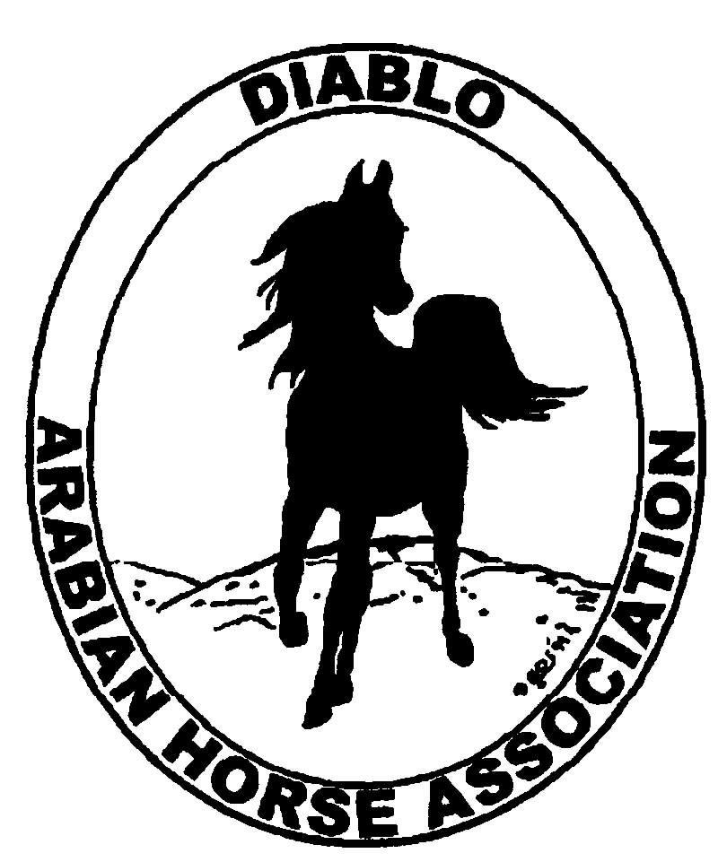

DIABLO ARABIAN HORSE ASSOCIATION
MINUTES—APRIL 2012 Board Meeting
3 April 2012

Board Members Present: Committee Members: Delegates/Guests

1. Amy Edwards !. Dorothy Burt
2. Pat Hendershot 2. Debbie Compilli
3. Jill Mitchell 2. Leigha Perry
4. Cindy Silvani
5. Cory Soltau
6. Mitch Sperte
7. Colleen Swift
8. Cindy Volz
9. Anne Wheeler

President Cory Soltau called the meeting to order at 7:08 P.M. The minutes of the March board meeting were reviewed. Pat Hendershot made a motion to approve the minutes, and Coke Swift seconded. Motion carried.

Correspondence: None

Treasurer’s Report: Amy Edwards emailed as well as distributed hard copies of the Balance Sheet and Transaction Report as of April 1, 2012. Total Assets and Liabilities equaled $65,857.27. The Transaction Detail Report for March 1, 2012 through April 1, 2012 included Total Income of $1,263.89 and Total Expenses of [$708.18] for a net balance of $555.71. Amy reported that there were relatively few transactions during the reporting period. Amy recommended that the club’s CD, which will mature April 27, 2012, be closed with her resignation as Treasurer as of April 15, 2012. The CD is in the club’s name as well as hers. A six-month CD, it can be reopened in the club’s name as well as Cory’s. Amy said that DAHA’s fiscal year runs from April 1 to March 31 with tax filing due in July. The club’s insurance coverage is with Equisure, and Amy reported that she had just received the renewal form. Evelyn Call submitted a bill for postage for a Membership mailing for $9.45. Pat Hendershot motioned to reimburse Evelyn, and Coke Swift seconded. Motion carried.

Calendar Review: Cory Soltau asked for verification of the club’s fiscal year; Amy Edwards said that it runs from April 1st to March 31st of the following year. The next Region 3 meeting is Friday, April 20, 2012.

COMMITTEE REPORTS

Awards Banquet: Debbie Compilli said that Classic Catering was very pleased to have been awarded the catering contract for the January 2013 Awards/Membership Banquet. She has secured the venue in Walnut Creek.

Breed Awareness/Public Relations/Horse Faire: Anne Wheeler presented the poster she had made to publicize Arabian Racing at the upcoming Horse Faire as well as the Spring Show. Anne has produced a very professional and eye-catching promotional piece. Cory Soltau has received a variety of AHA brochures to distribute at the Horse Faire. Anne presented a quote of $90 plus shipping and handling (to be determined) to print the DAHA brochure created by Sidney Simpson and Evelyn Call. Debbie Compilli, Pat Hendershot, and Mitch Sperte suggested replacing the cover photo and Reining horse photo with better images. Anne has purchased the required raffle prize for $55. Jill Mitchell reported that the cost of insurance to add the event to the club’s policy is $35. Leigha Perry read the list of volunteers for the Horse Faire. Leigha and Cory Soltau will arrive around 1 P.M. Friday to set up the DHA booth, although Horse Faire management would prefer that set-up be done at night. Jill mentioned that there will be a couple of DVD players and monitors to run several Arabian promotional DVDs. Heather Herman will transport Ibn Whitey and Anne Wheeler will bring a costume for him. Leigha still needs additional volunteers. Coke Swift will bring coloring books, crayons, porcelain models, and candy. She will also bring the club banners and tables. Cory will bring the Arabian coloring sheets supplied by AHA. The Horse Faire will run from 10 A.M. to 4 P.M. Arabian demonstrations will include Hunter, Native Costume, Western, and Reining horses. Mitch Sperte will try to bring an English Pleasure horse, and Jill said that there will be a Country English Pleasure Horse as well. Each demonstration is to last 5 minutes. Anne requested that all volunteers wear DAHA shirts or Western attire.

Family Outreach: Nothing to report

High Point Program: No report--Tracey Seals was absent. Cory Soltau asked for suggested additions or deletions to the High Point program. Dorothy Burt suggested that Trail and Racing be recognized apart from the Versatility category.

Horse Shows: Coke Swift distributed Sponsorship request forms together with a letter of welcome for “Friends and Exhibitors of Our Spring Show.” New vendors have been added. Coke plans to award the three buckles left from the Fall Show. She emailed Dean Lacey about Driving classes. Coke reported that numbers were down for the Santa Rosa show but up for Burbank. Premium packets have been mailed to Trainers and Exhibitors from last year, Mitch Sperte asked to be added to the list. He also suggested deleting obsolete classes such as Formal Driving and Formal Combination.

Membership: Evelyn Call was absent but emailed her report. DAHA’s member status, per AHA, as of March 31, 2012 is as follows.

Adults (1-Year) - 100
Adults (3-Year) - 27
Adults (Life) - 6

TOTAL VOTING ADULTS - 133

Adults – Associate - 6
Youth - 37

TOTAL MEMBERS - 176

Total income for month of March was $320, and the sole expense was $9.45 for postage.

Newsletter/Web Site: Meghan Johnson was absent but emailed her report. The Newsletter was sent out the first week of March and was also posted on the Web Site. Meghan posted the February minutes and will post the March minutes once they are approved by the Board and emailed to her. She received the Premium book from Coke Swift and will port it as well as the show entry and sponsorship forms once Coke sends them. She will also have Tracey Seals send them by e-blast. She requested suggestions for the June Newsletter.

Racing: Dorothy Burt reported that the insurance rider is in place. She has three riders and another for Native Costume. The Sheik’s Race is June 23rd. The Sheik donated $20,000, and Dorothy still has $10,000 from last year. The Alameda County Fair Day at the Races plus one additional TBA race will be funded from the $10K carry-forward. Racing in California is not healthy because of high insurance costs, e.g., $300 per jockey. Arabians are racing this year at Pimlico and raced at Churchill Downs last year. The Alameda County Fair Races celebrate their 100th anniversary this year, and Arabians, Thoroughbreds, and Quarter Horses will run.

Trail Rides: Nothing to report--Jill Mitchell is waiting for the rains to end.

Volunteer Awards: Nothing to report

Youth: Jill Mitchell is waiting for a report from the recent Youth meeting in Denver. Jill has submitted everything for Region 3.

Old Business: None

New Business: None

Cindy Volz motioned to adjourn the meeting, and Jill Mitchell seconded. Motion carried. The meeting was adjourned at 8:40 P.M.

Respectfully submitted,

Cindy Silvani
Secretary

