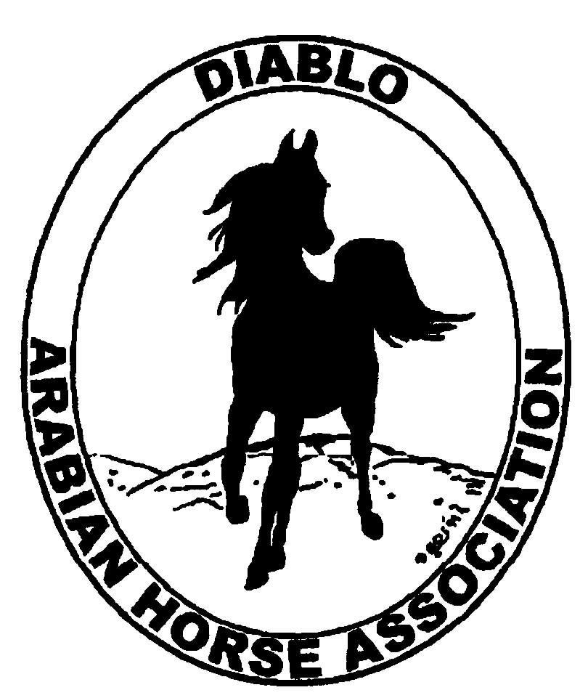

DIABLO ARABIAN HORSE ASSOCIATION
MINUTES—MAY 2012 Board Meeting
1 May 2012

Board Members Present: Committee Members: Delegates/Guests

1. Amy Edwards !. Dorothy Burt 1. Donna Bolla
2. Pat Hendershot 2. Evelyn Call
3. Cindy Silvani 3. Debbie Compilli
4. Cory Soltau 4. Leigha Perry
5. Mitch Sperte
6. Colleen Swift
7. Cindy Volz
8. Anne Wheeler

President Cory Soltau called the meeting to order at 7:13 P.M. The minutes of the March board meeting were reviewed. Colleen Swift made a motion to approve the minutes, and Cindy Volz seconded. Motion carried.

Correspondence: Cory Soltau received an email from a therapeutic riding program, Footprints of the Heart, requesting that the club provide a link for that organization from our web site. Consensus was that DAHA does not provide such links from its web site for such organizations, especially when, as is the case here, the requestor is not a member of Diablo.

Treasurer’s Report: Cory Soltau introduced the new Treasurer, Donna Bolla, who has been a Diablo member, delegate, treasurer, as well as president. Mitch Sperte made a motion that Donna be appointed Treasurer, and Cindy Silvani seconded. Motion carried. Donna’s appointment was confirmed unanimously. One of Donna’s goals as Treasurer is to simplify presentation of the club’s financial data to include budgetary, transaction, and net data. Donna will also assume responsibility for the club’s insurance coverage, including Horse Show and other special event riders and certificates. Amy Edwards presented the Treasurer’s Report as of April 30, 2012. Total Assets and Liabilities equaled $65,956.81. The Transaction Detail Report for April 1, 2012 through April 30, 2012 included Total Income of $31,432.30 and Total Expenses of [$31,360.24] for a net balance of $72.06. Amy will work with Donna Bolla through the transition. The CD, which matured, has been closed. Storage cost is $75.00 per month. Evelyn Call noted the need to go through the storage locker and to discard material no longer current or useful. Amy will pay forward, using the club’s credit card, two months’ rental to give everyone adequate time to clean up the storage locker after the Spring Show. Cindy Volz motioned to increase the club’s insurance coverage from $1 million to $2 million for an additional cost of $400 per year. Mitch Sperte seconded. Motion carried. Amy will also look into getting D & O coverage for the club.

Calendar Review: Cory Soltau will send his next Letter from the President to Meghan Johnson by mid-month for inclusion in the upcoming Newsletter.

COMMITTEE REPORTS

Awards Banquet: Nothing to report

Breed Awareness/Public Relations/Horse Faire: Anne Wheeler still has no contact at Golden Gate Fields. Linda Segel contacted Debbie Compilli asking DAHA to staff the Region 3 booth for a half day at Horse Expo. Consensus was that Diablo will be unable to accommodate the request. Coke Swift will apprise Linda of the club’s decision.

Family Outreach: Nothing to report

High Point Program: No report--Tracey Seals was absent.

Horse Shows: Coke Swift needs volunteers to distribute the additional, no-cost Premium Books to area tack shops, feed stores, etc. Amy Edwards volunteered to take some to Red Bluff. Coke then shared a list of candidate judges compiled by the Horse Show Judges Selection Committee. Coke needs class sponsorships. She has 21 Patron Sponsors, the same number as last year. She reported that the number of horses for the Spring Show is approximately the same, but the number of entries has decreased. Coke anticipates the number will decrease from the 295 before last year’s cancellation of the show.

Membership: Evelyn Call presented her report. DAHA’s member status, per AHA, as of April 30, 2012 is as follows.

Adults (1-Year) - 94
Adults (3-Year) - 27
Adults (Life) - 6

TOTAL VOTING ADULTS - 127

Adults – Associate - 6
Youth - 32

TOTAL MEMBERS - 165

Total income for the month of April was $525.

Newsletter/Web Site: Meghan Johnson was absent but emailed her report. The Web Site is up to date, and she is working on the June Newsletter. Sidney Simpson submitted an article with photos on the Horse Faire for the Newsletter. Anne Wheeler has offered to write an article on college equestrian teams. Meghan is hoping that Evelyn Call will submit another article on Arabian Racing. Meghan herself plans to update the Spring Show article with input from Coke Swift. Meghan is including articles about the High Point and Family Arabian programs in the June Newsletter. She would appreciate suggestions for the Newsletter and Web Site. She has asked Tracey Seals to e-blast a reminder about enrolling in the High Point program and submitting competition points now that the show season is underway.

Racing: Dorothy Burt has secured three demonstration riders, and Earl Kelley will send his horse for the demonstration. Dorothy will work with Donna Bolla on the insurance rider for the Sheik’s Race. Evelyn Call will write press releases for the local media.

Trail Rides: No report--Jill Mitchell was absent.

Volunteer Awards: Cindy Volz asked everyone to watch for volunteers at the Spring Show who “go above and beyond the call of duty.” The deadline for submission of nominations for AHA awards is July 31st.

Youth: Leigha Perry has nothing to report yet. This year’s theme is “Through the Erabs,” and DAHA’s “erab” assignment is “The Future.”

Old Business: None

New Business: None

Mitch Sperte motioned to adjourn the meeting, and Cindy Volz seconded. Motion carried. The meeting was adjourned at 8:19 P.M.

Respectfully submitted,

Cindy Silvani
Secretary

