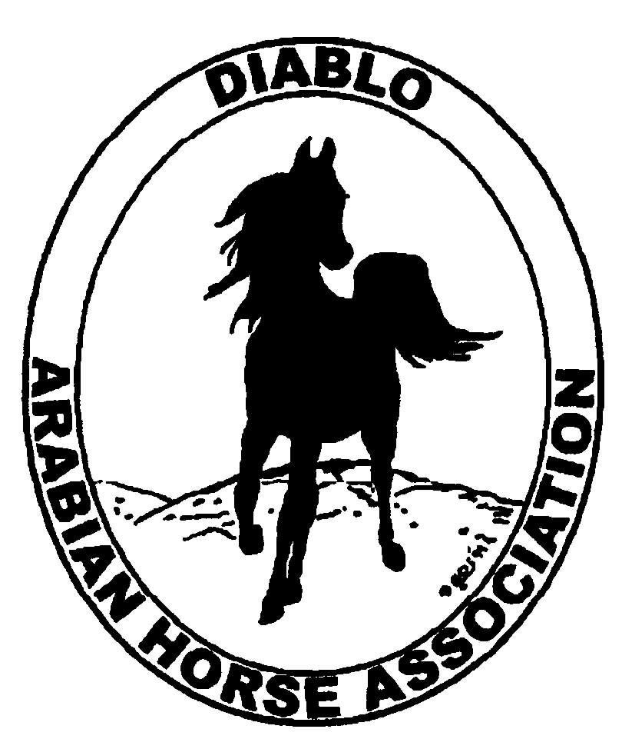

DIABLO ARABIAN HORSE ASSOCIATION
MINUTES—MAY 2013 Board Meeting
7 May 2013

Board Members Present: Committee Members: Delegates/Guests

1. Evelyn Call 1. Dorothy Burt 1. Pat Hendershot
2. Amy Edwards 2. Debbie Compilli 2. Cindy Silvani
3. Jill Mitchell
4. Tracey Seals
5. Cory Soltau
6. Colleen Swift
7. Anne Wheeler

President Cory Soltau called the meeting to order at 7:15 P.M. The minutes of the May board meeting were reviewed. After corrections were noted, Colleen Swift made a motion to approve the minutes, and Anne Wheeler seconded. Motion carried.

Correspondence: Amy Edwards received notification from the IRS regarding an error in the club’s tax ID number on its latest return. She also received a thank-you from the Bay Area Ridge Trail Council for DAHA’s recent $50 donation.

Treasurer’s Report: Donna Bolla was absent but emailed the Treasurer’s Report as of April 30, 2013. Total Equity and Liabilities equaled $76,716.84. The Profit and Loss Operating statement for April 2012 through April 2013 included Total Income of $885.00 and Total Expenses of $950.17 for a net of [$65.17]. Donna included an updated Profit and Loss Operating Budget Performance report. She sent Check Detail for the month of April 2013. Last, Donna included the Reconciliation Summary and Detail for Horse Show account for the period ending April 30, 2013.

COMMITTEE REPORTS

Awards Banquet: Nothing new to report

Breed Awareness/Public Relations/Horse Faire: Anne Wheeler said that the Horse Faire went better than she expected. The DAHA booth had a steady stream of people really interested in the Arabian horse. Vendors reported an increase in business over last year’s event. Coke Swift’s display of her porcelain horses was a great drawing card. Evelyn Call has contacted the two people who won DAHA memberships. Anne reported that donations to Horses’ Honor amounted to $50.50; Coke Swift will ask Donna Bolla to send a check for that amount to the charity. More than 50 bags of promotional materials were given to attendees expressing interest in the Arabian breed. Anne then reminded everyone that DAHA at Golden Gate Fields will be this coming Sunday, May 12th. Although volunteers may arrive at any time from 11 A.M. on, she really needs help for the 2 – 4 P.M. time slot. Anne then mentioned that the Arabian evening demonstrations October 25th and 26th at the Grand National will be an unsanctioned, judged-for-exhibition purposes event. Cory Soltau noted the importance of getting an announcer familiar with the Arabian breed. He is hoping to see 10 – 15 horses participating. Anne said that everything is being "comped," so it will be a fantastic promotional opportunity. Cory talked about the need to have banners and promotional materials available. We need to request brochures etc. of AHA.

Directory: Nothing new to report

Family Outreach: Debbie Compilli will write a brief description for the Newsletter regarding the revised, non-juried Family Arabian Recognition program. Those wishing to participate should submit a brief narrative outlining why a particular horse is important to them.

High Point Program: Tracey Seals is still working on the High Point User’s Guide. She is planning to produce an 8 ½” x 11” format to include some ads. She has revised the Point Schedule. A major change is that enrollment must be within 30 days of any show for which someone wants to accumulate points. Prizes will include a $500 gift certificate for the Junior Horse and Rider team and another for the 14 – 17 year-old age group, and another, yet-to-be-specified amount for the Bud Soltau award. Tracey needs sponsors for some of the awards. In the Junior division, entries can include a horse and rider team or multiple horses @ $20 per horse. The former Versatility division now encompasses the Specialty classes such as Side Saddle and Reining. Versatility now comprises other disciplines not generally incorporated in shows such as Racing and Jumping, with two sub-categories, Specialty Versatility and Trail. Tracey will submit a description to Coke Swift by Thursday morning, May 9th for inclusion in the Spring Show program. Tracey promised to have the High Point User’s Guide printed by the date of the Spring Show.

Horse Shows: Coke Swift still needs sponsors, and she is focusing her efforts on securing sponsorships. She still has some issues with the show program. Although ads are still being submitted and some are brand-new, they are down a little from last year. There were 25 sponsors last year. 250 horses are entered to date; Coke budgeted for 265, but she is still fielding calls. She has heard that numbers for the Red Bluff show were up (Debbie Compilli heard 180), but the Cal-Bred Futurities may not be held again. For Thursday, Coke needs the six volunteers Jill Mitchell promised, and she also needs volunteers for any other times people may be able to help. Coke has had a problem securing a vet for two of the show days. She may be able to apply for a special dispensation to use an on-call vet for those days. Pat Hendershot suggested hiring a vet from U.C. Davis for 3 days for $1,500. Start time is 8 A.M. except for Sunday when the vet would need to be there at 7:30 A.M.

Membership: Evelyn Call presented the DAHA Membership Report. She noted that we have 148 voting members to date, but she warned everyone that that number may fluctuate considerably over the next six weeks. Member status as of May 2, 2013 is as follows.

Adults (1-Year) - 116
Adults (3-Year) - 26
Adults (Life) - 6

TOTAL VOTING ADULTS - 148
Associate Members - 1

YOUTH - 35

TOTAL MEMBERS - 184

Income

L. Nordine Assoc. Membership $ 20.00

TOTAL INCOME $ 20.00
Expenses

13.80

TOTAL EXPENSES $0.00

Newsletter/Web Site: Meghan Johnson was absent but emailed the following report. She is working on the June Newsletter and plans to include articles on the Spring Show, Horse Faire, DAHA’s Golden Gate Fields volunteer day, Arabian Racing, Horse Expo, the new and improved High Point program, and others. The Web Site is up to date. Meghan has posted photos and ads and updated the Events page and Photo Album with photos of Bud and Lorraine Soltau and Bette Vinson for the Hall of Fame and of the Junior High Point Champion for the Youth page. She also helped Tracey Seals with eblasts.

Racing: Dorothy Burt reported that she needs a Certificate of Insurance. She has one rider for the demonstration and needs two more. Earl Kelly will not be participating this year. Dorothy has a rider who needs a horse if anyone has one that could be used. The race is July 6th. Tracey Seals will ask around, and Dorothy will call Leigha Perry.

Trail Rides: Jill Mitchell had nothing new to report

Volunteer Awards: No report--Cindy Volz was absent.

Youth: No report--Leigha Perry was absent.

Old Business: Pat Hendershot brought checklists from the Registry Commission; they are available on the AHA Web Site. Sample topics include sales, import/export, and other business transactions.

New Business: Tracey Seals was contacted by Terryl Reed regarding an upcoming Orientation to Endurance Riding; she would like to donate a breeding. Dorothy Burt suggested that Terryl publicize it through an ad or in the Newsletter. Evelyn Call said that it would be more appropriate to place an ad for the breeding. Pat Hendershot reported that she and Cory Soltau attended a Registry meeting at Michael Byatt’s farm in Texas. Changes are forthcoming; although they are still confidential at this time, they were very well received.

Anne Wheeler then motioned to adjourn the meeting, and Evelyn Call seconded. Motion carried. The meeting was adjourned at 8:45 P.M.

Respectfully submitted,

Cindy Silvani
Secretary

