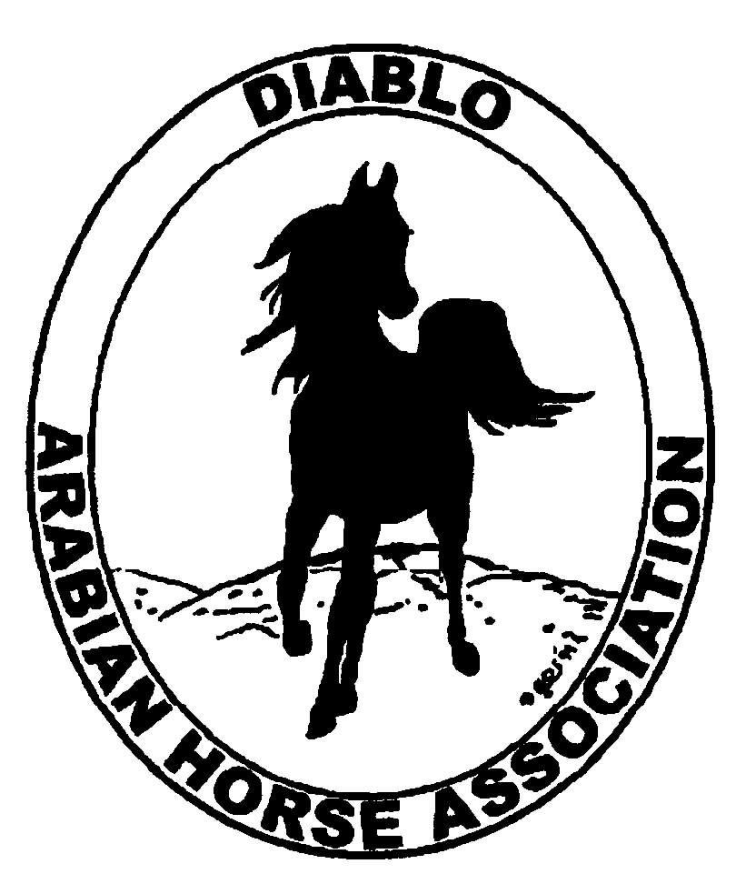

DIABLO ARABIAN HORSE ASSOCIATION
MINUTES—JUNE 2012 Board Meeting
12 June 2012

Board Members Present: Committee Members: Delegates/Guests

1. Pat Hendershot !. Donna Bolla
2. Jill Mitchell 2. Dorothy Burt
3. Cindy Silvani 3. Evelyn Call
4. Cory Soltau 4. Debbie Compilli
5. Mitch Sperte
6. Colleen Swift
7. Cindy Volz
8. Anne Wheeler

President Cory Soltau called the meeting to order at 7:05 P.M. The minutes of the May board meeting were reviewed. Colleen Swift made a motion to approve the minutes, and Pat Hendershot seconded. Motion carried.

Correspondence: None

Treasurer’s Report: Donna Bolla presented the Treasurer’s Report as of May 31, 2012. Donna reminded everyone that DAHA’s fiscal year runs April 1st through March 31st. Total Assets and Liabilities equaled $90,030.55. The Profit and Loss Operating statement for April through May included Total Income of $780.00 and Total Expenses of [$2,090.96] for a net income of [$1,310.96]. Donna also presented the Check Detail and Reconciliation Summary (including Reconciliation Detail) reports. The Profit and Loss Statement for the Spring Show showed Total Income of $124,450.50 and Total Expense of $99,370.29 for a Net Income of $25,080.21, almost exactly on budget. Donna then presented the Reconciliation Summary and Reconciliation Detail reports for the Horse Show account, as well as a Profit and Loss statement for the Spring Show. Donna then presented a Profit and Loss Budget Performance analysis for April through June 2012. Finally, Donna distributed a DAHA Expense report form for everyone to use when requesting bill payment or reimbursement. She encouraged everyone to suggest and changes or additions to the form. Colleen Swift motioned to pay the current bills, and Mitch Sperte seconded. Motion carried.

Calendar Review: Dates of the upcoming board meetings are July 3rd and August 7th.

COMMITTEE REPORTS

Awards Banquet: Nothing to report

Breed Awareness/Public Relations/Horse Faire: Dorothy Burt attended the Horse Expo and said that the Region 3 booth was not very exciting. She was disappointed that Arabian Racing was not represented at all. Vendors were fewer than in prior years. She missed the Arabian demonstrations (two were scheduled in the evening and one in the morning). Anne Wheeler reported that we should expect a fall date at Golden Gate Fields. Anne requested any updated information for the Club Excellence Award application. Coke Swift suggested a write-up of the Horse Faire. Jill Mitchell will ask Amy Edwards for the photo from the Horse Faire of the child sitting on an Arabian.

Family Outreach: Nothing to report

High Point Program: No report--Tracey Seals was absent.

Horse Shows:

Spring Show: Donna Bolla has received all of the Spring Show bills. Coke Swift received a nice thank-you note from Linda Craig of Arabian Star praising a very positive show experience. Marianne Clark of Liberty Stables in Roseville wrote hoping to volunteer at Golden Gate Fields. After resolving some personal issues, she is now ready to resume an active role in club and horse activities. Coke Swift reported that 286 horses participated in the Spring Show, meeting the targeted number. The show went smoothly overall. She said that Bill at Brookside loves the DAHA show. She still needed more volunteers. Jill Mitchell said that having the vendor area out of the way was very helpful. Both Jim and Sherry Pedder were sorely missed. Coke mentioned a few vendor complaints, noting that it is impossible to please everyone. Mitch Sperte said that the footing needs to be improved and arena maintenance stepped up. He suggested that Coke appoint a couple of trainers to constitute a Footing Committee to work with Bill to address issues in a timely manner, e.g., drag between sessions. The sound system was poor, although Coke reported that Bill will install a new system soon. She then suggested a Horse Show Committee meeting for the Fall Show. She also recommended that judges be hired at the same time for all DAHA shows. She will email a list of possible judges to everyone on the Judges Committee. Coke announced that after the Fall Show, Nancy Goertzen would be retiring to travel with her husband.

Fall Show: The Reiners would like to have an unrated schooling show in conjunction with DAHA’s Fall Show. They would use the back half of the Grand Prix arena. They would like Fall Show judges to score patterns. This will be discussed at the upcoming Horse Show Committee meeting Tuesday, June 19th at 6:30 P.M. at Applebee’s in Livermore. Dates of the Fall Show are 9/28 – 9/30, and it will likely draw fewer than 200 horses. The number last year was 186. Coke estimates that there will be 160-180 horses. Coke then shared highlights of Linda Reed’s highly complimentary Steward’s Report. The Barn Party was spectacular.

Membership: Evelyn Call presented her report. DAHA’s member status, per AHA, as of June 4, 2012 is as follows.

Adults (1-Year) - 98
Adults (3-Year) - 28
Adults (Life) - 6

TOTAL VOTING ADULTS - 132

Adults – Associate - 6
Youth - 30

TOTAL MEMBERS - 168

Total income for the month of May was $755 and AHA membership expenses were $315.

Evelyn thinks that AHA is very slow to process payments and new and renewal applications. If the club decides upon a membership campaign to reach the goal of 150 members and four delegates, checks should be forwarded immediately to Evelyn. Cory Soltau stressed the importance of this year’s convention/election. Cynthia Richardson will run for President, and Nancy Harvey for Vice President. Because the incumbent will run, we need as many delegates as possible. We have two weeks to try to get 18 more members to send four delegates to the annual meeting.

Newsletter/Web Site: Meghan Johnson was absent but emailed her report. The Web Site has just been updated for June. She is requesting photos from the Horse Faire and Horse Show, or personal horse photos to update the club photo album. The Newsletter is almost ready; Meghan is waiting on a Spring Show article and a Fall Show flyer from Coke. She asked the Board for anything to include in the June e-blast that accompanies the Newsletter and the call-out for High Point standings. Tracey Seals sent an e-blast for High Point in May.

Racing: Dorothy Burt reminded everyone about the Sheik’s Race Saturday at the Alameda County Fair and asked for a count of DAHA members planning to attend. ARAC will supply fair passes to those people, who would then have to pay just for parking. Dorothy will request 30-35 tickets and will ask for more if needed. Two weeks after the June 23rd Sheik’s Race, the DAHA-sponsored race will be held. The club needs to select the race it will sponsor. There will be a Stakes race Saturday, July 7th and a Maiden race Sunday July 8th, Cory Soltau suggested sponsoring the Stakes race. Dorothy will contact Tracey Seals to send an e-blast about the Sheik’s Race. She is trying to find someone to videotape the race. She needs to know the number of DAHA members who will attend the July 7th Stakes race.

Trail Rides: Jill Mitchell reported that she rode 30 miles of Amy Edwards’ 6,000-acre ranch and thinks it would be a fantastic venue for a ride and an overnight in September or October. It would also be a wonderful site for an endurance ride. There are fire roads, trails, great climbs, and abundant watering troughs.

Volunteer Awards: Cindy Volz has received one nomination for the Friends of DAHA award. The deadline for AHA awards is July 31st, and she encouraged everyone to submit a nomination.

Youth: Jill Mitchell said that Youths receive t-shirts every year at Youth Nationals. She would like the club to sponsor its listing on the shirt at the $500 level this year (the font used for the name would be larger. The Youth budget is $500. Cindy Silvani made a motion that the club sponsor at the $500 level, and Pat Hendershot seconded. Motion carried. Jill next requested donations of riding apparel for the Region 3 Youth Consignment Sale. She would also like to have T-shirts to tie-dye as well as raffle prizes. Jill then motioned to give Youth $50 to create a gift basket, and Pat Hendershot seconded. Motion carried.

Old Business: None

New Business: Dates of upcoming board meetings are July 3rd and August 7th. Cory Soltau constituted a Nominating Committee for the next BOD election to include Evelyn Call, Debbie Compilli, Pat Hendershot, Jill Mitchell, and himself. Cindy Silvani motioned to pay Coke Swift the Horse Show $1,500 base management fee, with the balance to be based on the final P & L statement. Jill Mitchell seconded. Motion carried.

Cindy Silvani motioned to adjourn the meeting, and Anne Wheeler seconded. Motion carried. The meeting was adjourned at 9:10 P.M.

Respectfully submitted,

Cindy Silvani
Secretary

