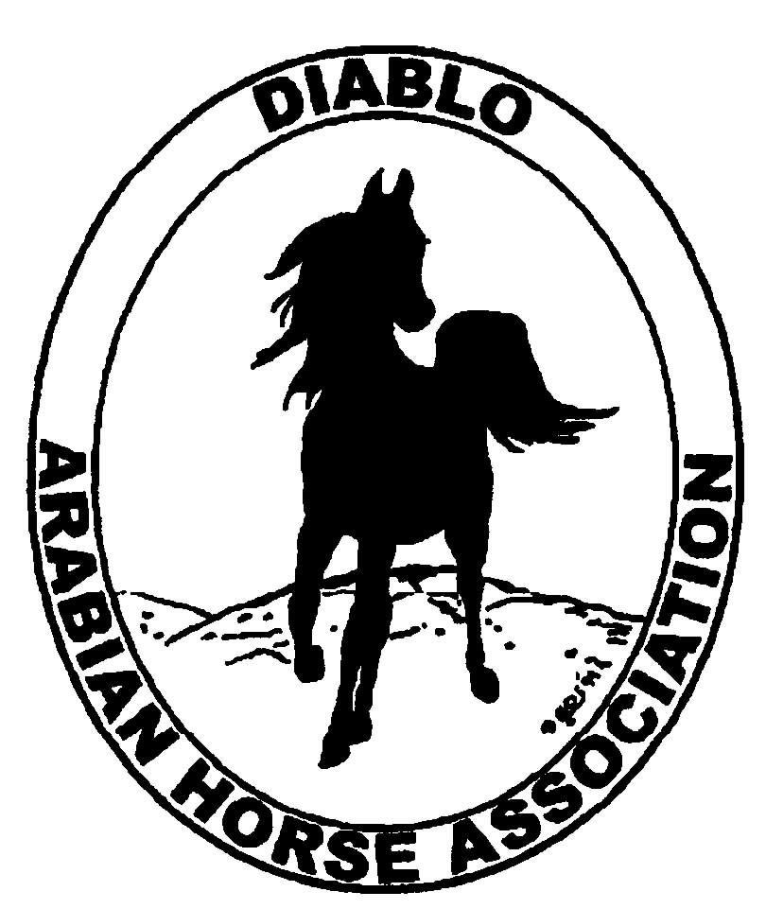

DIABLO ARABIAN HORSE ASSOCIATION
MINUTES—JUNE 2013 Board Meeting
4 June 2013

Board Members Present: Committee Members: Delegates/Guests

1. Evelyn Call 1. Dorothy Burt 1. Pat Hendershot
2. Amy Edwards 2. Debbie Compilli 2. Cindy Silvani
3. Ed Oto
4. Cory Soltau
5. Mitch Sperte

President Cory Soltau called the meeting to order at 7:15 P.M. The minutes of the May board meeting were reviewed. After corrections were noted, Evelyn Call made a motion to approve the minutes, and Amy Edwards seconded. Motion carried.

Correspondence: Debbie Fuentes of AHA asked Pat Hendershot to thank Amy Edwards for sending the beautiful photographs, which will appear soon on the AHA web site.

Treasurer’s Report: Donna Bolla was absent but emailed the Treasurer’s Report as of May 31, 2013. Total Equity and Liabilities equaled $91,842.76. The Profit and Loss Operating statement for April 2012 through May 2013 included Total Income of $1,395.00 and Total Expenses of $2,835.23 for a net of [$1,440.23]. Donna included an updated Profit and Loss Operating Budget Performance report. She sent Check Detail for the month of May 2013. Last, Donna included the Reconciliation Summary and Detail for the period ending May 31, 2013 as well as the Profit and Loss Horse Show account for April 1 through June 1, 2013 and the Horse Show Reconciliation Summary for the period ending May 31, 2013.

COMMITTEE REPORTS

Awards Banquet: Nothing new to report

Breed Awareness/Public Relations/Horse Faire: Anne Wheeler was absent but emailed a report in which she asked whether or not the donation amount (based upon tips earned at Golden Gate Fields May 12th) should be rounded up or down. The check amount will be rounded up to $125. Anne reported that Golden Gate Fields sent Amy Edwards a check for $1,000 for working the booth. Anne will make sure that in future checks are sent to Donna Bolla. Anne needs riders and costumes for the Arabian Native Costume demonstration rides October 25th and 26th at the Grand National. Sheri Lacey is interested in riding. Anne still needs volunteers to work at the event.

Directory: Nothing new to report

Family Outreach: Debbie Compilli sent information to Meghan Johnson describing the new, noncompetitive Family Arabian Recognition program to publish in the newsletter and on the web site.

High Point Program: Tracey Seals was absent but emailed asking about printing copies of the completed High Point User’s Guide which will be uploaded to the web site. Tracey will send an eblast about the High Point program. DAHA Spring Show results are not yet available online: Cory Soltau will contact AHA to inquire.

Horse Shows: Colleen Swift was absent but emailed a report. She has estimated roughly that the show did all right. Total entries were down by 15 horses; once Coke is able after her upcoming surgery, Cory Soltau would like to have a “post mortem” meeting on the show. With a goal of always trying to improve the show, Cory plans to create a survey, which Ed Oto will prepare, to be sent to trainers. Cory said that the majority of concerns expressed to him were about the schedule, improving footing by harrowing more often, moving Youth classes to Friday, improving the announcing as well as the sound system, rethinking those classes with only one or two horses, and having a stabling manager assign stalls. Cory noted in particular the need to develop a system for stall assignments. Pat Hendershot reported that the Red Bluff show will probably just break even. Ed offered to find out about the AHANC show. Cory noted consistently positive feedback about the owner of Brookside Equestrian Center and would like the club to express its gratitude in some way. Suggestions include giving him some wine, a Friends of DAHA award, an invitation to the annual Membership Banquet. Coke reported a very positive response to the Mardi Gras in May theme, barn party and costume class. Photos of that class as well as of the parade will be uploaded to the web site and incorporated into the Club Excellence Award application. Coke still does not have the buckles. 269 horses entered although Coke had projected 285. Refunds total approximately $1,250; some monies are still owed, and there are a few NSF checks. Dressage and Sport Horse in Hand numbers declined somewhat, and Halter classes were extremely small. In addition to addressing scheduling issues Saturday and Sunday, the Working Hunter division may need to be discontinued. Dorothy Burt noted a discrepancy between the entry fee listed on the application form and the one printed in the program.

Membership: Evelyn Call presented the DAHA Membership Report. She noted that we may not have the requisite 150 members by June 30th to send a fourth delegate to the convention. DAHA’s member count as of June 1, 2013 per AHA is a total of 144 voting members. Mitch Sperte and Cory Soltau volunteered to draft additional members. Member status as of May 31, 2013 is as follows.

Adults (1-Year) - 111
Adults (3-Year) - 27
Adults (Life) - 6

TOTAL VOTING ADULTS - 144
Associate Members - 2

YOUTH - 36

TOTAL MEMBERS - 182

Newsletter/Web Site: Meghan Johnson was absent but emailed the following report. She received and has posted the 2013 High Point program documents and will work with Tracey Seals to eblast the membership about the new and improved High Point program. Meghan needs additional photos for the online DAHA photo album. She helped Tracey send eblasts regarding the Day at the Races, Horse Faire, and Spring Show. She plans to finish the June newsletter by the end of the week; Anne sent Meghan two articles regarding the Day at the Races. Meghan will include information on the new Family Arabian Recognition program. Evelyn Call is writing an article about the Arabian Racing schedule. There will also be coverage of the Horse Expo and the Grand National Rodeo.

Racing: Dorothy Burt is looking into costumes for the demonstration riders at Sheikh’s and Sheikha’s races. Cory Soltau will ask Anne Wheeler about the condition of the costume available from Horses’ Honor. Dorothy needs an insurance rider for the people demonstrating Native Costume at the July 6th Sheikh’s Race during the county fair. Evelyn Call will provide a Hold Harmless form for the three riders. There will only be a few tickets for the official reception to be held in the upstairs Paddock Room. Dorothy then reported that DAHA will sponsor the Stakes Race for Fillies and Mares Sunday, June 23rd. Six people can be in the winner’s circle photograph, and the club’s banner, which Evelyn Call may have, will be included. The club will be mentioned in the program and included in the pre- and post-race announcements. Dorothy Burt will contact Jeanne Wasserman of the county fair racing office to find out how many passes she is allotted as an owner.

Trail Rides: No report--Jill Mitchell was absent.

Volunteer Awards: Cindy Volz was absent but asked that everyone be apprised of the July 31st deadline for submission of the AHA Volunteer Award nominations.

Youth: No report--Leigha Perry was absent.

Old Business: Evelyn Call is to check on items to be given to new members. Cory Soltau would like to have a dynamic new member packet developed by the end of the calendar year.

New Business: None

Mitch Sperte then motioned to adjourn the meeting, and Ed Oto seconded. Motion carried. The meeting was adjourned at 8:46 P.M.

Respectfully submitted,

Cindy Silvani
Secretary

