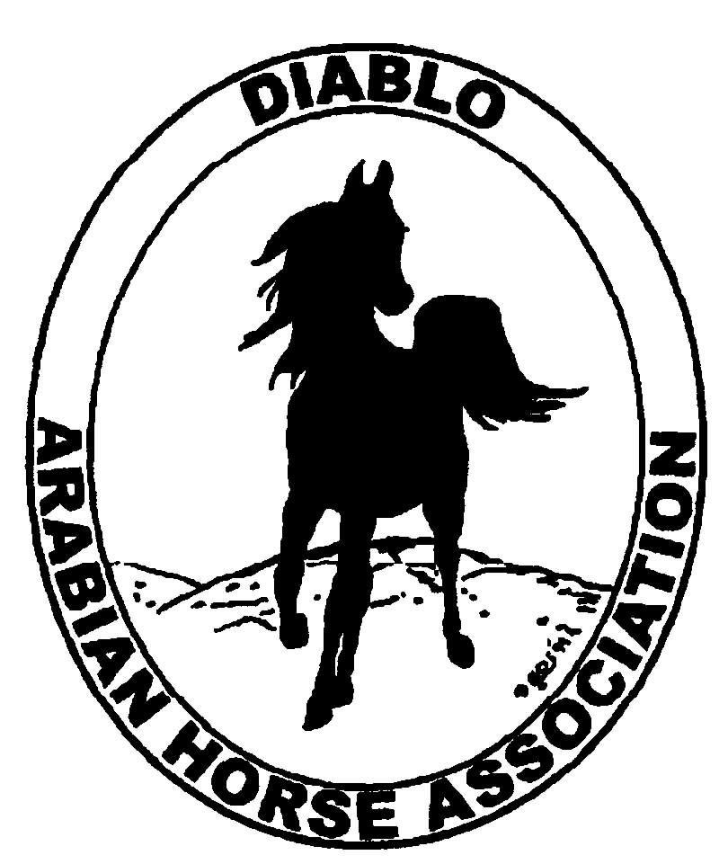

DIABLO ARABIAN HORSE ASSOCIATION
MINUTES—AUGUST 2012 Board Meeting
7 August 2012

Board Members Present: Committee Members: Delegates/Guests

1. Amy Edwards !. Evelyn Call
2. Cindy Silvani 2. Debbie Compilli
3. Cory Soltau
4. Mitch Sperte
5. Cindy Volz
6. Anne Wheeler

President Cory Soltau called the meeting to order at 7:17 P.M. The minutes of the July board meeting were reviewed. Cindy Silvani made a motion to approve the minutes, and Amy Edwards seconded. Motion carried.

Correspondence: Cory Soltau received a thank-you from the Arabian Racing Association of California for the club’s contribution to the success of the Sheikh Zayed Bin Sultan al Nahyan Cup race at the Fairgrounds in Pleasanton.

Treasurer’s Report: Donna Bolla was absent but emailed the Treasurer’s Report as of July 31, 2012. Total Assets and Liabilities equaled $80,759.76. The Profit and Loss Operating statement for April through July included Total Income of $2,386.00 and Total Expenses of $4,803.00 for a net income of [2,417.00]. Donna also presented the Check Detail and the Profit and Loss Statement for the Spring Show, which showed Total Income of $124,450.50 and Total Expense of $107,273.04 for a Net Income of $17,102.46. Last, Donna distributed a Profit and Loss Budget Analysis for April 2012 through March 2013 which showed to date an actual Net Income of $16,348.46 vs. a budgeted $18802.00 for a net loss of [$2,453.54]. Donna distributed Check Detail for the month of July 2012.

Calendar Review: Cory Soltau briefly reviewed the annual budget and noted, for example, that the Spring Show budget reflects $16,000 in income, but the actual figure is less by approximately $1,000—ecxpenses have increased.

COMMITTEE REPORTS

Awards Banquet: Nothing to report

Breed Awareness/Public Relations/Horse Faire: Anne Wheeler needs photographs from the Tevis Cup to include in DAHA’s Club Excellence Award submission. Anne asked if any DAHA members were involved with ride organization or management.. Anne can use photographs of club activities from the year ending June 30, 2012.

Directory: Cindy Silvani asked the Board to decide upon the number of copies to print, and it was decided to produce 250 each.

Family Outreach: Nothing to report. Debbie Compilli will create a poster to be displayed at the Fall Show.

High Point Program: No report--Tracey Seals was absent.

Horse Shows: No report. Colleen Swift was absent. Cory Soltau had spoken to Coke earlier in the day and said that the Premium List is almost finished and ready to print. Debbie Compilli noted the need to solicit class sponsors.

Membership: Evelyn Call presented the July DAHA Membership Report. DAHA’s member status, per AHA, as of August 1, 2012 is as follows.

Adults (1-Year) - 119
Adults (3-Year) - 28
Adults (Life) - 6

TOTAL VOTING ADULTS - 153

Youth - 29

TOTAL MEMBERS - 182

Total income for the month of July was $315 and AHA membership expenses were $25.

Newsletter/Web Site: Meghan Johnson was absent but emailed her report. The June 2012 Newsletter was e-blasted to the membership, mailed to the nine who require hard copy, and posted on the web site. The web site is up to date. Anne Wheeler contacted Meghan for help with the Club Excellence Award project. Meghan has started to work on the September Newsletter and plans to complete it before she leaves for vacation August 23rd. She asked for ideas and articles for the Newsletter as well as postings for the Web Site. She requested photographs for the DAHA album web page. For July, Meghan brought the web site up to date with new event dates and classified ads. She plans to request a list of philanthropic contributions to include in the Club Excellence submission. She has asked for input verifying entries. Again, Meghan requested articles for the Newsletter, which is coming along nicely and which will be completed upon Meghan’s return from vacation after the first week of September. She hopes to get the show Premium Book, entries, and sponsorship forms posted on the web site and e-blasted before her departure August 23rd.

Racing: No report-- Dorothy Burt was absent. Evelyn Call said that racing continues at other tracks such as Santa Rosa, Ferndale, and Fresno. She mentioned that the last two Tevis Cup winners were ex-race horses.

Trail Rides: No report--Jill Mitchell was absent.

Volunteer Awards: Cindy Volz noted that the nomination form has changed on the AHA web site.

Youth: No report—Leigha Perry was absent. Amy Edwards provided a synopsis of Youth Nationals. Our Region 3 float with a futuristic theme was good. Leigha Perry’s barn did well. Caroline Edwards brought home a Reserve Championship in Trail. Youth Nationals were down about 80 horses. Cory Soltau mentioned the need to get the club’s youth together for a fun activity.
Old Business: None

New Business: Evelyn Call found a form on the AHA web site to apply for matching funds from AHA for a promotional event.

Cindy Volz motioned to adjourn the meeting, and Mitch Sperte seconded. Motion carried. The meeting was adjourned at 8:43 P.M.

Respectfully submitted,

Cindy Silvani
Secretary

