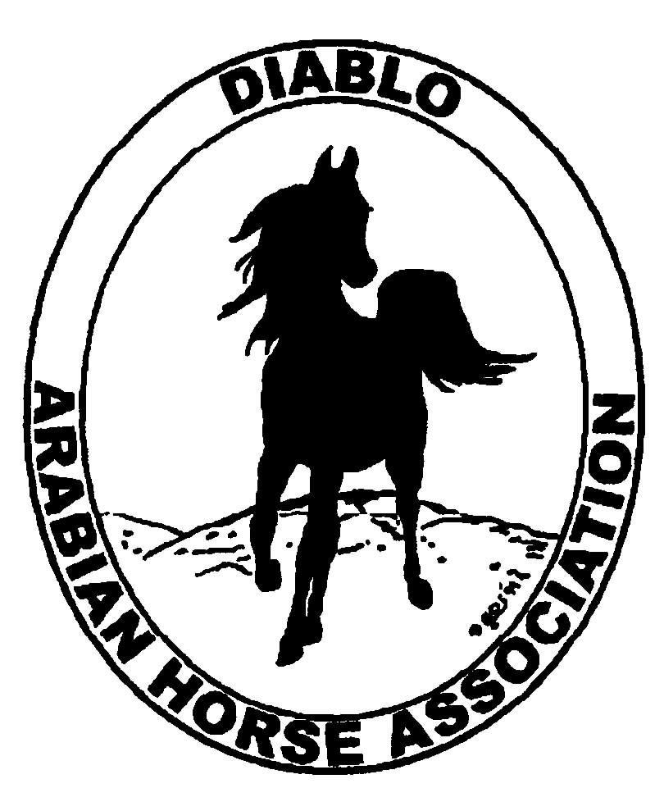

DIABLO ARABIAN HORSE ASSOCIATION
MINUTES—AUGUST 2013 Board Meeting
6 August 2013

Board Members Present: Committee Members: Delegates/Guests

1. Evelyn Call 1. Debbie Compilli 1. Pat Hendershot
2. Ed Oto 2. Cindy Silvani
3. Tracey Seals
4. Cory Soltau
5. Mitch Sperte

President Cory Soltau called the meeting to order at 7:10 P.M. The minutes of the July board meeting were reviewed. Evelyn Call made a motion to approve the minutes, and Ed Oto seconded. Motion carried.

Correspondence: None

Treasurer’s Report: Donna Bolla was absent but emailed the Treasurer’s Report as of July 31, 2013. Total Equity and Liabilities equaled $88,490.63. The Profit and Loss Operating statement for April 2012 through July 2013 included Total Income of $3,249.10 and Total Expenses of $3,698.33 for a net of [$449.23]. Donna included an updated Profit and Loss Operating Budget Performance report. She sent Check Detail for the month of July 2013. Last, Donna included the Reconciliation Summary and Detail for the period ending July 31, 2013 as well as the Horse Show account Reconciliation Summary and Detail for the period ending July 31, 2013. Cory Soltau noted that in keeping with DAHA’s bank’s policy, DAHA checks should be imprinted with a ninety-day stale date.

Cory Soltau proposed Debbie Compilli’s replacing Anne Wheeler on the BOD. Evelyn Call so motioned, and Ed Oto seconded. Motion carried.

COMMITTEE REPORTS

Awards Banquet: Debbie Compilli forwarded a radio interview of her friend Sharma Gaponoff about the Tevis Cup. Debbie recommended the interviewer as a speaker at the annual Membership Banquet; he lives in Auburn and has ridden the Tevis. Cory Soltau will also ask Cynthia Richardson and Bruce Clark. Debbie Fuentes and Stan Morey are also candidates. Tracey Seals will contact Meghan Johnson about the Club Excellence Award submission.

Breed Awareness/Public Relations/Horse Faire: No report

Convention: Pat Hendershot has taken care of submissions for each delegate and will send them via certified mail to AHA tomorrow. Cindy Silvani both faxed and mailed the AHA Club Delegate/Alternate form. Pat asked about booking plane flights. Activities during the Convention include a regionally-sponsored farm tour, and a tour of the Arabian Horse Gallery followed by dinner Friday. Ed Oto made a motion to spend $150 for tickets, and Tracey Seals seconded. Motion carried. Once everyone has decided upon travel dates, Pat will work on booking hotel rooms.

Directory: Nothing new to report

Family Outreach: Debbie Compilli has not received any entries yet; Tracey Seals will send another eblast to encourage submissions. Debbie has 9 volunteers for Golden Gate Fields and still needs one more for the afternoon session. Debbie asked about the disposition of the tip jar proceeds. Mitch Sperte suggested the Horsemen’s Distress Fund, and Pat Hendershot spoke in favor of it. Everyone concurred.

High Point Program: Tracey Seals has received input from Earthquake Arabians, Diablo View Farms, and Debbie Bartman. Cory Soltau reminded everyone that the August 1st deadline was clearly communicated to all potential program participants. Tracey will publish High Point standings monthly and will track data in an Excel spreadsheet. Cory asked everyone to watch for potential High Point award items.

Horse Shows: Colleen Swift was absent. Cory Soltau spoke to her yesterday about the judges; Ashley Toye, well-versed in Working Western, will judge the main ring. Deb Whitty has canceled, so an additional main ring judge is needed—candidates include Jim Lowe, John Lambert, and Cindy Wright. Coke thinks that everything else is in place. Jill Mitchell has arranged for volunteers. Amy Edwards will coordinate Patrons. Sponsors are needed. Cory said that Cowboy Dressage will be a judged class. He will ask Coke to email a preliminary class list.

Membership: Evelyn Call presented the DAHA Membership Report with an AHA count as of August 5, 2013. Member status is as follows.

Adults (1-Year) - 101
Adults (3-Year) - 27
Adults (Life) - 6

TOTAL VOTING ADULTS - 134

Associate Members - 5

YOUTH - 36

TOTAL MEMBERS - 175

Newsletter/Web Site: Meghan Johnson was absent but emailed the following report. She is working on the Club Excellence application to submit it by the August 15th deadline. She has emailed a number of people to ask for their help in updating the 2013 entry. Meghan worked with Tracey to eblast members about upcoming events. She received a suggestion from a member to eblast everyone a monthly reminder to submit High Point standings in a timely manner. With the Board’s approval, Meghan will post the flyer she received from Lee Winters regarding the Arabian mare to be auctioned; Meghan will also work with Tracey Seals to eblast the flyer. Pat Hendershot suggested providing a free club membership (pending Board approval) to the new owner if the mare is auctioned successfully. Meghan has updated the web site as of last week and will update it further this week. Per the Board’s feedback, Meghan has incorporated the June newsletter into the September issue. Cindy Silvani suggested that Meghan include a newsletter web page on the web site rather than using the present Word/PDF file format. This approach will reduce the amount of effort, time, and frustration Meghan expends trying to obtain articles/input as well as eliminate duplicate postings. Last, Meghan has started using InstaGram, the latest online communication vehicle—Evelyn Call suggested adding that to the Club Excellence Award submission.

Racing: No report--Dorothy Burt was absent. Evelyn Call said that there are ongoing discussions with ARAC. She has a disk of photos of the Sheikh’s/Sheikha’s Race Day to give to Amy Edwards for the Club Excellence Award submission and Banquet video presentation.

Trail Rides: No report--Jill Mitchell was absent. Cory Soltau has spoken to Jill—he is talking to the Brumleves of Diablo Ranch, members of the San Ramon Valley Horsemen’s Association, about having a trail ride.

Volunteer Awards: No report--Cindy Volz was absent. She emailed a request for nominations for the Friends of DAHA award. Cory Soltau suggested constituting a committee to work with Cindy to select nominees.

Youth: No report--Leigha Perry was absent. Cory Soltau asked if anyone else might like to work with Youth. He also mentioned involving Youth members in community outreach activities.

Old Business: Cory Soltau will meet with Ed Oto about the Arabian Exhibition at the Cow Palace. Cory contacted Bill Harless at AHA about using their pop-up banners. A recent Cow Palace eblast mentioned the “Arabians are back!” slogan. Cory is also working with Sidney Simpson on the event and asked if anyone else wanted to volunteer. Pat Hendershot complimented Cory on the recent article and photograph about him in Modern Arabian Horse. She asked about the availability of offprints and about including a reprint in the DAHA Newsletter.

New Business: Tracey Seals asked about the chestnut horse to be donated. She was contacted by a DAHA member who works for Ariat about recent college graduates who might be interested in a marketing internship at the company. She would like to place an ad in the club’s online classified ad section.

Evelyn Call asked about nominations for the upcoming Board election. Three positions will be open. Candidates need to submit their brief biographical sketches by September 30th. The slate is to be published in the September Newsletter. Ballots must be printed and mailed the first week of October and returned by October 31st. The following people were nominated.

Kathy Campbell
Tammy Collins
Pat Hendershot
Meghan Jenkins
Jill Mitchell
Mitch Sperte

Cory will confirm everyone’s willingness to run.

Debbie Compilli then motioned to adjourn the meeting, and Ed Oto seconded. Motion carried. The meeting was adjourned at 8:50 P.M.

Respectfully submitted,

Cindy Silvani
Secretary

