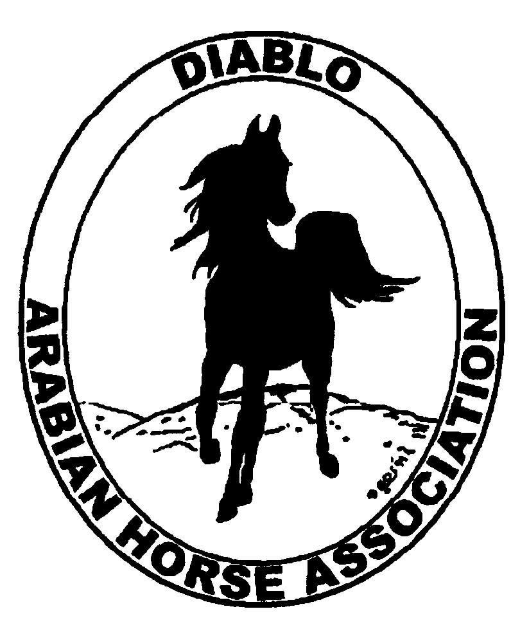

DIABLO ARABIAN HORSE ASSOCIATION
MINUTES—SEPTEMBER 2012 Board Meeting
4 September 2012

Board Members Present: Committee Members: Delegates/Guests

1. Amy Edwards 1. Dorothy Burt
2. Pat Hendershot 2. Evelyn Call
3. Jill Mitchell 3. Tracey Seals
4. Cindy Silvani
5. Cory Soltau
6. Mitch Sperte
7. Coke Swift
8. Cindy Volz
9. Anne Wheeler

President Cory Soltau called the meeting to order at 7:15 P.M. The minutes of the August board meeting were reviewed. Cindy Volz made a motion to approve the minutes, and Coke Swift seconded. Motion carried.

Correspondence: None

Treasurer’s Report: Donna Bolla was absent but emailed the Treasurer’s Report as of August 31, 2012. Total Assets and Liabilities equaled $78,438.26. The Profit and Loss Operating statement for April through August 2012 included Total Income of $2,386.00 and Total Expenses of $6,303.60 for a net income of [$3,917.60]. Donna also presented the Profit and Loss Statement for the Spring Show, which showed Total Income of $124,450.50 and Total Expense of $108,530.94 for a Net Income of $15,919.56. Donna then distributed a Profit and Loss Budget Performance Analysis for April 2012 through August 2012 which showed to date an actual Net Income of $13,379.96 vs. a budgeted $14,726.60 for a net loss of [$1,346.64]. Last, she presented Check Detail for the month of August 2012.

Calendar Review: Cory Soltau will forward to Cindy Silvani as soon as possible the list of nominees for the upcoming BOD Election so that it can be published in the upcoming Newsletter. In addition, there are two write-in nominees who are not club members, and who are ineligible as candidates until their membership is confirmed.

COMMITTEE REPORTS

Awards Banquet: No report—Debbie Compilli was absent.

Breed Awareness/Public Relations/Horse Faire: Anne Wheeler needs volunteers for Golden Gate Fields Sunday, September 9th both morning and afternoon. Anne would like people to arrive by 11 A.M. pat Hendershot motioned that the contents of the tip jar be donated to Horse’s Honor and to the Horsemen’s Distress Fund in alternating years. Mitch Sperte seconded. Motion carried.

Directory: Nothing to report.

Family Outreach: No report -- Debbie Compilli was absent.

High Point Program: Tracey Seals has received 10 entries to date; the number seems low compared to last year to date. Amy Edwards noted that entries and points are likely to be submitted after the Fall Show and Nationals. Amy will solicit photographs of High Point entries for the next Winter Membership Banquet. Entries will be published in the Newsletter.

Horse Shows: Coke Swift asked for help soliciting sponsorships, which are needed in a few days. Debbie Compilli needs a break from the task. Last year, there were 20 patrons. Coke really needs class sponsorships. Procedure is to contact everyone who has sponsored in the past. Coke does not solicit businesses because the show is in Elk Grove while member/participants tend to conduct business in the Bay Area. A discussion of post-entry fees ensued. Coke suggested extending the post-entry date by a week to September 14th. There was additional discussion of extending the drop-dead date for receipt of entries to September 21st. Coke will contact Region 3 Secretary Marjie Becker to send an e-blast regarding the extension. Coke asked about the bonus that she is to receive if the Spring Show makes $15,000 or more now that final numbers are in for the Spring Show. Treasurer Donna Bolla’s email and financial report indicate that the Spring Show made a net profit of $16,348.46. Jill Mitchell motioned to pay Coke the approved bonus of $1,000 based on show profits. Pat Hendershot seconded. Motion carried. Coke asked for volunteers to present ribbons at the Fall Show, and Jill Mitchell volunteered to find people to help.

Membership: Evelyn Call presented the August DAHA Membership Report. DAHA’s member status (per AHA) as of August 31, 2012 is as follows.

Adults (1-Year) - 122
Adults (3-Year) - 32
Adults (Life) - 6

TOTAL VOTING ADULTS - 156

Youth - 32

TOTAL MEMBERS - 188

Total income for the month of July was $80 and AHA membership expenses were $60.

Newsletter/Web Site: No report--Meghan Johnson was absent.

Racing: Dorothy Burt reported that the state of California has increased the purse per race by $1,500 across the board.

Trail Rides: Nothing to report--Jill Mitchell plans a ride at the beginning of October if the weather holds to Barbecue Terrace, staging at Macedo Gate.

Volunteer Awards: Cindy Volz has received nominations that will be submitted by the September 15th deadline.

Youth: Jill Mitchell reported that DAHA Youth members Camille Waechter and Victoria Oto have been elected AHYA President and Vice President respectively. This is a first—to have the two highest AHYA positions filled by members not only from the same region (3), but from the same club, (DAHA)! Morgan Annand was elected Region 3 Youth Director. Jill Mitchell suggested that Ed Oto be given a bottle of wine as a thank-you for all his work on the Region 3 Youth entry as well as for his dedication to helping Region 3 Youth.

Old Business: Cory Soltau discussed the list of names submitted by the Nominating Committee.

- Donna Bolla
- Debbie Compilli
- Amy Edwards
- Amara Morrison
- Ed Oto (needs to become a DAHA member)
- Tracey Seals
- Janet Shaw (needs to become a DAHA member)
- Cindy Silvani
- Anne Wheeler

Cory needs to contact each person to ascertain willingness to run.

New Business: Cory Soltau discussed the upcoming AHA Convention. Coke Swift asked for suggestions for a theme for next year’s Spring Show. The Brookside Equestrian owner is donating $1,000 toward theme development. Several ideas were discussed.

Jill Mitchell motioned to adjourn the meeting, and Cindy Volz seconded. Motion carried. The meeting was adjourned at 8:45 P.M.

Respectfully submitted,

Cindy Silvani
Secretary

