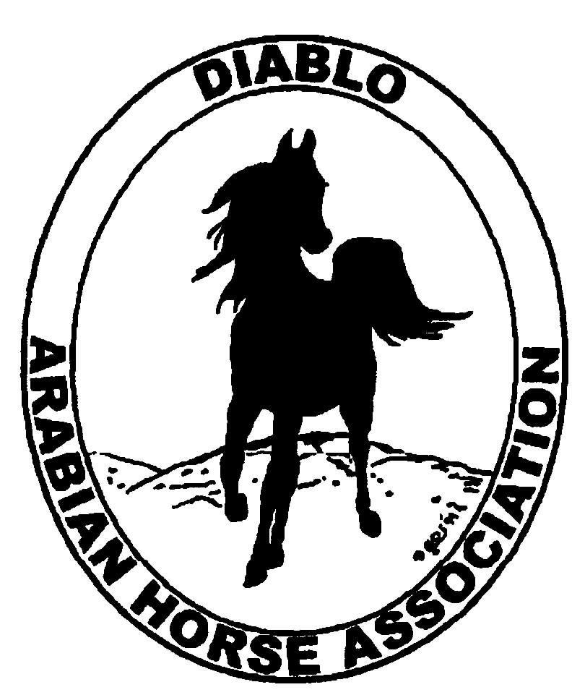
DIABLO ARABIAN HORSE ASSOCIATION
MINUTES – SEPTEMBER BOARD MEETING
September 3, 2013

Board Members Committee Members Delegates/Guests

Evelyn Call Dorothy Burt Tammy Collins
Debbie Compilli Meghan Johnson Pat Hendershot
Amy Edwards Cindy Volz Katie Kreske
Jill Mitchell
Ed Oto
Coke Swift

Vice President Jill Mitchell called the meeting to order at 7:05 p.m. The minutes of the August board meeting were reviewed. Evelyn Call made a motion to approve the minutes, and Coke Swift seconded. Motion carried.

Correspondence: None

Treasurer’s Report: Donna Bolla was absent but emailed the Treasurer’s Report as of August 31, 2013. Total Liabilities & Equity was $87,239.96. The Profit & Loss Operating statement for April through August 2013 included Total Income of $3,389.10 and Total Expense of $5,888.33 for a net of [$2,499.23]. Donna included an updated Profit and Loss Operating Budget Performance report. She sent Check Detail for August 2013 and the Horse Show Account Reconciliation Summary and Detail for August 2013.

There was discussion about other Arabian horse clubs being required to have annual audits and the possible need for DAHA to have audits done. It was decided to ask Donna to ask DAHA’s tax preparer about this matter.

Calendar Review: Sept. 13 – Region III Meeting, 8 p.m., Vacaville
Jan. 26, 2014 – Winter Banquet, Shadelands, Walnut Creek
May 15-18, 2014 – Spring Show
Sept. 26-28, 2014 – Fall Show

COMMITTEE REPORTS

Awards Banquet: Debbie Compilli reported that a speaker still needs to be chosen.

Breed Awareness/Public Relations/Horse Faire: Meghan Johnson brought a copy of the entries for the Club Excellence Award submission for all to see. Entries were submitted in four categories: Breed Promotion/Community Involvement, Membership Recruitment/Retention, Communication and Club Projects.

Grand National Costume Class: Ed Oto and Sidney Simpson will go to the Cow Palace for a meeting on Sept. 5. Ed reported that he had emailed Steve Freeman about a Region III eblast, but has gotten no response yet. He will contact Rick Harnden about the eblast now. DeeDee Kramer would like to incorporate the TAIL program at this event.

Convention: Pat Hendershot sent in the delegate registrations and will make the hotel reservations.

Family Outreach: Debbie reported that notices asking for entries for this program have been eblasted to the membership periodically. For the club’s day at Golden Gate Fields, all volunteers are in place.

High Point Program: Ed Oto said that the committee has updated the standards and they will be posted at the end of the week.

Horse Shows: Coke Swift reported that Cindy Carlson will judge the Trail classes at the Fall 2013 show. Deb Witty and Hillary Hoffman will be the judges at the Spring 2014 show. She is working on contracting the judges for Fall 2014. Coke shared that there will be a show in Las Vegas that will qualify horses for Regions 3 and 7 on the same weekend as our Fall 2013 show. This will probably impact the number of entries that we will have.

Tammy Collins presented a new idea for promotion of the club. She suggested offering a new photo opportunity for anyone at our shows. This would use life size character posters with cutouts for the face. Participants can have their photos taken. She has seen photos like this posted on Facebook and suggested it would be a great way to promote our show. Discussion and it was suggested that the cutouts be based on the current theme of the Spring Show.

Membership: Evelyn presented the DAHA Membership report with an AHA count as of Sept. 2, 2013. Member status is as follows:
Adult (1 yr.) 99
Adult (3 yr.) 27
Adult Life 6
Voting members 132

Associates 5
Youth 33
Total members 170

Evelyn has ordered the DAHA lapel pins to be given to new members and for resale.

Newsletter/Web Site: Meghan Johnson reported that she has posted the newsletter on to the website and updated the website.

Racing: Dorothy Burt reported that there will be four Arabian races at Pomona from Sept. 6 – 12. Purses will be $12,000, $16,000, $25,000 and $30,000 which should draw entries.

Trail Rides: Cory and Jill will continue to work on putting together a ride.

Volunteer Awards: Cindy Volz reported that the AHA nominations have been submitted. She has received two nominations for the Friends of DAHA award.

Old Business: Tammy Collins said that Show Season has requested ads in our show programs since they are sponsoring a $500 gift certificate for the 14-18 age group in the High Point program. Coke agreed.

Discussion about notification of the list of nominees to the DAHA board of directors. Debbie will send out a notice to all club members by the end of the week. Nominees are:

Kathy Campbell Megan Jenkins
Tammy Collins Jill Mitchell
Pat Hendershot Cindy Volz

Jill asked for nominations to fill Mitch Sperte’s board position for the remainder of 2013. Ed nominated Tammy Collins, Debbie seconded. Motion passed.

Coke motioned to adjourn the meeting, Amy Edwards seconded. Motion carried. The meeting was adjourned at 8:30 p.m.

Respectfully submitted,

Debbie Compilli
Acting Secretary

