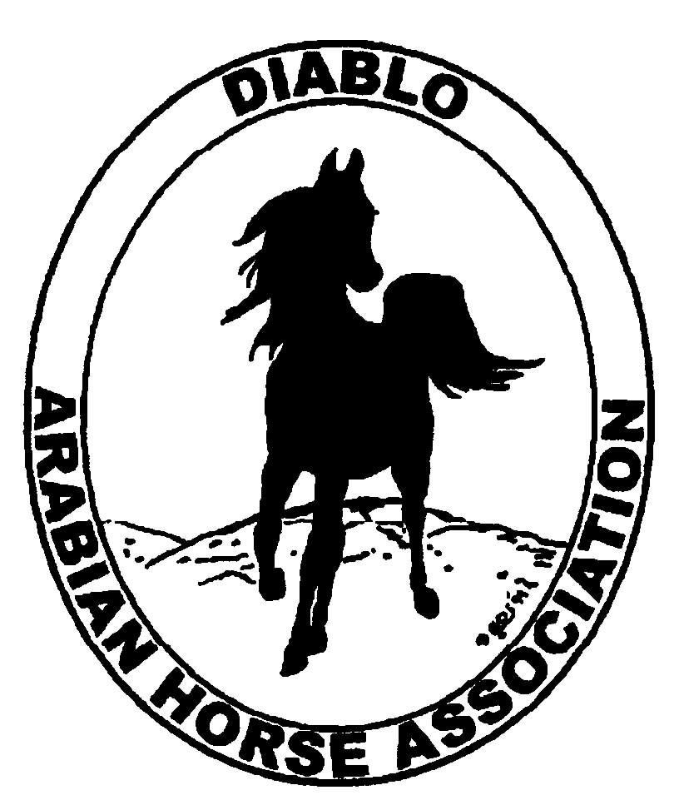

DIABLO ARABIAN HORSE ASSOCIATION
MINUTES—OCTOBER 2012 Board Meeting
2 October 2012

Board Members Present: Committee Members: Delegates/Guests

1. Pat Hendershot 1. Dorothy Burt
2. Cindy Silvani 2. Evelyn Call
3. Cory Soltau 3. Debbie Compilli
4. Mitch Sperte 4. Tracey Seals
5. Cindy Volz
6. Anne Wheeler

President Cory Soltau called the meeting to order at 7:09 P.M. The minutes of the September board meeting were reviewed. Pat Hendershot made a motion to approve the minutes, and Cory Soltau seconded. Motion carried.

Correspondence: Anne Wheeler sent a thank-you letter to Jerry Aldroity of Golden Gate Fields to tell him that the $1,000 DAHA earned in September 2011 was divided between U.C. Davis and Horses’ Honor.

Treasurer’s Report: Donna Bolla was absent but emailed a message—she does not yet have financials as she has not yet received bank statements. She will forward financials next week and hopes to provide a preliminary statement of financial position on the Fall Show at that time.

Calendar Review: The National Day of the Horse is December 13, 2012.

COMMITTEE REPORTS

Awards Banquet: Debbie Compilli reminded everyone that the Awards Dinner will be at Shadelands in Walnut Creek Sunday, January 27, 2013. There will be 140 seats. She has paid a deposit of $500. The club owes an additional $955 October 29th. Debbie will contact Donna Bolla regarding the payment. Debbie then asked the Board’s permission to buy wine for the Banquet when it is on sale to save the club money. Sales typically occur in October and November. The club will be rebated the $750 security deposit assuming that there will be no damage. We will have the same caterer as last year. Cory Soltau asked about having a speaker. Debbie is concerned that the evening is long enough—we really do not have time for a speaker. Debbie plans to work with Jessica Mattson, when Jessica has time, to delineate the program. Mitch Sperte suggested that any entertainment be geared toward youth as they seem to be the target audience of the event.

Breed Awareness/Public Relations/Horse Faire: Anne Wheeler received a call from the Grand National at the Cow Palace—they requested a Native Costume class for a Friday and Saturday Night program break. The class would be judged and ribbons awarded. Indoor stalls would be provided for as many Arabian Costume Horses as we care to send. Anne will make some calls to determine the potential pool of Costume horses. Cory Soltau said that there should be a minimum of five or six and furthered the idea of a parade of Arabians, three per discipline (not just Costume horses). Anne will investigate that possibility. She mentioned the National Day of the Horse December 13th,which will be celebrated locally December 8, 2012 with a ride, barbeque, and exhibitions. Anyone willing to trailer a horse to the Castle Rock Park staging area is welcome to participate. Anne then asked about rounding up the check to Horses’ Honor to $100 from the $77.40 received in tips at Golden Gate Fields. Cindy Volz motioned to do so, and Mitch Sperte seconded. Motion carried.

Directory: Nothing new to report.

Family Outreach: Debbie Compilli had nothing new to report. She plans to work with Tracey Seals and Meghan Johnson to publicize Family Outreach.

High Point Program: Tracey Seals has received no additional entries to date; she took brochures to the Fall Show. Nancy DuPont suggested a meeting with youth in her group to encourage High Point entry. Tracey will include High point in an upcoming eblast. Cory recommended contacting youth trainers such as Tammy, Jill Mitchell, and Leigha Perry to find out why more youths haven’t entered the High Point program.

Horse Shows: Coke Swift was absent. Cory reported that the Fall Fling was a good show despite the record high temperatures. Bills have been paid. 175 horses entered, although the Sport Horse Division was terrible. Coke is anticipating a profit.

Membership: Evelyn Call presented the September DAHA Membership Report. DAHA’s member status (per AHA) as of October 2, 2012 is as follows.

Adults (1-Year) - 125
Adults (3-Year) - 28
Adults (Life) - 6

TOTAL VOTING ADULTS - 160
Associate Members - 1

Youth - 36

TOTAL MEMBERS - 196

Total income for the month of September was $220, and AHA membership expenses were $95

Evelyn notes that our membership is the highest it has been for some time. We could reach 200 easily if we make a concerted recruiting effort. Pat Hendershot discussed, with Cynthia Richardson and Debbie Fuentes, a forthcoming resolution to return to calendar-year membership. Anyone who joined after June 30th will not count toward a club’s delegate total. People do not want to pay for a club membership valid for less than a year. Cindy Silvani will attend membership meetings at the upcoming convention to represent Evelyn’s expressed wish not to change the date structure as she does not want to process bunches of memberships at year-end.

Cory Soltau reported that all facets and all breeds of the industry are down. The Quarter Horse organization has acknowledged that it cannot be a show organization exclusively. We need to offer something for all members. Mitch Sperte is planning an event with another trainer that could offer both an educational and a social opportunity for DAHA. Cory Soltau is planning a presentation at his ranch and has approached Bob Marx about hosting a social event at Summit, which can be conducted in winter as the facility is weatherproof. All of those proposed activities offer a chance to introduce new people to the Arabian horse.

Newsletter/Web Site: Meghan Johnson was absent but emailed the following report. The September Newsletter was emailed this week, posted to the web site and mailed to the 8 snail-mail members. The web site is up to date as of today. Meghan is looking for submissions to the web site. Meghan worked on two eblasts with Tracey Seals this month including one for the Fall Fling show deadline extension and High Point and another for the Newsletter. Meghan will begin work on the December Newsletter in October and is looking for submissions, which must be in by the first week in December. Meghan plans on including an article on her French riding vacation, new board members, articles on the Banquet, Convention, Fall Show with photos, Club Excellence, classified ads, and a flyer for the Banquet. Meghan requests that any candid or show Arabian horse photos to update the web site photo album be sent to her in JPEG format.

Racing: Evelyn Call reported that the season is winding down. Fresno starts in a few days and runs for 1 ½ to 2 weeks, and that will conclude the California season.

Trail Rides: No report--Jill Mitchell was absent.

Volunteer Awards: Cindy Volz has forwarded two nominations.

Youth: No report—Leigha Perry was absent.

Old Business: Pat Hendershot reported some Region 3 business. The Region 3 horse show made less than $3,000 ($27,000 under budget). Rik Harnden discussed the Region 3 web site and directory with instructions for log-on. He would like each club to name a representative to manage the club section. There was a lengthy discussion of directory access, a sensitive subject to some people.

Dorothy Burt would like Donna Bolla to include separate line items in the club’s financials for any income derived from the following two sources: Golden Gate Fields and Club Excellence Awards. Dorothy is also seeking clarification on how those monies are to be disbursed.

New Business: Cory Soltau discussed the importance of the upcoming AHA Convention. He noted that Region 3 Director Steve Freeman endorsed Cynthia Richardson; Cory wants all DAHA delegates to speak up in support of Cynthia’s candidacy. Pat Hendershot made a motion that DAHA contribute $300 to offset the costs of the non-hosted Convention in Denver, and Cindy Silvani seconded. Motion carried.

Anne Wheeler motioned to adjourn the meeting, and Mitch Sperte seconded. Motion carried. The meeting was adjourned at 9:03 P.M.

Respectfully submitted,

Cindy Silvani
Secretary

