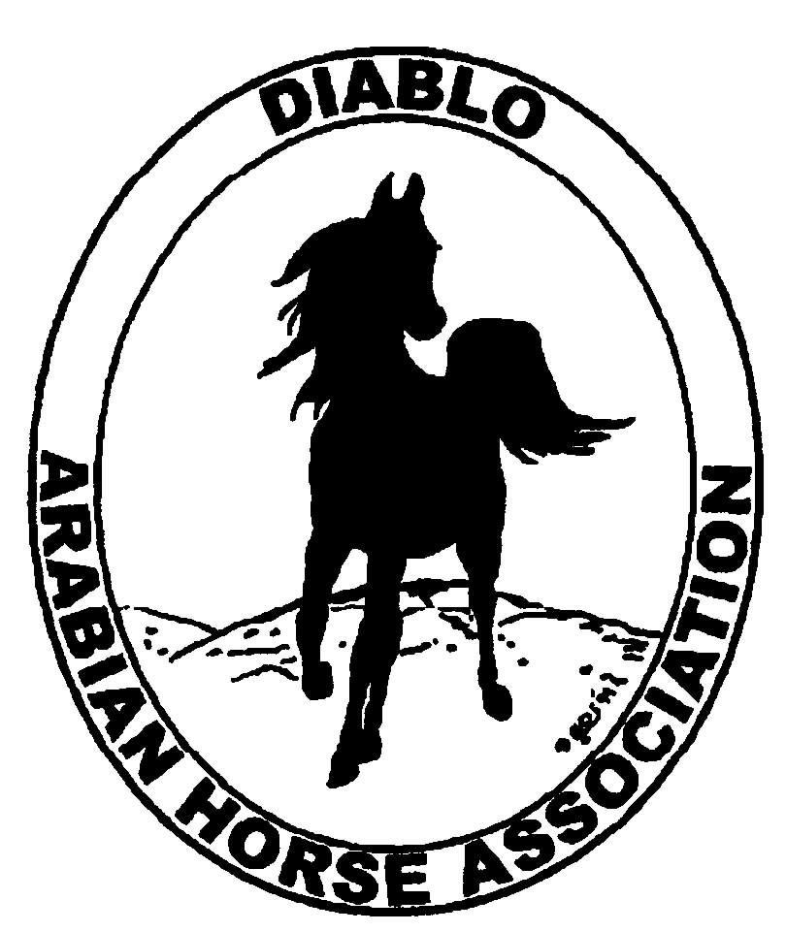
DIABLO ARABIAN HORSE ASSOCIATION
MINUTES – SEPTEMBER BOARD MEETING
October 1, 2013

Board Members Committee Members Delegates/Guests

Debbie Compilli Dorothy Burt Pat Hendershot
Tammy Collins Cindy Volz Megan Jenkins
Amy Edwards Mitch Sperte
Jill Mitchell
Tracey Seals
Cory Soltau
Coke Swift

President Cory Soltau called the meeting to order at 7:08 p.m. The minutes of the September board meeting were reviewed. Jill Mitchell made a motion to approve the minutes, and Tracey Seals seconded. Motion carried.

Mitch Sperte thanked all of us for his experience as a board member with DAHA. He had to resign his position at DAHA for a job opportunity in North Carolina. The board wished him good luck.

Correspondence: None

Treasurer’s Report: No report was available as it is October 1. Donna Bolla will confirm with our bank regarding the time period to print on our checks: “check is void after ___ days”.

Calendar Review: Oct. 25-26, 2013 – Native Costume Classes, Grand National
Jan. 26, 2014 – Winter Banquet, Shadelands, Walnut Creek
May 15-18, 2014 – Spring Show
Sept. 26-28, 2014 – Fall Show

COMMITTEE REPORTS

Awards Banquet: Cory spoke with Bruce Clark, Pres. of the Arabian Horse Owners Foundation, about speaking at our banquet. Bruce agreed. Cory will follow up with him as the date draws nearer.
Tammy Collins suggested using a Top Five or Top Ten system for the awards. Discussion and it was decided to use this format.
She also suggested that high point entrants’ information and the Family Arabian entrants’ stories be available on each dinner table.

Breed Awareness/Public Relations/Horse Faire: Amy Edwards received the $1,000 check from Golden Gate Fields for our day manning the snack bar. $106.02 was raised in the tip jar and will be donated to the Horsemen’s Distress Fund.

Grand National Costume Class: Cory reported that the poster with the costume horses looks great and has been posted on the Grand National website. They would like to have at least 10 horses for the event. Tracey posted information to Facebook and Instagram. Ed Oto and Mike Cheatwood will decorate the stall area.

Convention: Pat Hendershot has reserved all rooms for our delegates, Evelyn, Jill, Pat and Cory. Cory will host a meeting to discuss the resolutions in Nov.

Family Outreach: Tracey Seals reported that she had just sent out another eblast that asked club members for entries, again.

High Point Program: Tracey said the number of entries is lower this year than in the past.

Horse Shows: Coke reported on the Fall Show. 197 horses were entered. 26 more than last year. They had 27 rides in western dressage. 38 horses in halter division. Coke invites suggestions for the scheduling for next year. A big thank you to Jill for organizing the volunteers for the show.
Cindy Volz said that on Dec. 1, western dressage will be a recognized division of USEF. It was suggested that DAHA put on a clinic to help educate about this new division. Earthquake Arabians volunteered to host. Cindy Volz will chair with Jill Mitchell as a co-chair.
There will be a horse show committee meeting on Tues., Nov. 12, at 6:30 p.m. The meeting site will be determined.

Membership: No report as Evelyn Call was absent.

Newsletter/Web Site: Meghan emailed her report to all board members:

As of today, the website is up to date. I received some emails to remove some classified ads because items had sold which is good. I also posted Sid's flyer for the Grand National Rodeo. I added Tammy Collins to the Contacts webpage as the new board member.

With the Fall Show over, I sent an email to Tracey to e-blast out to the members regarding submitting High Points which should probably go out this week. Tracey also sent out Sid's e-blast regarding Arabians at the Grand National Rodeo.

I plan to start working on the December newsletter soon. I am looking for articles/photos on the DAHA Fall Show and GGF. If anyone wants to submit anything to the website or newsletter, please let me know.

Racing: Dorothy Burt reported that the Arabian Breeders’ Cup will be held at Santa Anita on Nov. 1 & 2.

Trail Rides: Cory and Jill will table trail rides until 2014.

Volunteer Awards: Cindy Volz reported that she has received two nominations for the Friends of DAHA award. She asked for suggestions for awards.

Youth: Cory will contact Leigha Perry to see what she has planned for the juniors.

Cory received an emergency vet call and needed to leave the meeting. He turned the meeting over to Vice President Jill Mitchell.

Old Business: Pat and Cory attended the Registration Commission meeting at Manny Vierras ranch in Brentwood on Sept. 20. They said that both the horse presentation and the food were great.
Pat Hendershot reported from the last Region III meeting that the attendance at the Horse Expo was down. Region III is considering not participating in 2014. Reg. III’s show profit was $29,740 in 2013. A considerable increase over recent years. There was discussion concerning the double region qualifying shows. It seems to be a trend across the country.
Debbie reported that Pat helped her get the ballots ready for mailing. They were mailed out on Oct. 1.

New Business: Dorothy Burt suggested donating $500 to donate for the replanting of Mt. Diablo after the recent fire. Discussion. Megan Jenkins will look into which organizations are involved and accepting donations.

Jill asked for a motion to adjourn the meeting. Coke motioned to adjourn the meeting, Tracey Seals seconded. Motion carried. The meeting was adjourned at 8:43 p.m.

Respectfully submitted,

Debbie Compilli
Acting Secretary

