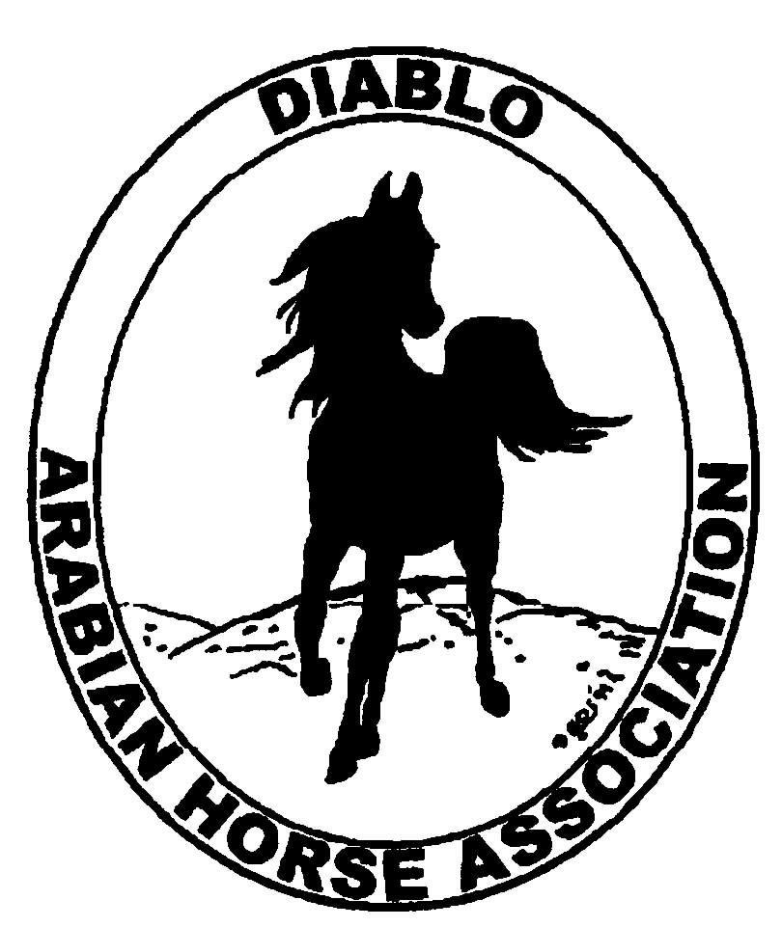

DIABLO ARABIAN HORSE ASSOCIATION
MINUTES—NOVEMBER 2013 Board Meeting
5 November 2013

Board Members Present: Committee Members: Delegates/Guests

1. Evelyn Call 1. Dorothy Burt 1. Pat Hendershot
2. Tammy Collins 1. Cindy Volz 2. Megan Jenkins
3. Debbie Compilli 3. Cindy Silvani
4. Jill Mitchell
5. Tracey Seals
6. Cory Soltau

President Cory Soltau called the meeting to order at 7:12 P.M. The minutes of the October board meeting were reviewed. Jill Mitchell made a motion to approve the minutes, and Debbie Compilli seconded. Motion carried.

Correspondence: None

Calendar Review: Convention is coming up, and Resolutions are available online. Cory asked delegates present to note those resolutions of particular importance; Delegate Pat Hendershot mentioned the Membership resolution as well as the Country English Pleasure resolution. Everyone was amenable to conducting the Resolution Discussion meeting immediately after the Horse Show Committee meeting next Tuesday, November 12th at 6:30 P.M. at the home of Cory Soltau.

Treasurer’s Report: Donna Bolla was absent but emailed the Treasurer’s Report as of October 31, 2013. Total Equity and Liabilities equaled $88,435.82. The Profit and Loss Operating statement for April 2012 through October 2013 included Total Income of $4,095.12 and Total Expenses of $8,875.97 for a net of [$4,780.85]. Donna included an updated Profit and Loss Operating Budget Performance report. She sent Check Detail for the month of October 2013. Donna then included Spring and Fall Horse Show Income and Expense summaries for April through October 2013 as well as the Fall Horse Show Profit and Loss statement and Check Detail for October 2013. Last, she incorporated The Chase Operating Account together with the Horse Show Account Summaries and Reconciliation Detail for the period ending 10/31/2013.

Both Evelyn Call and Cory Soltau noted the decrease in revenue for the Spring Show. Cory noted the loss posted for the Spring Show while Evelyn Call said that the Fall Show looked good. Cory will scrutinize the reports carefully but stated the need to tighten up Horse Shows across the board.

COMMITTEE REPORTS

Awards Banquet: Debbie Compilli will be ordering wine tomorrow for the Banquet to take advantage of Safeway’s 30% off wine sale. She has talked to Tom McKillop who will again cater; he will provide a menu. Donations are being solicited now.

Breed Awareness/Public Relations/Horse Faire/Cow Palace: No report – Cory Soltau would like Ed Oto to assume the chair of this committee. Cory reported that Ed, Sidney Simpson, and Mike Cheatwood were a great help in organizing the Native Costume “class” at the Cow Palace. The reaction of the representative for the Cow Palace was favorable and the venue would probably allow the “class” to be held again. The Cow Palace’s full-page ad for Native Costume has been forwarded to AHA for use in an eblast. With regard to publicity, Tracey Seals asked about a sponsor for embroidery on shirts, sheets, blankets, etc.

Convention: Pat Hendershot reported that everything is in place. She noted several price increases, e.g., the $15 increase in AHA membership.

Directory: Nothing new to report

Family Outreach: Debbie Compilli is still not receiving any entries; however, she noted that historically, no one submits material until the “eleventh hour.” Tammy Collins mentioned the need for mentoring; she noted that one of the changes in the T.A.I.L. Program is the inclusion of an “ambassador” for each horse show, especially to answer questions from new participants/members. Evelyn Call suggested fulltime staffing of the Membership Booth at the shows.

High Point Program: Nothing new to report -- Tracey Seals has not received any additional submissions; she has received data, primarily from adults, but the total is still “light.” The number of children is good. Jill Mitchell that she has a problem submitting data by deadlines. Jill submits standings for all of her clients (Sherry Pedder used to help Jill submit data). Several people noted that individuals should take responsibility for data submissions. Jill then suggested reverting to the “old format,” listing/publishing standings monthly on the club web site. Tracey Seals agreed that such an approach would provide the impetus to entering/participating in the High Point Program. Cory Soltau suggested sending a monthly eblast of standings. Diablo is one of the few clubs to offer a High Point Program; Mother Lode provides one on a much smaller scale. Evelyn Call would like to have more material/entry forms available in the Membership Booth.

Horse Shows: No report--Colleen Swift was absent. Jill Mitchell said that English Trail should be added (it had 20 entries at Nationals). There has been increasing emphasis on Adult Horsemanship and Showmanship, and DAHA class lists should reflect that emphasis.

Membership: Evelyn Call presented the DAHA Membership Report with an AHA count as of October 31, 2013. Member status is as follows.

Adults (1-Year) - 98
Adults (3-Year) - 26
Adults (Life) - 6

TOTAL VOTING ADULTS - 130

Associate Members - 6

YOUTH - 34

TOTAL MEMBERS - 170

Evelyn reported that she typically does not receive submissions at this time of year. Membership numbers are down somewhat from last year when we made a great effort to gain enough members to send an additional delegate to the annual convention. Evelyn’s reporting shows a substantial degree of turnover. When Cory Soltau asked about the 6 Associate members, Evelyn said that many of them were given gratis to volunteers assisting at shows. Megan Jenkins suggested giving T-Shirts to parents paying for Associate memberships as a way to encourage them to upgrade to full Adult memberships. Tammy Collins recommended redesigning DAHA shirts to “modernize” them. Cory asked everyone to bring ideas to the next board meeting for increasing Membership.

Newsletter/Web Site: Meghan Johnson was absent but emailed the following report. The web site is updated vis a vis events, horse shows, photos, ads etc. She has started to work on the December Newsletter. Sidney Simpson submitted an article regarding the Grand National/Cow Palace. Meghan needs a volunteer to write a brief article on the Fall Show and would appreciate photographs. She needs the same type of submission for the Golden Gate Fields event. She would like a delegate to write a summary of the upcoming Convention. Meghan will include an article on her “horse vacation” in Italy. She worked with Tracey Seals on a couple of eblasts regarding High Point, DAHA Board Election, Family Arabian, and upcoming events.

Racing: Dorothy Burt said that the winner of the $150K race at Santa Anita had visited the Alameda County Fairgrounds several years ago on Arabian race day. There will be a Sheikh’s/Sheikha’s Race Day in the coming year; it will have a more “Hollywood” theme to appeal to the Sheikhs’ predilection for “bling.”

Trail Rides: Jill Mitchell had nothing new to report. Cory Soltau said that many of his friends and some DAHA members recently participated in the San Ramon Valley Horsemen’s Association’s Midnight Ride. He would like DAHA to sponsor a ride next year.

Volunteer Awards: Cindy Volz has received the letters, certificates, and pins of this year’s winners (unlike last year, when they were mistakenly mailed directly to the recipients). Unfortunately, the certificates have been marred as they were defaced by the pins’ having been sent in the envelopes rather than in boxes; the certificates have holes in them.

Youth: Tammy Collins suggested establishing a Youth of the Year Award competition in addition to and to encourage participation in the High Point Program. Entries would consist of essays and photographs. The award could be a $150 belt buckle. Evelyn Call suggested that Tammy write a proposal outlining the Youth of the Year Award, and Pat Hendershot supported the idea.

Old Business: Cindy Volz contacted some clinicians regarding the Western Dressage Committee. She presented a summary of costs and procedures for Western Dressage clinicians Nailia Abdoukadyrov, an FEI Dressage rider who now also rides and teaches Western Dressage and her colleague Lisa Horning, who rides Western. They would be available in January or February. The clinic would begin around 8 A.M. with a brief presentation of Western Dressage and its rules. They would bring two demonstration horses. Then the first of eight or so riders would have a 45-minute lesson. Costs include a nonrefundable $300 booking fee, $120 per lesson, and a $120 transportation fee. They would need two stalls for their horses and a speaker system. They would advertise the clinic in their area (Lincoln, CA). Tammy Collins and Megan Jenkins will ask the owners of Earthquake about using their facility for the clinic. Evelyn Call motioned to approve the event, and Jill Mitchell seconded. Motion carried. Earthquake representatives will get back to Cindy Volz on dates at next Tuesday’s Horse Show Committee meeting.

Dorothy Burt asked about Mt. Diablo restoration. She talked to a representative of Open Spaces about it. Dorothy will make some follow-up calls. She reminded everyone that the club discussed donating $500 from funds earmarked for charitable donations. Cory Soltau asked that the issue be tabled until the next board meeting.

New Business: Jill Mitchell mentioned the Western States/Tevis golfing event. She asked about DAHA’s hosting a fundraiser. Jill and Megan will develop the idea further.

Board Election Results: 36 of 130 ballots mailed were returned, and Pat Hendershot, Jill Mitchell, and Cindy Volz were elected.

Jill Mitchell then motioned to adjourn the meeting, and Debbie Compilli seconded. Motion carried. The meeting was adjourned at 8:59 P.M.

Respectfully submitted,

Cindy Silvani
Secretary

