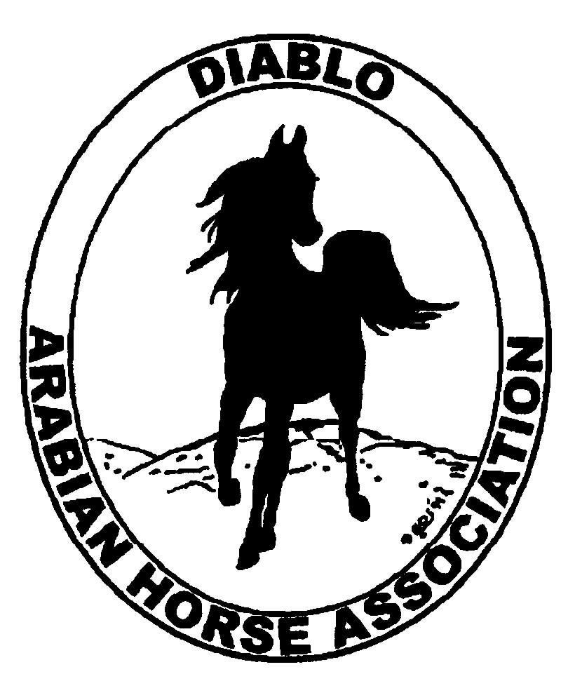

DIABLO ARABIAN HORSE ASSOCIATION
MINUTES—DECEMBER 2012 Board Meeting
4 December 2012

Board Members Present: Committee Members: Delegates/Guests

1. Amy Edwards 1. Dorothy Burt
2. Pat Hendershot 2. Evelyn Call
3. Cindy Silvani 3. Debbie Compilli
4. Cory Soltau 4. Tracey Seals
5. Mitch Sperte
6. Colleen Swift
7. Cindy Volz
8. Anne Wheeler

President Cory Soltau called the meeting to order at 7:07 P.M. The minutes of the November board meeting were reviewed. Pat Hendershot made a motion to approve the minutes, and Amy Edwards seconded. Motion carried.

Correspondence: None

Treasurer’s Report: Donna Bolla was absent but emailed the Treasurer’s Report as of November 30, 2012. Total Equity and Liabilities equaled $80,302.70. The Profit and Loss Operating statement for April through November 2012 included Total Income of $4,523.40 and Total Expenses of $8,108.31 for a net income of [$3,584.91]. Donna also presented the Profit and Loss Statement for the Horse Show account, which showed Total Income of $189,498.50 and Total Expense of $170,333.99 for a Net Income of $19,164.51. Donna then distributed a Profit and Loss Operating Budget Performance analysis for April 2012 through November 2012 as well as Check Detail for the month of November 2012. Coke Swift mentioned taking funds from the Horse Show account to open a CD or Money Market account. After a brief discussion, Cory Soltau noted that the ROI is not worth the necessary paperwork.

Calendar Review: Nothing to report

COMMITTEE REPORTS

Awards Banquet: Cory Soltau suggested asking Youth of the Year Victoria Oto and Camille Waechter speak together at the Banquet. Bruce Clark was again mentioned as a possible speaker. Cory would like to ask Cynthia Richardson to return to DAHA as our keynote speaker. Debbie Compilli has mailed the Banquet announcement. Nancy and Debbie Bartman will once again manage the Silent Auction. Cory will MC and will ask if Victoria and Camille would help. Cory has ordered a brand-new video, Gift of the Desert, (available from AHA) to play during the evening.

Breed Awareness/Public Relations/Horse Faire: Anne Wheeler announced that DAHA’s Golden Gate Fields date is January 20, 2013 (the Martin Luther King holiday weekend). Anne needs 10 volunteers to staff the booth (minimum age is 18). Anne will take back any DAHA shirts to add 2012 Club of the Year to reflect Diablo’s third win in three consecutive years. The Day of the Horse will be Saturday, December 8, 2012. Unless there is inclement weather, there will be a ride and a barbeque. Riders depart the Castle Rock Road staging area at 10 A.M.

Directory: Cindy Silvani continues to update Directory information.

Family Outreach: Debbie Compilli has received one entry for the competition. The deadline is December 15th. Tracey Seals said that she knows of another entry that will be submitted. Cory Soltau is nonplussed at the lack of participation in and promotion of this worthwhile program.

High Point Program: Tracey Seals contacted Sherry Pedder about High point awards. There are again cash prizes for Trainer of the Year and Runner-Up, so Tracey will contact Donna Bolla about having two checks cut. Tracey will order plaques and ribbons this week. Evelyn Call suggested having everyone in contention submit a photo so that Tracey has winning photos in plenty of time for the Banquet. She said that there are fewer than twenty people; the High Point program is shrinking. Anne Wheeler recommended including the entry form and details as part of the Horse Show entry form. Pat Hendershot pointed out the decrease in the number of trainers in this area as well as in the number of people showing. We should publicize the winner annually with a photo in the Premium List and the Horse Show program. Cory Soltau wants High Point entry forms sent to the trainers. Anne Wheeler recommended restructuring the program to award the entry with the highest number of points. As the program is not self-sustaining, it may be time to change it. Perhaps it could be limited to DAHA members only. Cindy Volz suggested creating a one-page “join DAHA and be eligible for the club’s year-end High Point awards. Give people another reason to join DAHA.

Horse Shows: Coke Swift announced the show secretary for both shows—Melanie Hershberger of AZ, who will drive rather than fly here. Donna Bolla created a General Ledger for Coke, who will announce categories to Horse Show committee members. Some categories need to be refined, redefined, or further subcategorized. Coke was unable to find any additional Spring Show Premium books—she would like to send a copy to Melanie. Anne Wheeler volunteered to donate her own copy. Coke also suggested that Melanie look at the Brookside web site. Melanie needs to draft the class list in January if possible. The next Horse Show committee meeting will be Thursday, January 3, 2013 at 6:30 P.M. at the home of Cory Soltau. At that meeting, Fall Show judges will be discussed.

Membership: Evelyn Call presented the November DAHA Membership Report. DAHA’s member status as of November 2012 is as follows.

Adults (1-Year) - 124
Adults (3-Year) - 28
Adults (Life) - 6

TOTAL VOTING ADULTS - 158
Associate Members - 0

Youth - 36

TOTAL MEMBERS - 194

Income

AHA Memberships $105.00

Expenses

Postage renewal reminders 5.85

Evelyn asked Meghan Johnson to include an ad for a DAHA holiday gift membership (the ad includes a photo of one of Evelyn’s Arabians in a Santa hat) in the Newsletter/on the web site.

Newsletter/Web Site: Meghan Johnson was absent but emailed the following report. The web site is up to date with the Club Excellence Award news, dates, events, October meeting minutes, and photos. She plans to add some seasonal/holiday photos. She will include the DAHA Banquet invitation as soon as she receives it. The December Newsletter is complete except for a few articles but is on target for dissemination the second week of December. Meghan assisted with several e-blasts this month including a reminder of important dates and events, including The Day of the Horse, Castle Rock Thanksgiving Horse Camp, a clinic, schooling show, and the AHA Club Excellence Awards. Meghan requests submissions for the Newsletter/Web Site.

Racing: Dorothy Burt reported that Jeanne Wasserman, who represents the Alameda County Fairgrounds, mentioned eliminating the Costume horse presentation this coming year. Dorothy stated that without the Costume horses, it is just one more ordinary race to the fair-going public. Dorothy then reported on the addition of H.H. Sheikha Fatima Bint Mubarak’s Ladies World Championship with female jockeys to the 2013 Alameda County Fair Racing schedule.

Trail Rides: No report—Jill Mitchell was absent.

Volunteer Awards: Cindy Volz has received one nomination for the Friends of DAHA (deadline is December 15th) and will transmit the Volunteer Awards, which she has received from AHA, to the President/MC for announcement at the Banquet.

Youth: No report—Leigha Perry was absent. Tracey Seals said that there will be a Youth outing soon to a holiday fun site with fake snow for sledding and skiing/snowboarding, and holiday lights.

Old Business: Dorothy Burt asked why next year’s AHA Convention will be held in Lexington, KY rather than in Denver. Cindy Silvani explained that AHA had already signed a hotel/meeting hall contract when AHA made its decision to hold future conventions in Denver.

New Business: Anne Wheeler motioned to donate $500 each to the U.C. Davis Center for Equine Research and to the Horseman’s Distress Fund; Pat Hendershot seconded. Motion carried.

The meeting was adjourned. Subsequently, the new Board elected officers for 2013 as follows.

President: Cory Soltau
Vice President: Jill Mitchell

Cindy Volz then motioned to adjourn the meeting, and Coke Swift seconded. Motion carried. The meeting was adjourned at 8:59 P.M.

Respectfully submitted,

Cindy Silvani
Secretary

