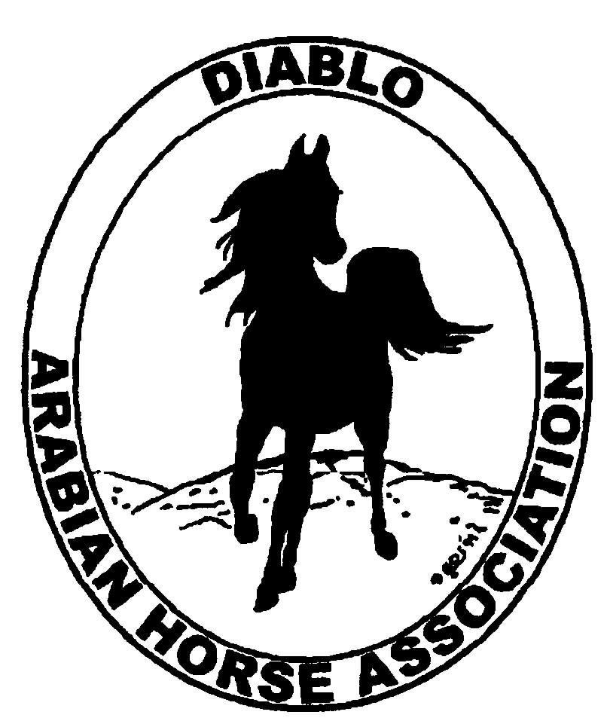

DIABLO ARABIAN HORSE ASSOCIATION
MINUTES—NOVEMBER 2013 Board Meeting
3 December 2013

Board Members Present: Committee Members: Delegates/Guests

1. Evelyn Call 1. Dorothy Burt 1. Pat Hendershot
2. Tammy Collins 2. Cindy Volz 2. Megan Jenkins
3. Debbie Compilli 3. Cindy Silvani
4. Amy Edwards
5. Jill Mitchell
6. Ed Oto
7. Colleen Swift
8. Cory Soltau

President Cory Soltau called the meeting to order at 7:10 P.M. The minutes of the November board meeting were reviewed. Jill Mitchell made a motion to approve the minutes, and Debbie Compilli seconded. Motion carried.

Correspondence: Evelyn Call received an advertisement for a promotional item (flashlight) together with price list.

Calendar Review: Evelyn Call will distribute, within a few days, an updated calendar with a few emendations.

Treasurer’s Report: Donna Bolla was absent but emailed the Treasurer’s Report as of November 30, 2013. Total Equity and Liabilities equaled $88,463.37. The Profit and Loss Operating statement for April 2012 through November 2013 included Total Income of $5,150.12 and Total Expenses of $9,348.92 for a net of [$4,198.80]. Donna included an updated Profit and Loss Operating Budget Performance report. Donna then included Profit and Loss Show Account statement for April through November 2013. She presented the Spring Show Budget vs. Actual statement for April through November 2013 as well as Check Detail for the month of November. Last, Donna shared Profit and Loss statements for both Spring and Fall shows.

COMMITTEE REPORTS

Awards Banquet: Debbie Compilli distributed the budget for the January 26th 2014 Annual Membership Banquet, which she created by combining last year’s budget vs. actuals. The caterer has agreed to hold the cost per plate at the same $22 level he charged last year. The Bartmans are working on auction items. Cory Soltau has been talking to Bruce Clark, who is dealing with some medical issues, about being the keynote speaker. Cory also suggested asking Mary Trowbridge of the Arabian Horsemen’s Distress Fund. Debbie also shared the menu and reported that last year, the Banquet attracted 145 adults at a cost of $35 each and 23 children at a cost of $22 each.

Breed Awareness/Public Relations/Horse Faire/Cow Palace: The T.A.I.L. program is progressing. Tammy Collins has 5 – 6 volunteers for the horse show. Evelyn Call suggested that DAHA post its events on the AHA Local Events bulletin board. Cory Soltau is planning several open houses, at various venues from his own breeding farm to a training barn, in the coming year.

Convention: Pat Hendershot and other delegates as well as Ed Oto, Tammy Collins, and Megan Jenkins participated. First-time attendees noted that everyone talked about what is in the best interest of the Arabian horse. As has been the case previously, the greatest problem was the overlap of meetings. Pat Hendershot noted that it was worse this year.

Family Outreach: Debbie Compilli has still not received any entries; however, she is actively soliciting participants.

High Point Program: Tracey Seals was absent but emailed some updates including a list of participants. She plans to tabulate points and share results with the Board. The High Point Committee needs to meet, hopefully during the week of December 16th, to review the awards presentation format as well as prizes by category. Tracey is working with Megan Johnson to eblast the announcement of DAHA’s win in 3 categories as Club of the Year at the annual convention. That eblast will include announcements of the increase in Membership dues as well as the upcoming banquet and request for silent auction items.

Committee member Tammy Collins reported that there will be larger ribbons. The embroiderer will donate 10 embroidered bridle bags. Tammy wants to create a tricolored ribbon that incorporates neon green (popular with children this year) with the traditional blue and white DAHA colors. The High Point committee will make the final decision when it meets. The total budget is $2,200. Ribbons should cost $400 - $500. Amy Edwards mentioned that Silent Auction income will be used to offset costs. Megan Jenkins reported on a proposal to expand the High Point program to other clubs in the region. Several representatives of those clubs expressed concern that the expansion might result in a loss of members.

Horse Shows: Colleen Swift distributed the 2014 schedule with an eye toward making some changes, eliminating some things, and incorporating rule changes. Coke asked that the Horse Show committee meet January 14th at 6:30 P.M.; Cory Soltau offered to host the meeting at is home.

Membership: Evelyn Call presented the DAHA Membership Report with an AHA count as of December 2, 2013. Member status is as follows.

Adults (1-Year) - 97
Adults (3-Year) - 26
Adults (Life) - 6

TOTAL VOTING ADULTS - 129

Associate Members - 6

YOUTH - 34

TOTAL MEMBERS - 169

Evelyn reported that she sent reminder letters December 2nd to those whose memberships expired during the last four months or will expire at the end of the month.

Newsletter/Web Site: Meghan Johnson was absent but emailed the following report. The web site is updated. Meghan posted a preliminary banner for the AHA Club of the Year award. The Events page has been updated with new photos. She is working on the Newsletter. Meghan would like someone to write a few paragraphs about the Fall Show. Pat Hendershot sent her Convention report to Meghan. Sidney Simpson submitted a summary and photos of the Arabian event at the Grand National Rodeo. Meghan needs information to publicize the upcoming Western Dressage clinic. She is writing an article on her riding vacation in Italy and is expecting a summary from Debbie Compilli on the Golden Gate Fields event.

Racing: Pat Hendershot said that Sue Meyers discussed establishing an Arabian Triple Crown in conjunction with the Alameda County Fair Arabian races. Evelyn Call said that races abroad are classified differently than domestic races. There will be a meeting at the Darley Awards in Hollywood in April.

Trail Rides: Cory Soltau and Jill Mitchell are working on a ride but have no date as yet.

Volunteer Awards: Cindy Volz is waiting for replacement certificates. Cory Soltau suggested that Frank Wipfli of Western Saddlery be given the Friends of DAHA Award. Frank will be invited to the upcoming Banquet.

Youth: Tammy Collins drafted a Youth of the Year Award program outline as a starting point for discussion. She distributed the proposal and asked for comments and suggestions.

Old Business: Dorothy Burt asked again about the $500 donation to Save Mt. Diablo. Colleen Swift made a motion to donate $500 to the Mt. Diablo Interpretive Association for the restoration effort (repair of trails, signage etc.), and Jill Mitchell seconded. Motion carried.

New Business: Jill Mitchell attended the Thanksgiving Show at Rancho Murrieta and was favorably impressed. Forty horses were entered. Jill will investigate the facility rental cost.

Debbie Compilli then motioned to adjourn the meeting, and Ed Oto seconded. Motion carried. The meeting was adjourned at 8:50 P.M.

Jill Mitchell and Amy Edwards were nominated for and chosen by acclamation as 2014 President and Vice President respectively.

Respectfully submitted,

Cindy Silvani
Secretary

