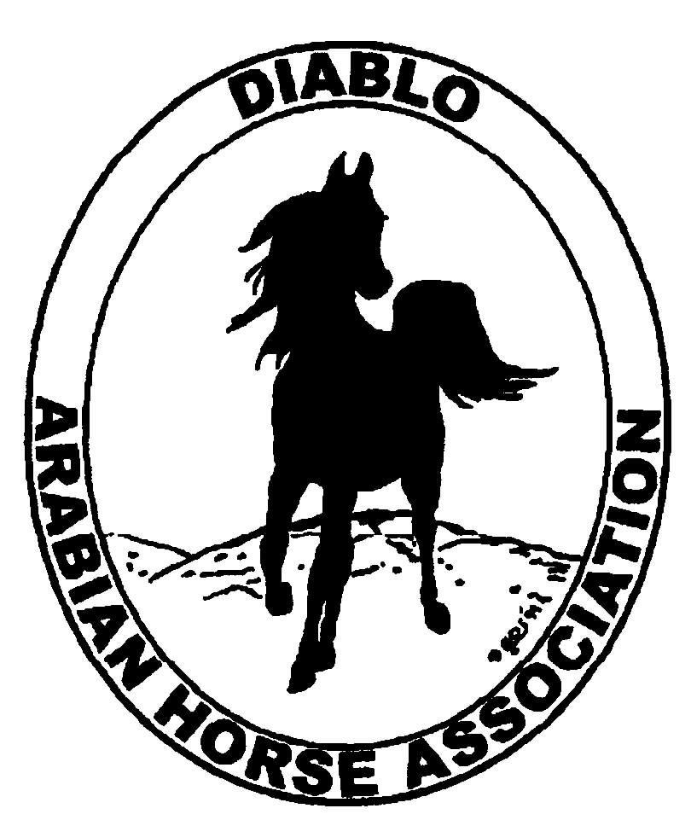
DIABLO ARABIAN HORSE ASSOCIATION
MINUTES –BOARD MEETING
January 10, 2017

Board Members Committee Members
Dorothy Burt Debbie Compilli
Evelyn Call Jill Mitchell
Tammy Collins Tracey Seals
Marla Melloway Meghan Skilling
Joanna Mylin
Cory Soltau

President Tammy Collins, called the first meeting of the 2017 Board to order at 7:05 p.m.

Tammy asked if there were any corrections to the minutes of the December board meeting. Evelyn made a motion to approve the minutes. Joanna seconded. Motion passed.

Correspondence: No correspondence

Calendar Review: March, June, Sept. & Dec. – Newsletter to be posted on website
Jan. 21 & 22, 2017 – Red Bluff Show, Corning
Jan. 28, 2017 – Winter Banquet
Feb. – Budget Meeting
May 18-21 – DAHA Spring Show, Brookside
July 7-12 – Region III Championship Show, Rancho Murietta
July 13 – 16 – Region III Sport Horse Championship Show, Rancho Murietta
Sept. 29 – Oct. 1 – DAHA Fall Show, Brookside

Treasurer’s Report: Meghan had emailed the treasurer’s reports for December. The Total Net Assets are $139,520.25. Total Revenues of ($256.86). Total Expenses of $2,903.91. The Change in Net Assets is ($3,160.77). Meghan also included the check detail for December 2016, the Statement of Activities for all accounts and the Budget-Actual Statements for both the spring and fall shows. Tammy asked if there were any questions with this month’s report. Discussion about bookkeeping procedures for both the show and the upcoming banquet. The treasurer’s report was reviewed and accepted.

COMMITTEE REPORTS

Awards Banquet: Cory reported that a committee meeting was held today at Sherman’s with the caterer. Good discussions about table arrangements and other evening’s details. Tracey has an audio visual technician who will set up everything for the evening. Both Kevallyn and Kim Edwards will photograph the event. Rory O’Neill charges $500 plus airfare to emcee. Discussion and decided to hire him. Discussion about wine glasses and a possible new club logo. The purchase of wine glasses was approved. Decision about a new logo was tabled for a future meeting. We may use youth members as parking attendants. Ashley Gallun from National Horseman magazine will be attending. Tammy will create the program to be handed out. Dorothy suggested having photos from the banquet included in our Club of the Year entry.

Breed Awareness/Public Relations/Horse Fair: Nothing to report.

Convention: Nothing to report.

Family Outreach: The story of the one entrant will be printed and distributed on each dinner table. Debbie will order the award from Janda.

High Point Program: Tammy showed the buckle design that will be given to all 1st place winners. The two youth champions will receive jackets. Equine products will be given as awards. Tammy has ordered all of the ribbons.
Cory suggested an amendment to the rules. Each participant is required to hold a voting adult membership or youth membership in order to participate in the high point.

Horse Shows: Jill, Tammy and Debbie met earlier in the evening. They went over the schedule and made adjustments to the trail, sport horse and youth eq. classes. Jill has gotten no response yet from the company that would do the live feed and internet streaming. Discussion about fees for incomplete entries and printing of entries by the show secretary. The theme for the spring show will be “It’s a Small World”.

Membership: Evelyn’s report was as of December 4, 2016. Member status is as follows:
Adult 1 & 3 yrs. 98
Adult Life 10
Voting members 108

Associates 3
Youth 36
Total members 147

Newsletter: Evelyn said she needs input in order to create a new newsletter.

Social Media/Website: Joanna reported that she has promoted the banquet on our Facebook page. She is continuing to work on the content of the website. She continues to post on other social media websites. The flyer for riding lessons was posted to “Mom” groups on Facebook. She will make a Valentine flyer to post. And she has posted photos from Convention.

Racing: Dorothy reported that they are trying to open the Alameda County track sooner so that the horses can train.

Trail Rides: Nothing to report.

Volunteer Awards: The two AHA certificates have been received. Debbie will have them at the banquet to be presented to the winners.

Youth: Nothing to report.

Old Business: Tammy said that a chairman was needed for the Club of the Year presentation. Tammy nominated Dorothy, and she accepted. Jill has contacted AHA and asked for our previous binders. She will follow up with them.

New Business: Tammy called for nominees for delegates to AHA. The nominations were made and the vote taken. The club’s new delegates will be: Tammy, Jill and Joanna. Alternates are: Tracey, Megan and Leigha were tied, and Cory.

Cory made a motion to adjourn the meeting. Marla seconded. Motion passed. The meeting was adjourned at 9:17 p.m.

Respectfully submitted,
Debbie Compilli
DAHA Secretary

