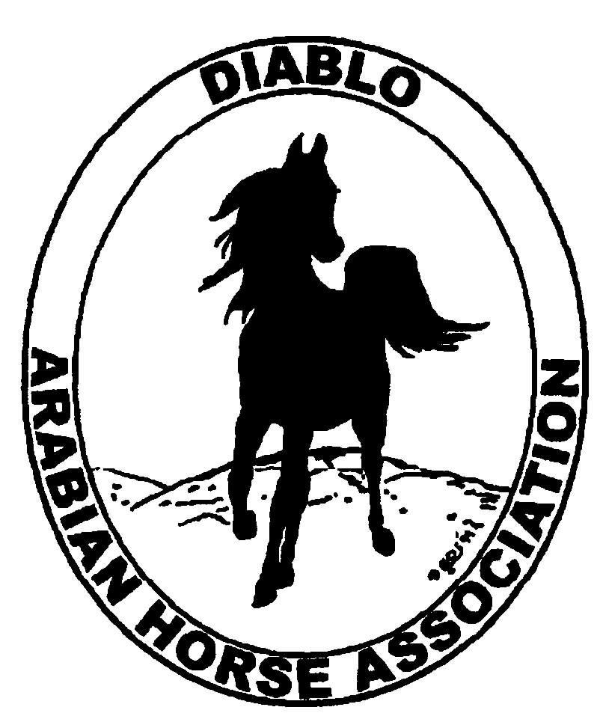
DIABLO ARABIAN HORSE ASSOCIATION
MINUTES –BOARD MEETING
January 7, 2014

Board Members Committee Members Delegates/Guests

Evelyn Call Dorothy Burt
Debbie Compilli Megan Jenkins
Amy Edwards Coke Swift
Pat Hendershot
Jill Mitchell
Cory Soltau
Cindy Volz

President Jill Mitchell called the meeting to order at 7:07 p.m. The minutes of the December board meeting were reviewed. Cindy Volz made a motion to approve the minutes, and Amy Edwards second. Motion carried.

Correspondence: The Mount Diablo Interpretive Assn. sent a thank you letter for DAHA’s recent $500 donation.
Cindy Volz has received several emails regarding the Western Dressage Clinic that took place on Jan. 5, 2014. She will bring them to the Feb. board meeting.
Jill and all board members received an email from Ed Oto asking to resign his position as a board of director. Debbie Compilli made a motion that DAHA regretfully accept Ed’s resignation. Evelyn second. Motion passed.

Calendar Review: Jan. 14 – Horse Show Committee Meeting, Cory’s home, 6:30 p.m.
Jan. 18 – Reg. III budget meeting, Sharon Richard’s home, 10 a.m.
Jan. 21 – Budget Meeting, Cory’s home, 6:30 p.m.
Jan. 26 – Winter Banquet, Shadelands, Walnut Creek, 5 p.m.
Jan. 31 - Delegate Meeting, Courtyard Marriott, Vacaville, 8:00 pm.

Treasurer’s Report: Donna Bolla was absent but emailed the Treasurer’s Report as of December 31, 2013. Total Liabilities & Equity was $86,626.26. The Profit & Loss Operating statement for April through December 2013 included Total Income of $8,375.12 and Total Expense of $14,683.03 for a net of [$6,307.91]. Donna included an updated Profit and Loss Operating Budget Performance report. She sent Check Detail for December 2013 and the Horse Show Account Reconciliation Summary and Detail for December 2013.

All committee chairs need to bring their committee budgets to the budget meeting on Jan. 21.

COMMITTEE REPORTS

Awards Banquet: Debbie Compilli reported that the event plans are moving forward: the floorplan and equipment list was sent to Shadelands, Classic Catering is on track, Tracey and Tammy are handling the awards. Instead of a having a speaker this year, Cory suggested that we show the video of the 2013 Arabian Breeder’s Cup Race.
Debbie asked if we could make a special exception and give a donation to the Oakland Zoo. They have donated zoo tours for the past 4 or 5 years for our silent auction, and have done so again this year. Debbie Bartman, had asked if DAHA would make a donation. Discussion. Debbie Compilli made a motion to donate $100 to the Oakland Zoo. Cindy Volz second. Motion passed.
Professional photographer Kevallyn Paskos offered to photograph the banquet and provide us with a CD in exchange for a family membership to DAHA. Discussion. Evelyn made a motion that since we already have a club member who has volunteered to take photos, her services were not needed at this time. Amy second. Motion passed.
Volunteers are always needed to help with set up and clean up. The doors will be open to us at 3:30 on Sunday.

Breed Awareness/Public Relations/Horse Faire: Walnut Creek’s Horse Faire: Coke will email to find out the dates for this year.
Amy suggested that DAHA put on a summer barbeque for all club members.
Reg. III may not be participating in the Horse Expo. More on this after the regional meeting at the end of Jan.

Convention: Jill will turn in her convention report soon.

Family Outreach: Debbie reported that we have no entries for the Family Arabian award this year.
Cory would like to find a club member who could expand on Sidney Simpson’s personal touch that she put into the Family Outreach program.

High Point Program: Tracey and Tammy Collins worked on the revised tabulation of point. Amy will meet with them to coordinate the awards presentations. Tammy has ordered the ribbons and awards. Megan Jenkins will consult with Ed Oto regarding creation of a large, presentation check for Show Season’s $500 award.

Horse Shows: Coke Swift reported that there will be a show committee meeting on Jan. 14. The committee will work on the show schedule. Megan suggested that we offer academy classes at the spring show. Discussion. Because of the spring show’s full schedule, those classes may be added to the Fall show. We need information on the number of classes that would be needed. Discussion about the possibility of an All Amateur show at Livermore, Ranch Murietta or Brookside.

Membership: Evelyn presented the DAHA Membership report with an AHA count as of Sept. 2, 2013. Member status is as follows:
Adult (1 yr.) 95
Adult (3 yr.) 27
Adult Life 6
Voting members 128

Associates 7
Youth 34
Total members 169

To help generate new members, Evelyn mailed 68 invitation letters to local AHA members who are not affiliated with a local club. The letter packet contained the DAHA brochure, western dressage clinic flyer, website information and a DAHA membership application.

Newsletter/Web Site: Meghan Johnson reported that The website is up to date. She posted the newsletter in early December. She included an obituary for Lorraine Soltau. She also posted a flyer for the Western Dressage clinic and the invite for the banquet. Meagan worked with Tracey to send out a couple of e-blasts in the past month including one for the banquet and western dressage clinic and they are working on another e-blast for the silent auction. She plans on starting to work on the March newsletter soon. Please let her know if you have any thing to contribute to the newsletter or website or need anything to e-blast to the members.
Cindy Volz will write an article and send photos about the western dressage clinic.

Racing: Dorothy Burt said that the next meetings is in Feb.

Trail Rides: No ride is scheduled.

Volunteer Awards: Discussion and it was decided to give a $100 gift certificate to a restaurant for the winner of the Friends of DAHA award. Cory will follow up on this.

Youth: Jill will talk to Leigha Perry about remaining the chair of the youth committee. Tammy Collins is willing to assist her.

Old Business: Cindy Volz reported that they had a great turnout for the club’s first western dressage clinic. Naila Abdoukadyrov and Lisa Horning were the clinicians. There were 6 riders and 15 auditors. It ran smooth and on time. Cindy received positive feedback.

Income: riders $780 Expenses: clinicians $ 720
Lunches 180 stall 20
Auditors travel 120
& drinks 358 sandwiches 200
$1,318 breakfast food 80
$1,140
For a profit of $178.

New Business: Dorothy suggested that we buy sandwich sign boards to use for directing people to our events.

Election of delegates for 2014. The convention will be in Nov. in Denver.
As president, Jill is an automatic delegate. Nominations and voting took place. The additional delegates, in order of serving, are: Pat Hendershot, Cindy Volz, Amy Edwards. Evelyn Call and Megan Jenkins tied for fifth position. Tammy Collins.

Evelyn motioned to adjourn the meeting, Cindy Volz second. Motion carried. The meeting was adjourned at 8:53 p.m.

Respectfully submitted,

Debbie Compilli
Acting Secretary

