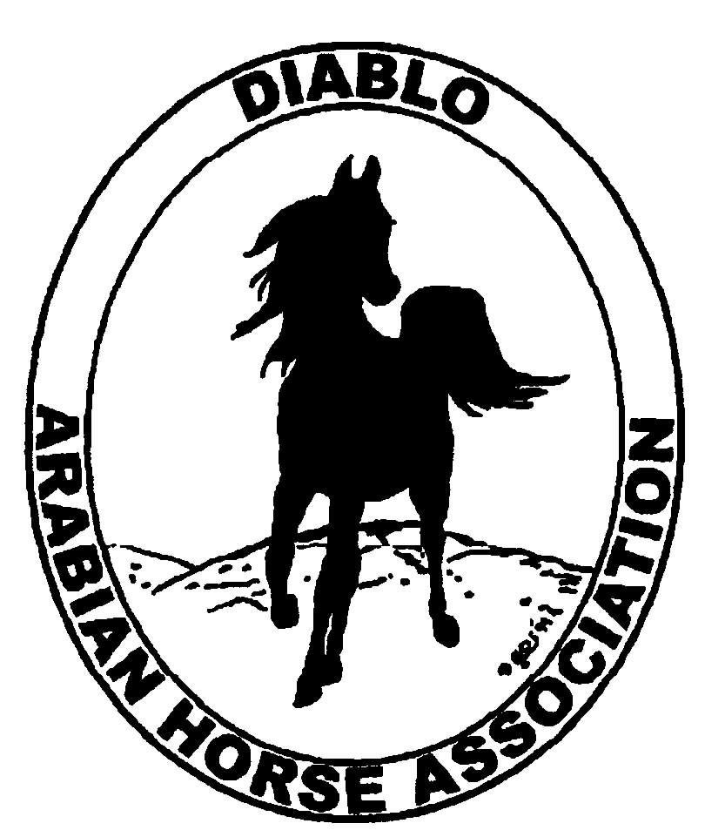
DIABLO ARABIAN HORSE ASSOCIATION
MINUTES –BOARD MEETING
October 3, 2017

Board Members Committee Members Guests
Dorothy Burt Debbie Compilli Kathy Campbell
Evelyn Call Katy Dubnoff
Tammy Collins Alex Farly
Marla Melloway Kevallyn Paskos
Joanna Mylin
Leigha Perry
Cory Soltau

President Tammy Collins, called the meeting to order at 6:59 p.m.

Tammy asked if everyone had reviewed the minutes of the September board meeting. Marla made a motion to approve the July meeting minutes. Joanna second. Motion passed.

Correspondence: Nothing received.

Calendar Review: Oct. 20 & 21 – Grand National, Cow Palace
Nov. 15-18 – AHA Convention, Denver, CO

Treasurer’s Report: The Sept. bank statements are not yet available. Meghan will email the Board her reports later in October.

COMMITTEE REPORTS

Awards Banquet: Tammy reported that the banquet will be held at the Chateau Hall at the Pleasant Hill Senior Center on Sat., Jan 27. Set up will begin at 2:30 p.m. Doors will be open from 5 to 10 p.m. The rental fee is $2,700. The theme will be, “Around the World of Arabian Horses.” Rory O’Neil could possibly be our emcee and speaker for the night.
Caterers were discussed. It was decided to have a high end buffet dinner. Suggestions for decorations were discussed. A person to chair the silent auction is needed. Kevallyn offered to photograph the banquet.
.

Breed Awareness/Public Relations: Grand National: Leigha is the chairman of our presence at the Cow Palace this year. Joanna will organize the front booth. Tammy will order ribbons for the participants.

Convention: The airfare for our three delegates was approximately $600 each. Cory suggested that we should plan to discuss the resolutions at our Nov. 7, board meeting.

Family Outreach: Debbie will organize an eblast to be sent out about this program.

High Point Program: As there are very few entries so far, Leigha will send out information about the prizes and entry forms to the club members. Kevallyn offered to send out the eblast.
Debbie will post the high point information to the DAHA website.

Horse Shows: Debbie reported that we had 166 horses. Up over last year’s show with 155 horses. Jill wanted to ask the board their opinion about starting the fall show on Thurs. afternoon and running the english trail and regular trail that day. Jill proposed that we start with the English at 12:00. Then the other trail classes would start at 3:00; with the Open going first and Youth last. The reason behind this change is to drop the need for an arena #2 judge. The main ring judge would judge the trail and reining, too. The reining entry numbers have dropped over the past few years. Debbie had already talked to Kelly Alcorn, and she is eager to do it all. Dorothy asked for the cost difference between the extra day of showing costs at Brookside vs. the extra judge. Debbie will ask Jill to provide those numbers at the Nov. board meeting.
Suggestions for the sport horse schedule: Kevallyn asked about moving the sport horse off of Fri. to make it easier for amateur riders to show their horses. Alex would like the classes spread out over the 3 days of the show, instead of all on one day. That would enable exhibitors to show their horses in more classes.
Tammy is concerned that exhibitors are not entering the championship classes, as the championship exhibitor numbers seem to be smaller than the qualifying classes. She suggested adding purse money to entice people to stay and show.
It was suggested that we have a theme for the Fall show, as well as the Spring show, to make our show more fun.
Also, exhibitors would like to have hard copies of any changes in the scheduling.

Membership: No report available at this date.

Newsletter: Tammy asked for committee chairs and members to send her articles about DAHA’s events; such as Cow Palace. And news about club members participating at Nationals.

Racing: As a number of the Arabian race horses have moved to Texas for the races there, there were no Arabian races at the recent race schedule at the Pleasanton Track.

Social Media/Website: At our Fall show, Joanna had flyers with DAHA’s social media information available for both exhibitors and guests. She has videos and photos to post and will continue promoting DAHA through new posts.
Joanna continued consulting with Leah at Arabian Horse Global on the content of our new website.

Trail Rides: Nothing to report.

Volunteer Awards: Debbie said she that the two awards will be presented at the Winter Banquet.

Youth: Alex is the new Youth advisor. She is planning on going to area barns for a “Meet and Greet”. She will talk to the Youth about nominating new Youth officers. Alex would like to set up a scholarship derby on horsemanship to entice youth participation in DAHA.

Old Business: Nominations for the Board: Five club members agreed to run for the Board: Dorothy Burt, Kathy Campbell, Katy Dubnoff, Alex Farly and Leigha Perry.

New Business: Nothing to report.

Evelyn made a motion to adjourn the meeting. Marla second. Motion passed. The meeting was adjourned at 8:50 p.m.

Respectfully submitted,
Debbie Compilli
DAHA Secretary

