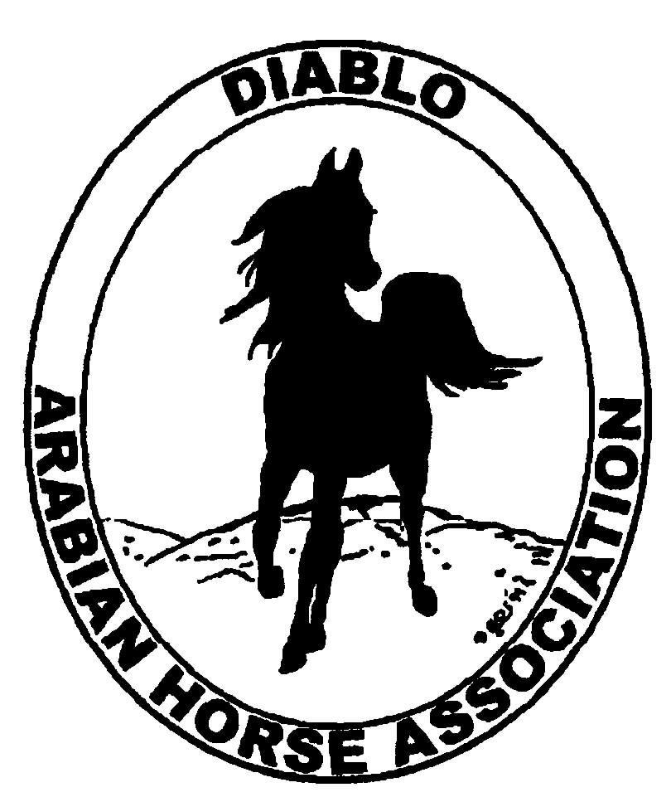
DIABLO ARABIAN HORSE ASSOCIATION
MINUTES –BOARD MEETING
October 4, 2016

Board Members Committee Members
Dorothy Burt Joanna Mylin
Evelyn Call
Tammy Collins
Debbie Compilli
Megan Jenkins
Leigha Perry
Tracey Seals
Cory Soltau

President Cory Soltau, called the meeting to order at 7:10 p.m.

Cory asked if there were any corrections to the minutes of the September board meeting. Evelyn made a motion to approve the minutes. Dorothy second. Motion passed.

Correspondence: Debbie received a letter from Judy Gillivan regarding Horses’ Honor and a request for a donation from DAHA. As had been discussed on previous occasions, the Board decided that our mission statement is to promote the Arabian breed. Therefore, the Board decided not to make a donation. The Board asked Debbie to contact Judy and let her know that we are very supportive of their cause. It was suggested to offer to include them at our exhibit at the Cow Palace and to offer booth space at the Winter Banquet.
Evelyn received a brochure regarding photography workshops that Scott Trees will be presenting.

Calendar Review: March, June, Sept. & Dec. – Newsletter to be posted on website
Nov. 16-19 -- AHA Convention, Tulsa
Jan. 21 & 22, 2017 – Red Bluff Show, Corning
Jan. 28, 2017 – Winter Banquet
May 18-21 – DAHA Spring Show, Brookside
July 7-12 – Region III Championship Show, Rancho Murietta
July 13 – 16 – Region III Sport Horse Championship Show, Rancho Murietta

Treasurer’s Report: Meghan emailed the treasurer’s reports for September. The Total Net Assets are $131,563.06. Total Revenues of $30.03. Total Expenses of $2,474.16. The Change in Net Assets is ($2,444.13). Meghan also included the check detail for September 2016, the Statement of Activities for all accounts and the Budget Actual Statements for both the spring and fall shows. Cory asked if there were any questions with this month’s report. The treasurer’s report was reviewed and accepted.

COMMITTEE REPORTS

Awards Banquet: Cory had a meeting with Marty Sherman last week to discuss the banquet. Cory has received three bids from caterers and is expecting one more. It will be limited to 200 people, with DAHA members getting first priority.
The horse exhibit may be liberty horses or possibly riders of various disciplines. Rory O’Neill is a possible emcee.
Leigha suggested honoring the youth members who will be graduating to adult status. Discussion about the slide show. Perhaps Katie Kreske will produce it again. Or Joanna Mylin may work on it as well.
Committee members are Tammy, Tracey, Lisa Dhillon, Andrea and Debbie.

Breed Awareness/Public Relations/Horse Fair:
Grand National – Tammy said she has a good group of horses that will participate. Suggested that Mike Cheatwood be the judge of the presentation.
2017 Clinic – Megan reported that Gene LaCroix charges $2,000 plus expenses. He also is willing to do “An Evening with Gene LaCroix”. Megan will work on a venue for the evening presentation and will follow up with possible dates with Gene.

Convention: The Convention was moved to Tulsa. Registrations are due by Nov. 1. Megan, Tracey and Jill Mitchell will be our delegates.
Megan said that two of the important topics will be regarding the youth commission and the USDA legislation to ban all substances and action devices. She urged everyone to send their comments to USEF.

Family Outreach: Nothing to report at this time.

High Point Program: Tracey will be sending out the current point standings in an eblast this week.

Horse Shows: Coke was not able to attend. Debbie reported that we had 150 horses and shared the preliminary entry report that Melanni had provided. Melanni will be sending the final show reports soon.

Membership: Evelyn’s report was as of October 1, 2016. Member status is as follows:
Adult (1 yr.) 67
Adult (3 yr.) 35
Adult Life 10
Voting members 112
Associates 2
Youth 34
Total members 148

Newsletter: Nothing to report.

Social Media/Website: Joanna has been very busy creating and posting to new accounts for us on Facebook, Twitter, Instagram, Pinterest, Snapchat, YouTube and Vimeo.com. She will focus on content for the youth. She’s also posted photos for the fall show to our hashtag account. It is: #dahaFF16.
She has ideas to update and modernize our website. She has received two bids so far.

Racing: Dorothy reported that there is talk to close the race meets at Pleasanton and move them to Golden Gate Fields. The race meet this fall was moved from Stockton to Pleasanton with good support in the Arabian races.

Trail Rides: Nothing to report.

Volunteer Awards: Debbie received the award certificates for our two recipients from AHA.

Youth: Tracey will prepare a report for Nov. Discussion regarding putting flyers into the public schools newsletters to promote DAHA and Arabian horses.

Region III Meeting: Megan said that the dates for Reg. III will be July 7-12, 2017. They moved the dates so that the show would not conflict with Youth Nationals. The sport horse regionals will be July 13-16. The profit for the 2015 show in Reno was $19,000. This year it was $6,000.
Reg. III is looking for photos and information to post to their new website.
Red Bluff has moved their show to Jan. 21-22, in Corning.
AHANC will be a double qualifier for Regions II and III.
Comstock will qualify for Regions III and IV on May 5-7.

Old Business: Nominations were made for the 2017 Board. Three who accepted were Tammy Collins, Megan Jenkins and Joanna Mylin. Marla Melloway and Coke will be asked if they will run for the Board. Cory, Dorothy, Evelyn and Leigha will remain on the Board.

New Business: Nothing to report.

Leigha motioned to adjourn the meeting. Tracey second. Motion carried. The meeting was adjourned at 9:07 p.m.

Respectfully submitted,

Debbie Compilli
DAHA Secretary

