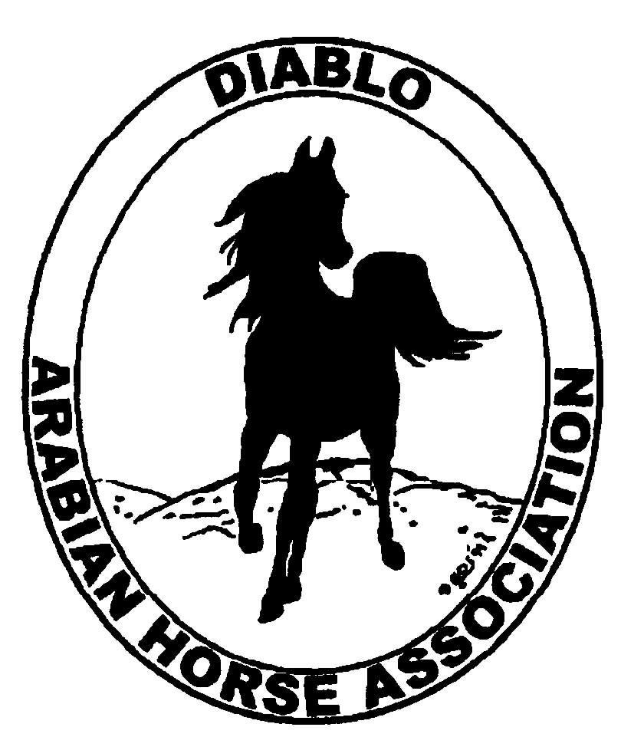
DIABLO ARABIAN HORSE ASSOCIATION
MINUTES –BOARD MEETING
November 7, 2017

Board Members Committee Members Guests
Dorothy Burt Debbie Compilli Kathy Campbell
Evelyn Call Alex Farly Katy Dubnoff
Tammy Collins Jill Mitchell Pam Farly
Marla Melloway
Joanna Mylin
Cory Soltau
Cindy Volz

President Tammy Collins, called the meeting to order at 7:07 p.m.

Tammy asked if everyone had reviewed the minutes of the October board meeting. Marla made a motion to approve the October meeting minutes. Joanna second. Motion passed.

Correspondence: Joanna received an invitation from Midcrest Arabians for their Christmas Festival in Enumclaw, WA. She will send the club’s regrets.

Calendar Review: Nov. 15-18 – AHA Convention, Denver, CO
Dec. 9 – Day of the Horse, Heather Farms, Walnut Creek
Jan. 27, 2018 – Winter Banquet, Pleasant Hill, CA

Treasurer’s Report: The Oct. treasurer’s report is not yet available. Meghan will email the Board her report later in November.

COMMITTEE REPORTS

Awards Banquet: Tammy reported that she is looking for a caterer for the banquet. The committee is considering adding special lighting for the hall. Joanna volunteered to create the invitations. Tammy will get them printed and mailed. Tammy asked all board members to be responsible for getting two silent auction items.
.

Breed Awareness/Public Relations: Grand National: Joanna organized the front booth for our exhibit. There were photo ops with Whitey. Marla made coloring pages for the kids. The costume classes went well. All thought it was well received and another successful event.
National Day of the Horse, Heather Farms: They called Leigha and asked if DAHA would be participating. The event is on Dec. 9. Marla volunteered to organize our booth. She can use the same booth that was at Cow Palace and use Whitey for photos.
AHA Club of the Year: Marla volunteered to collect materials from each of our events for our next year’s entry.

Convention: The proposed resolutions were discussed by the Board.

Family Outreach: Debbie will organize an eblast to be sent out about this program.

High Point Program: Leigha was absent. Tammy asked for suggestions for this year’s awards. Suggestions were silver rings, other jewelry and bling jackets.

Horse Shows: Spring Show: Alex asked if the sport horse classes could be spread out over the four days.
Fall Show: Jill said that by using one judge for the whole show and adding a day, we would save on the expense of a second judge’s travel and hotel expenses. Since we have been having less than 200 horses, we are only required to have the vet and farrier on call. The additional day will allow us to spread out the open and sport horse classes.

Membership: Evelyn’s report was as of November 1, 2017. Member status is as follows:
Adult 1 & 3 yrs. 101
Adult Life 11
Voting members 112

Associates 2
Youth 32
Total members 144

Newsletter: Tammy has received only one article. She asked for committee chairs and members to send her articles about DAHA’s events.

Racing: Nothing to report at this time.

Social Media/Website: Joanna has posted photos from our Fall show on the social media sites. At the Grand National, Joanna had flyers with DAHA’s social media information available for guests that came to our booth at the stalls. She has videos and photos to post and will continue promoting DAHA through new posts.
Joanna continued consulting with Leah at Arabian Horse Global on the content of our new website.

Trail Rides: Nothing to report.

Volunteer Awards: Debbie said that she has the two awards that will be presented at the Winter Banquet.

Youth: Alex will be moving to Chico soon. Pam Farly volunteered to take over as the new Youth advisor. The Board gladly accepted Pam in this role. Alex said that she will come down periodically and will help Pam with the Youth program.

Old Business: Joanna made a motion to declare that the five nominees are now DAHA’s new Board members. The five new Board members are: Dorothy Burt, Kathy Campbell, Katy Dubnoff, Alex Farly and Leigha Perry.

New Business: Nothing to report.

Evelyn made a motion to adjourn the meeting. Dorothy second. Motion passed. The meeting was adjourned at 9:15 p.m.

Respectfully submitted,
Debbie Compilli
DAHA Secretary

