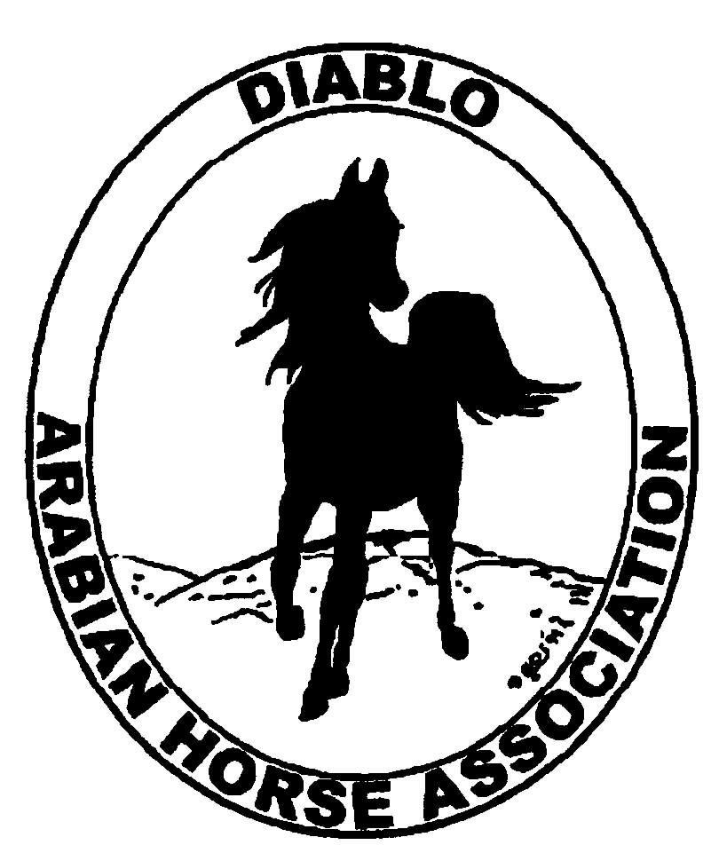
DIABLO ARABIAN HORSE ASSOCIATION
MINUTES –BOARD MEETING
December 5, 2017

Board Members Committee Members Guests
Dorothy Burt Debbie Compilli
Evelyn Call
Kathy Campbell
Tammy Collins
Katy Dubnoff
Marla Melloway
Joanna Mylin

President Tammy Collins, called the meeting to order at 7:17 p.m.

Tammy asked if everyone had reviewed the minutes of the November board meeting. One correction was noted: It should be added that Joanna will be helping Marla at the Horse Faire. Evelyn made a motion to approve the November meeting minutes, as corrected. Marla second. Motion passed.

Correspondence: Joanna emailed with Meghan Skilling regarding securing the club’s non-profit status. Meghan will look into having her employer do the work on this for us.

Calendar Review: Dec. 9 – Day of the Horse, Heather Farms, Walnut Creek
Jan. 27, 2018 – Winter Banquet, Pleasant Hill, CA
May 17-20, -- DAHA Spring Show, Brookside

Treasurer’s Report: The Nov. treasurer’s report is not yet available. Meghan will email the Board her report later in December.

COMMITTEE REPORTS

Awards Banquet: Tammy reported that Zandonella Catering will be our caterer. The price will be between $29 - $34, depending on the final food choices. This price does include the linen and tableware. Rory O’Neill will be our emcee, at $500. There will be a live band, at $800. Wine glasses with the DAHA logo are being ordered, at $500. The committee is projecting to stay under the current budget of $15,000. Joanna presented the invitations, game cards and DAHA business cards that she created. She will get them printed and Katy will prepare and mail out the invitations. Silent auction items are still needed.

Breed Awareness/Public Relations: Horse Faire, Heather Farms: Marla, Joanna and Katy will all be there to represent DAHA. Joanna will bring promotional material to pass out. DAHA water bottles and coloring pages will be included. Whitey will be used there. Penny Maars will set up a microscope so attendees can see examples of intestinal parasites that affect horses.
AHA Club of the Year: At the AHA Convention, DAHA won the Breed Promotion/Community Outreach award.

Convention: Tammy talked about the resolutions that were passed or were withdrawn. She said that the “one day value show” has grown so clubs may offer “multiday value shows”. This may be something we would want to consider in the future.
Tammy reported that the Reg. III Championship show will be held at Rancho Murieta in 2018 and Reno in 2019.

Family Outreach: Debbie will organize an eblast to be sent out about this program again.

High Point Program: Joanna reported for Leigha that there are 24 entries for this year’s awards. Tammy will order the awards and ribbons.

Horse Shows: Coke had sent two emails to all Board members regarding the horse shows. In her absence, the Board discussed three items. 1) Coke requested the manager’s bonus pay for the May 2016 show that netted $25,202. Discussion. Dorothy made a motion to pay the $1,000 bonus. Evelyn second. Motion passed. 2) The Board wants to pay for a vet to be on the grounds during the spring show, even though this is not required by USEF. 3) No decision on having the Global Network videoing of the spring show. It was tabled until Jan. Discussed and seemed to be in favor of raising the fee to $5 or $6 per horse. But the Board did not vote on it.

Membership: Evelyn’s report was as of December 4, 2017. Member status is as follows:
Adult 1 & 3 yrs. 100
Adult Life 11
Voting members 111

Associates 2
Youth 32
Total members 145

Newsletter: Discussion about the club’s newsletter. Historically, it is difficult to get articles from the club’s members. Katy suggested that Tammy may want to consider blogging about events and stories about DAHA and its members.

Racing: Nothing to report at this time---(except Dream Pearl won her race in TX.)

Social Media/Website: Joanna presented extensive, detailed content for our new website and asked for the Board’s input. Discussion. Board members gave their ideas and Joanna will try to incorporate them into the website content.

Trail Rides: Nothing to report.

Volunteer Awards: Debbie said that she has the two awards that will be presented at the Winter Banquet.

Youth: Pam Farly notified the club that she and her family are moving out of the area, so she will not be able to be the Youth advisor.

Old Business: Nothing to report.

New Business: Evelyn made a motion to adjourn the meeting with the out-going Board. Dorothy second. Motion passed. The meeting was adjourned at 9:04 p.m.

The 2018 Board was introduced and the meeting was opened. Tammy entertained nominations for officers of the new Board. President: Evelyn nominated Tammy. No other nominations were made. Tammy will be President. Vice President: Dorothy nominated Katy. No other nominations were made. Katy will be Vice President.

Evelyn made a motion to adjourn this meeting. Dorothy second. Meeting adjourned at 9:09 p.m.

Respectfully submitted,
Debbie Compilli
DAHA Secretary

