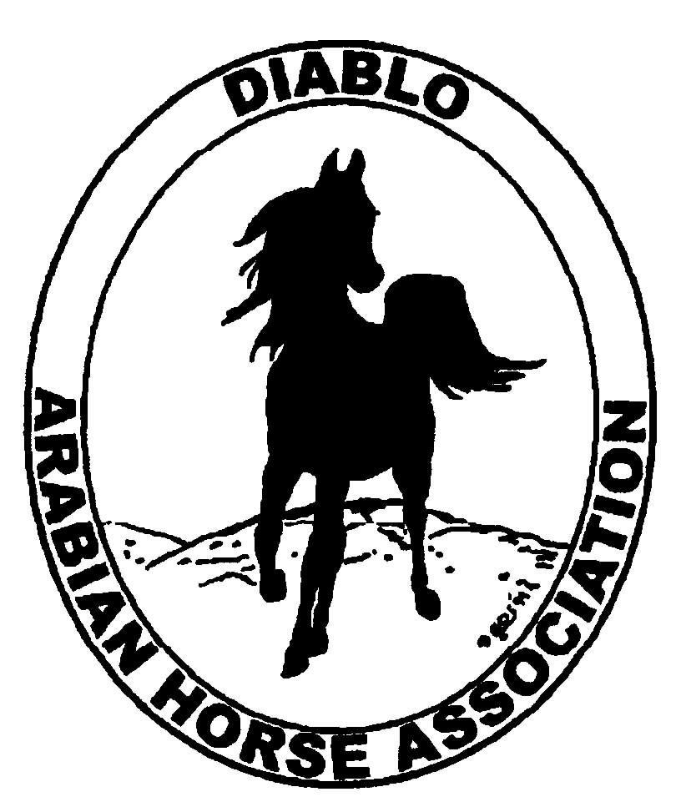
DIABLO ARABIAN HORSE ASSOCIATION
MINUTES –BOARD MEETING
December 6, 2016

Board Members
Dorothy Burt
Evelyn Call
Tammy Collins
Debbie Compilli
Megan Jenkins
Jill Mitchell
Joanna Mylin
Leigha Perry
Cory Soltau

President Cory Soltau, called the meeting to order at 7:07 p.m.

Cory asked if there were any corrections to the minutes of the November board meeting. Evelyn made a motion to approve the minutes. Dorothy seconded. Motion passed.

Correspondence: No correspondence

Calendar Review: March, June, Sept. & Dec. – Newsletter to be posted on website
Jan. 21 & 22, 2017 – Red Bluff Show, Corning
Jan. 28, 2017 – Winter Banquet
Feb. – Budget Meeting
May 18-21 – DAHA Spring Show, Brookside
July 7-12 – Region III Championship Show, Rancho Murietta
July 13 – 16 – Region III Sport Horse Championship Show, Rancho Murietta
Sept. 29 – Oct. 1 – DAHA Fall Show, Brookside

Treasurer’s Report: Meghan emailed the treasurer’s reports for November. The Total Net Assets are $142,681.02. Total Revenues of $14,562.34. Total Expenses of $23,282.04. The Change in Net Assets is ($8,719.70). Meghan also included the check detail for November 2016, the Statement of Activities for all accounts and the Budget-Actual Statements for both the spring and fall shows. Cory asked if there were any questions with this month’s report. The treasurer’s report was reviewed and accepted.
Cory said that in January, the new Board will schedule a budget meeting to be held in February.

COMMITTEE REPORTS

Awards Banquet: Cory reported that our caterer will be Gianni’s Italian Bistro, Danville. Gianni’s wants to be highlighted during the banquet. They want DAHA members to do a server switch at their restaurant one evening. A Save the Date card was discussed. Decided that will not be necessary. The invitations will be sent out asap. Club members will have first priority until Jan. 5. After that, tickets will be available for non-members.
Joanna will post the event on DAHA’s facebook page. She has a slide presentation organized with photos from our shows, Cow Palace and horse races.
Discussion about the horse presentation. Three horses will be presented at liberty and possibly a horse and rider and a halter horse presentation.
Tammy needs 15 more silent auction items.
The ticket prices will remain the same as last year: $75 for adults and $25 for children.

Breed Awareness/Public Relations/Horse Fair:
Patty Colbert was the keynote speaker at Convention. Her presentation falls in line with what Joanna has been working on: marketing to women; both the 50+ and 20-30s age groups. She suggested focusing on open houses at barns in our area, Mom bloggers and PTAs.

Convention: Tammy, Jill and Megan turned in their reports. Nancy Harvey is our new president and Deborah Johnson is the AHA Vice President.

Family Outreach: Debbie will ask Tracey to include information on the program in the next club eblast.

High Point Program: Tammy asked for suggestions for prizes. Suggested items were custom cutting boards, Equifuse products, buckles and jackets. Youth funds will be used for the Youth awards.

Horse Shows: Jill suggested having a meeting to go over the spring schedule. Leigha, Tammy, Megan, Debbie and Jill will attend. Jill reported that all of the judges are in place. Discussion about using products as prizes again, and it was decided to continue with products. We may have a new announcer and a new back gate man. Discussion about utilizing a live feed streaming for our show. Exhibitors would pay an additional fee per horse. Trainers and businesses could advertise on the live feed.

Membership: Evelyn’s report was as of December 4, 2016. Member status is as follows:
Adult 1 & 3 yrs. 107
Adult Life 8
Voting members 115

Associates 3
Youth 40
Total members 158

Newsletter: Evelyn said she will work on it.

Social Media/Website: Joanna suggested a web provider for DAHA whose work she likes. The initial cost is $2,000 and then $65 a month for administering. Tammy made a motion to accept, Jill seconded. The motion was passed. She is still working on getting all of the social media sites finalized.

Racing: Dorothy reported that the Alameda County track is being closed down through the winter. Racing activities will be moved to Golden Gate Fields.

Trail Rides: Nothing to report.

Volunteer Awards: Debbie reported that Mike Cheatwood was slated to receive the Friends of DAHA award. But he joined last June. Therefore, he can’t get this award. The other volunteer awards have been received from AHA

Youth: Nothing to report.

Old Business: Nothing to report.

New Business: Cory nominated Coke as a Distinguished Member. Cory and Pat could contribute to the write up.

Megan motioned to adjourn the meeting. Jill seconded. Motion carried. The meeting was adjourned at 9:00 p.m.

The new Board of Directors opened the nominations for the offices of President and Vice President.

Cory nominated Tammy Collins. There were no additional nominations. Tammy will be the new DAHA President.

Cory asked for nominations for Vice Pres. Evelyn was nominated. There were no additional nominations. Evelyn will be the new Vice President.

Megan made a motion to adjourn the meeting. Dorothy seconded. Motion passed. The meeting was adjourned at 9:05 p.m.

Respectfully submitted,
Debbie Compilli
DAHA Secretary

