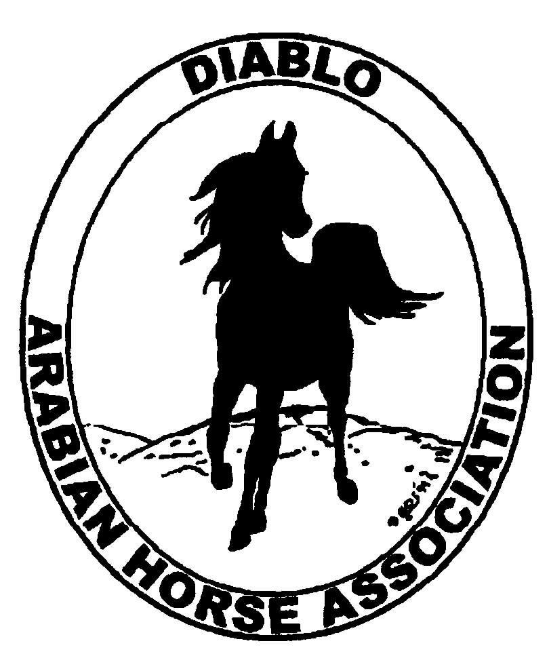
DIABLO ARABIAN HORSE ASSOCIATION
MINUTES –BOARD MEETING
February 3, 2016

Board Members Committee Members Guest
Dorothy Burt Evelyn Call
Debbie Compilli Pat Hendershot
Megan Jenkins Meghan Skilling
Tracey Seals Coke Swift
Cory Soltau

President Cory Soltau called the meeting to order at 7:05 p.m.

Cory asked if there were any corrections to the minutes of the January board meeting. Dorothy made a motion to approve the minutes. Megan second. Motion passed.

Correspondence: President Cory Soltau read a letter from AHA President Cynthia Richardson, sent from David Matlock, who attended the Registration Commission at Stachowski Farms in Ohio. Mr. Matlock had previously been very involved in Arabian horses but has not been for a few years. He recently purchased an Arabian and intends to be involved again. He expressed concern regarding the low number of registrations, members and horses being shown. He said that we all need to get on board and try to do events and programs to bring more people into the Arabian breed. Cory stated that DAHA needs to have a “brainstorming” session to discuss things that our club might do.

Debbie received an email for two western dressage seminars on Feb. 12, in Santa Rosa. The information will be included in an eblast to the membership.

Calendar Review: Feb. 26 – Budget Meeting, Cory’s house, 6:30 p.m.
March, June, Sept. & Dec. – Newsletter to be posted on website
May 19-22 – Spring Show, Brookside
June 2016 – Prepare Club of the Year Nomination
Sept. 30-Oct. 2 – Fall Show, Brookside

Treasurer’s Report: Meghan emailed the treasurer’s reports for Jan. The Total Net Assets are $107,318.13. Total Revenues of $9,733.79. Total Expenses of $13,255.68. The Change in Net Assets is -$3,521.89. Meghan also included the check detail for Jan. 2016, the Statement of Activities for all accounts and the Budget Actual Statements for both the spring and fall shows. Cory asked if there were any questions with this month’s report. Discussion. The report was reviewed and accepted.
Tracey asked if we want to keep the Wells Fargo credit card machine. Discussion. Board approved keeping it for use at the shows, etc. and decided that Meghan will store it.
Discussion about the debit cards for our accounts. Meghan said another club member should have the debit cards in addition to her. Then if she is out of town or unavailable, someone will have access to the accounts. It was decided by the Board that Debbie will activate the debit cards that were issued to her. All others will be turned in to Meghan.
Discussion about the Ryan Melendez fund raiser and where the funds are. Meghan will contact Jill and Tammy to track the money that was raised.

COMMITTEE REPORTS

Awards Banquet: Cory said that it was a great night with 185 people attending. The four horses presented at liberty were well received. Great job done by all of the committee members. Good food, Rich Doran did a great job as our emcee and lots of silent auction items. Cory will send out a letter to all attendees and DAHA club members, thanking Sherman Ranch and Whitehall Winery for hosting. And will include our other sponsors, as well.

Breed Awareness/Public Relations/Horse Faire:
DAHA’s next date to work the snack bar at Golden Gate Fields is Sunday, March 13. New volunteers are always needed and welcome. Please contact Debbie to sign up.

Convention: Nothing new to report.

Family Outreach: Natalie Colello and her mother were very pleased to have her horse, Heart of Golde, honored at the Banquet.

High Point Program: Megan, Tammy and Tracey will meet to evaluate the categories and decide if any changes need to be made. It was suggested that the high point standings be posted in our newsletter throughout the year, as this may be one way to increase participation.

Horse Shows: Coke said that Ann Lang has the bulk of the data so she can create our premium book. There is a possibility that Western Dressage will be added on Sunday afternoon. Bill Madden will distribute flyers for our show at Scottsdale. Sponsorships are always needed.
Discussion about having one manager or two. It was decided that a job description is needed to outline what each manager’s duties will be.

Membership: Evelyn gave the DAHA Membership report with an AHA count as of Feb. 3, 2016. Member status is as follows:

Adult (1 yr.) 68
Adult (3 yr.) 32
Adult Life 9
Voting members 109

Associates 4
Youth 29
Total members 142

Newsletter/Web Site: Tracey volunteered to contact Stacy to see if she wants help updating the website.

Racing: Dorothy reported that she and Evelyn will be attending the Darley Awards in Hollywood on April 1.

Trail Rides: Nothing to report.

Volunteer Awards: Dorothy and Sidney Simpson were both presented with their Volunteer Award in Jan.

Youth: Jamie Seals went to the Region III meeting in Vacaville on Jan. 29. She will attend the Youth Conference in Denver in March.

Old Business: Nothing to report.

New Business: Discussion about other activities that we can put on for our members. Suggestions were: a summer barbeque, a guest speaker and a clinic. Megan volunteered to be on the committee.
Pat passed out Region III information from the last meeting: the Treasurer’s Report, annual budget and Committee Appointment Request Forms.

Tracey motioned to adjourn the meeting. Dorothy second. Motion carried. The meeting was adjourned at 9:05 p.m.

Respectfully submitted,

Debbie Compilli
DAHA Secretary

