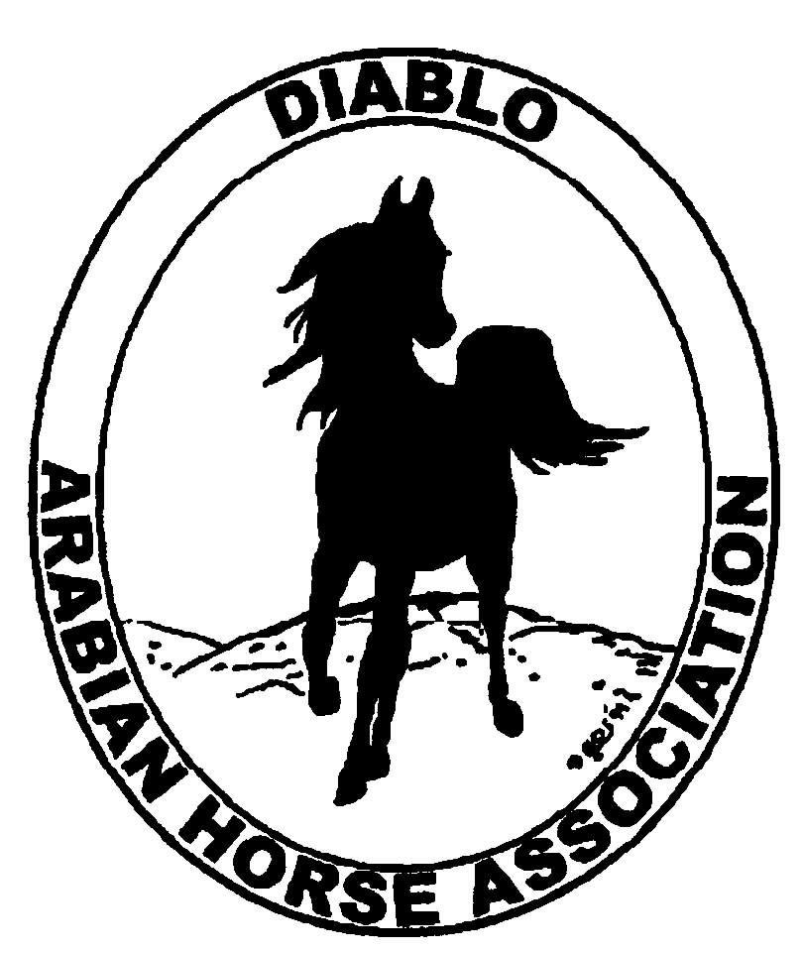
DIABLO ARABIAN HORSE ASSOCIATION
MINUTES –BOARD MEETING
February 4, 2014

Board Members Committee Members Delegates/Guests

Evelyn Call Dorothy Burt
Tammy Collins Coke Swift
Debbie Compilli
Amy Edwards
Pat Hendershot
Cory Soltau
Cindy Volz

Vice President Amy Edwards called the meeting to order at 7:06 p.m. The minutes of the January board meeting were reviewed. Pat Hendershot made a motion to approve the minutes, and Evelyn Call second. Motion carried.

Correspondence: No correspondence was presented

Calendar Review: Jan. 25, 2015 – Winter Banquet, Shadelands, Walnut Creek, 5 p.m.

Treasurer’s Report: Donna Bolla was absent but emailed the Treasurer’s Report as of January 31, 2014. Total Liabilities & Equity was $87,691.79. The Profit & Loss Operating statement for April through January 2014 included Total Income of $11,819.12 and Total Expense of $17,061.50 for a net of [$5,242.38]. Donna included an updated Profit and Loss Operating Budget Performance report. She sent Check Detail for January 2014 and the Horse Show Account Reconciliation Summary and Detail for January 2014.

COMMITTEE REPORTS

Awards Banquet: Debbie Compilli reported that we had another successful event. The income was a total of $7,483.16. The income of: dinner - $3,764, bar - $442.16 and raffle - $1,021; totaling $5,227.16 will go the banquet budget.
The silent auction raised $2,256 that will go to the High Point budget.
Cindy Volz will send in the photos that she took for the website. Tammy Collins suggested that Kasey Kreske’s video also be posted to the website. The board agreed to reserve Shadelands for the 2015 banquet.

Breed Awareness/Public Relations/Horse Faire: Cory suggested that we expand our promotion of the costume class at the 2014 Grand National. Discussion. Evelyn moved that the committee budget be increased to $1,500 for this event. Debbie second. Motion passed.

Convention: Nothing to report

Family Outreach: Debbie suggested that we change the format from written essays to videos. All entrants could be shown at the banquet. Discussion. Decided that all formats will be accepted: essays with photos, videos or slide shows.

High Point Program: Tammy has worked on revising the rules and entry forms for clarification. She and the committee will work to get this done before Scottsdale.

Horse Shows: Tammy handed out a flyer for the Showmanship Calcutta that has been added to the spring show. Discussion. Coke said that she is continuing to work on the show budgets.

Membership: Evelyn presented the DAHA Membership report with an AHA count as of Feb. 3, 2014. Member status is as follows:
Adult (1 yr.) 93
Adult (3 yr.) 25
Adult Life 6
Voting members 124

Associates 7
Youth 32

Total members 163

Newsletter/Web Site: Nothing to report.

Racing: Dorothy Burt said that the next meetings is on Feb. 15, at Harris Ranch. She and Evelyn will attend.

Trail Rides: No ride is scheduled.

Volunteer Awards: Discussion and it was decided to give a $100 gift certificate to a restaurant for the winner of the Friends of DAHA award. Cory will follow up on this.

Youth: Tammy reported that 20 youth attended the last youth meeting. An election of officers was held for their Youth Council. The meetings will be held quarterly.

Old Business: Discussion about the Board of Directors and Officers insurance policy. Coke will compile the additional information that the insurance company needs.

Coke will email a draft of the budget to committee chairs and the board of directors for their review.

New Business: Cindy Volz attended the Reg. III meeting on Jan 31. There was discussion about Reg. III’s participation at the 2014 Horse Expo. Margie Pope will chair that committee.
Sport Horse Regionals lost money.

Pat motioned to adjourn the meeting, Evelyn second. Motion carried. The meeting was adjourned at 8:50 p.m.

Respectfully submitted,

Debbie Compilli
Acting Secretary

