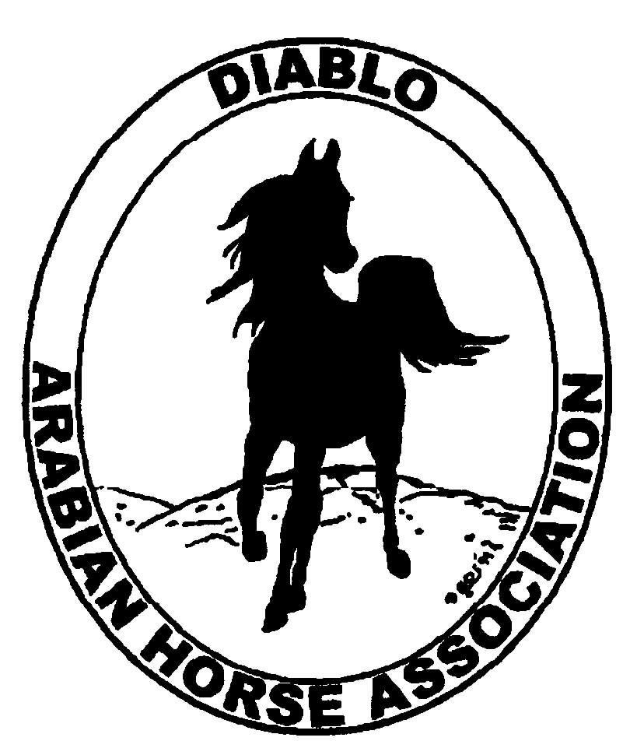
DIABLO ARABIAN HORSE ASSOCIATION
MINUTES –BOARD MEETING
March 4, 2014

Board Members Committee Members Delegates/Guests

Evelyn Call Dorothy Burt Jamie Seals
Tammy Collins Coke Swift
Debbie Compilli
Amy Edwards
Pat Hendershot
Jill Mitchell
Tracey Seals

President Jill Mitchell called the meeting to order at 7:10 p.m. The minutes of the February board meeting were reviewed. Evelyn Call made a motion to approve the minutes, and Pat Hendershot second. Motion carried.

Correspondence: Coke Swift has received some email inquiries regarding the spring horse show.

Calendar Review: April 10-13 – AHANC Horse Show, Rancho Murietta
April 18 – Reg. III meeting, Vacaville
July 5 – Sheik’s & Sheika’s Arabian Races, Pleasanton
Sept. 26-28 – Fall Show, Brookside
Oct. 24-25 – Costume Class, Grand National
Nov. 18-22 – AHA Convention, Denver
Jan. 25, 2015 – Winter Banquet, Shadelands, Walnut Creek, 5 p.m.

Treasurer’s Report: Donna Bolla was absent but emailed the Treasurer’s Report as of Feb. 28, 2014. Total Liabilities & Equity was $87,343.04. The Profit & Loss Operating statement for April through Feb. 2014 included Total Income of $18,356.28 and Total Expense of $24,480.41 for a net of [$6,124.13]. Donna included an updated Profit and Loss Operating Budget Performance report. She sent Check Detail for February 2014 and the Horse Show Account Reconciliation Summary and Detail for February 2014.

The February report was reviewed. Discussion regarding expense items that could be decreased or eliminated. Coke, Jill & Debbie will meet at the storage unit to clean it out and see if we can eliminate this expense.

COMMITTEE REPORTS

Awards Banquet: Debbie Compilli reported that the catering bill was $4,262.37; bringing total expenses to $5,751.68. The income total was $5,227.16 that will go the banquet budget. Our loss was [$524.52], which falls in line with our past performance.

Breed Awareness/Public Relations/Horse Faire: Tammy Collins continues to work on the TAIL program that will be in place at the spring show.

Convention: Nothing to report

Family Outreach: An eblast was sent out to the membership in Feb. reminding the club members about this program.

High Point Program: Tammy redesigned the entry form and rule booklet for clarification. Discussion about the rules and the booklet. She and the committee will work to have the booklets ready for the Golden Gate show at the end of March.

Horse Shows: Coke has been working on the proof of the premium book. She has received requests for the premium booklet. A horse show committee meeting was set for March 25, 6:30 p.m. Place to be determined.

Membership: Evelyn presented the DAHA Membership report with an AHA count as of March 3, 2014. Member status is as follows:
Adult (1 yr.) 93
Adult (3 yr.) 25
Adult Life 6
Voting members 124

Associates 7
Youth 32

Total members 163

Newsletter/Web Site: Meagan reported that the website is up to date as of Sunday evening. I have received some requests to add some events to our calendar including the GGF event and Grand National Rodeo. Tracey Seals provided me with the new 2014 High Point entry form that was posted on the High Point webpage. I still need the rest of the High Point documents to post. I updated the Family Arabian webpage with the new rules. She is working on the youth page with the Youth Committee.
I'm working on the March Newsletter, its a little light on content. It currently contains articles on Western Dressage Clinic, Western Dressage, Family Arabian, High Point Program, DAHA Day At the Races, Grand National Rodeo and an article I wrote about a DAHA Arabian's family tree. If anyone would like to add something to the newsletter, let me know.
I have worked with Tracey to send out a few e-blasts in the last month on the revised Family Arabian program, GGF Day at the Races, High Point, Youth Scholarship and Leadership, and Sylvia's Clinic and Performance. Sidney Simpson has requested that we send out an eblast on the Grand National Rodeo which I'll work on. Let Tracey and I know if you have anything that needs to be sent to the DAHA members by eblast.

Racing: Evelyn and Dorothy Burt attended the ARAC meeting on Feb. 15. Pleasanton Fair will have the first Arabian races in California in July 2014.

Trail Rides: Discussion about a ride to Barbeque Terrace when the weather is better.

Volunteer Awards: Nothing to report.

Youth: Tammy reported that the Pres. and Vice Pres. had their first meeting. Tammy will schedule a youth judging completion of two classes at each show this year.

Old Business: Discussion about the proposed budget. Evelyn made a motion that we approve it. Amy Edwards second. Motion passed.

New Business: Debbie reported that Christine Perry inquired about buying Whitey, the club’s life size horse model, for $500. She would allow DAHA to continue using him at their events. Discussion. Decided that DAHA will retain ownership and will allow Christine to continue displaying him, as well.

Pat motioned to adjourn the meeting, Tracey second. Motion carried. The meeting was adjourned at 8:40 p.m.

Respectfully submitted,

Debbie Compilli
DAHA Secretary

