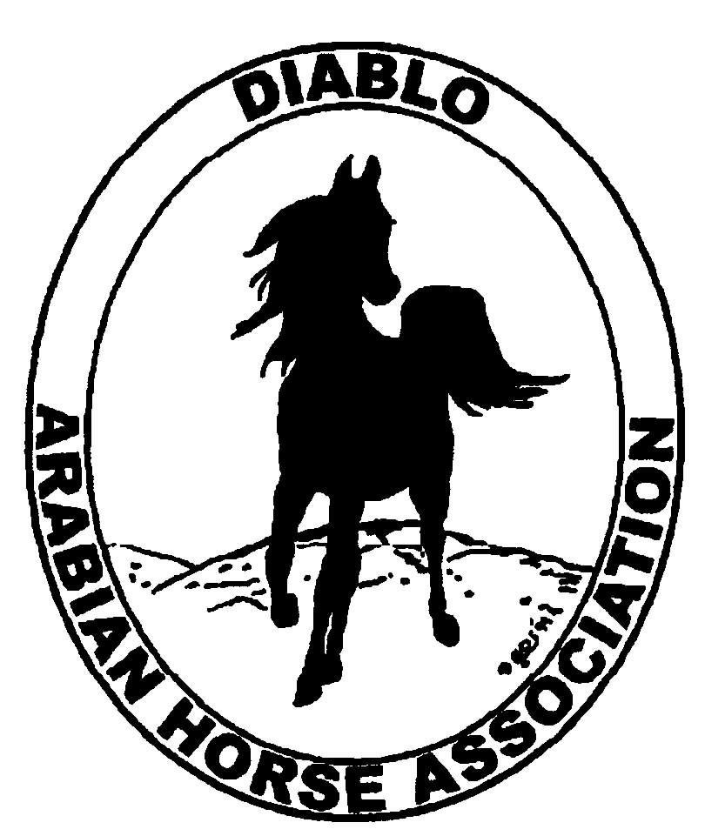
DIABLO ARABIAN HORSE ASSOCIATION
MINUTES –BOARD MEETING
April 1, 2014

Board Members Committee Members

Evelyn Call Dorothy Burt
Tammy Collins Coke Swift
Debbie Compilli
Amy Edwards
Jill Mitchell
Cory Soltau
Cindy Volz

President Jill Mitchell called the meeting to order at 7:10 p.m. The minutes of the March board meeting were reviewed. Evelyn Call made a motion to approve the minutes, and Amy Edwards second. Motion carried.

Correspondence: No correspondence.

Calendar Review: April 10-13 – AHANC Horse Show, Rancho Murietta
April 18 – Reg. III meeting, 7:00 p.m., Vacaville
July 5 – Sheik’s & Sheika’s Arabian Races, Pleasanton
Sept. 26-28 – Fall Show, Brookside
Oct. 24-25 – Costume Class, Grand National
Nov. 18-22 – AHA Convention, Denver
Jan. 25, 2015 – Winter Banquet, Shadelands, Walnut Creek, 5 p.m.

Treasurer’s Report: Donna Bolla was absent but emailed the Treasurer’s Report as of March 31, 2014. Total Liabilities & Equity was $87,373.49. The Profit & Loss Operating statement for April 2013 through March 2014 included Total Income of $19,061.28 and Total Expense of $25,037.96 for a net of [$5,976.68]. Donna included an updated Profit and Loss Operating Budget Performance report. She sent Check Detail for March 2014 and the Horse Show Account Reconciliation Summary and Detail for March 2014.

The March report was reviewed.

COMMITTEE REPORTS

Awards Banquet: Nothing to report at this time.

Breed Awareness/Public Relations/Horse Faire: Tammy Collins continues to work on the TAIL program that will be in place at the spring show. After that will be the costume class at the Grand National.

Convention: Cindy Volz had to resign as a club delegate. Megan Jenkins is the next alternate to replace Cindy.

Family Outreach: Nothing to report.

High Point Program: The rules have been updated. Tammy and Tracey will meet and finish the booklets for distribution at AHANC.

Horse Shows: The premium book is online at the DAHA website. Coke is already receiving entries. Coke will send out hard copies to trainers and any individual who requests it. We cannot have Western Dressage classes at the same show with recognized USDF classes, according to USDF. She is still looking for a judge for the FEI dressage classes. Dusty Morgan will judge the trail and reining. Coke asked for ideas for class prizes. Suggestions were: large buckets, tail bags, baby oil gel, quick braid & bands. Coke will call Kris Haigh about products from Ariat. She will call Janda for the ribbons and trophies. The buckles are ordered.
Jill suggested making pattern books to give out to exhibitors at check in. Tammy will give all trainers who are participating in the Showmanship Calacutta information packets about a month prior to the show.
Coke asked for every board member to get five class sponsors.

Membership: Evelyn presented the DAHA Membership report with an AHA count as of April 1, 2014. Member status is as follows:
Adult (1 yr.) 88
Adult (3 yr.) 24
Adult Life 6
Voting members 118

Associates 7
Youth 33

Total members 158

Newsletter/Web Site: Meagan reported that the March newsletter was sent out a couple of weeks ago. The website is up to date as of this week. I'm hoping to get the Horse Show Premium and entry from Coke in the next week to post to the website and work with Tracey to send out an e-blast about the horse show. At Coke's request I updated the horse show flyer on the website and sent some photos from the last spring and fall show for the premium book. I posted the sponsorship form this week to the website. I also need high point documents to post to the website. The show season has started and members will want to start sending in their competition points. I worked with Tracey to send out an eblast on the judging seminar, newsletter, membership renewal and Grand National Rodeo. I am working on putting together an eblast for the Family Arabian program, I would like to send out periodic reminders to our members.

Racing: Evelyn and Dorothy Burt will attend the Darly Awards in Hollywood on April 5—6.

Trail Rides: No trail ride is planned at this time.

Volunteer Awards: Cindy Volz has nominations for both AHA and Friends of DAHA awards.

Youth: Tammy reported that a Youth Directors Meeting has been planned on Saturday night during the AHANC show.

Old Business: Nothing to discuss.

New Business: Nothing to discuss.

Cory motioned to adjourn the meeting, Cind second. Motion carried. The meeting was adjourned at 8:40 p.m.

Respectfully submitted,

Debbie Compilli
DAHA Secretary

