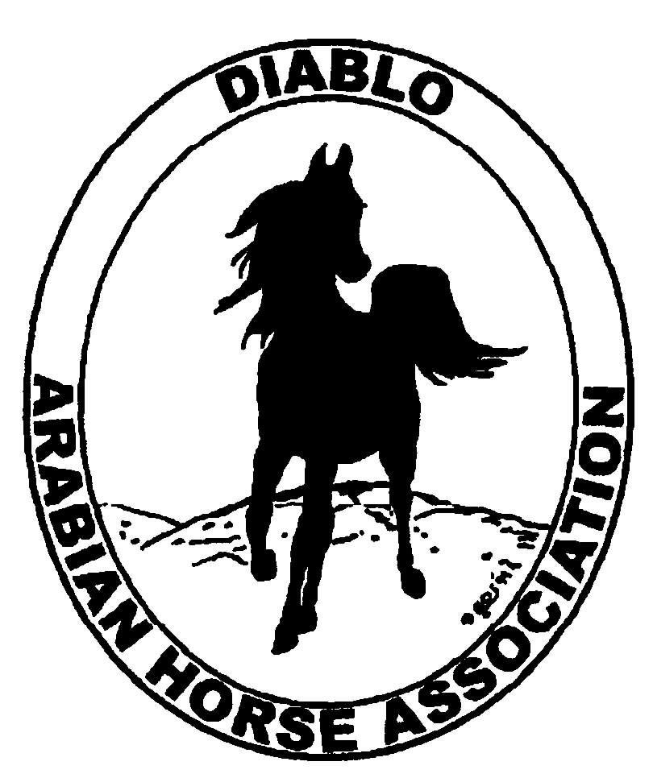
DIABLO ARABIAN HORSE ASSOCIATION
MINUTES –BOARD MEETING
April 4, 2017

Board Members Committee Members
Dorothy Burt Debbie Compilli
Evelyn Call Jill Mitchell
Tammy Collins
Marla Melloway
Joanna Mylin
Leigha Perry
Cindy Volz

President Tammy Collins, called the meeting to order at 7:11 p.m.

Tammy asked if there were any corrections to the minutes of the March board meeting.
Leigha made a motion to approve the March minutes. Evelyn second. Motion passed.

Correspondence: No correspondence received.

Calendar Review: March, June, Sept. & Dec. – Newsletter to be posted on website
April 8 – Reg. III meeting – 8 p.m. Vacaville
May 2 – Board Meeting – Comm. chairs will submit Club Excellence data
May 18-21 – DAHA Spring Show, Brookside
July 7-12 – Region III Championship Show, Rancho Murietta
July 13 – 16 – Region III Sport Horse Championship Show, Rancho Murietta
Sept. 29 – Oct. 1 – DAHA Fall Show, Brookside

Treasurer’s Report: Meghan had emailed the treasurer’s reports for March. The Total Net Assets are $124,723.13. Total Revenues of $62.00. Total Expenses of $2,307.90. The Change in Net Assets is ($2,245.90). Meghan also included the check detail for March 2017, the Statement of Activities for all accounts and the Budget-Actual Statements for both the spring and fall shows. Tammy asked if there were any questions with this month’s report. The treasurer’s report was reviewed and accepted.

COMMITTEE REPORTS

Awards Banquet: Tammy said that at the last meeting, two events were discussed. She asked if we wanted to have both of those events in 2017. One would be an extravaganza, held during the day in the summer. The other would be a High Point presentation with dinner and dancing and demonstrations using some of the High Point participants. Discussion and the Board decided to have only one event this year---the High Point banquet.

Breed Awareness/Public Relations/Horse Fair: Tammy will host an Open Barn at Earthquake Arabians, on Sat. June 10, from 10 a.m. to 3 p.m. Kevallyn Paskos will also participate as her barn is adjacent to Tammy’s. Tammy has arranged for National Horseman magazine to document the event. It will feature DAHA, the two barns and youth riders. Tammy asked Joanna to help with the advertising. Joanna will place a sponsored ad on Facebook. She will also look into a paid ad on PeachJar—a school oriented digital flyer, using Patch websites, the Claycord website and community calendars. Joanna volunteered to create a flyer for the Open Barn.
Dorothy brought the Club Excellence box with some data that she has already collected. She would like to add Keveallyn’s photos of the Jan. banquet and information on the Darly Awards.
Marla asked if DAHA was going to be involved at the Breeders’ Forum to be held at Sherman Ranch. Discussion and Tammy will talk to Jill Sherman about DAHA having a display. DAHA will offer to supply water bottles with DAHA information on them.

Convention: Nothing to report.

Family Outreach: Nothing to report.

High Point Program: The new forms and rules were reviewed and suggestions were made. Tammy will email them to all Board members for review. Then they will be emailed to all club members.

Horse Shows: Jill reported that Arabian Horse Global Network’s bill is going to be more than $1,500. Probably closer to $2,000. We had already added $3.00 per entry to help cover their fee. We could sell ad spots on our live feed. Jill will confirm how many spots we will receive. There will be one camera for the main arena and one roving camera.
CDS wrote to Coke that they are not approving breed shows any longer. Jill called Annette and she said ours is the fourth show that was declined that she knows about. Jill will call CDS and ask for a judgement.
Jill has gotten 21 buckle sponsors and is still working on more. The Trainer competition will be during the 20 minute break before the costume class on Sat. Debbie Canaday’s high point award presentation will be in the main arena at noon on Sunday. Mark Hill Equine Ins. will sponsor the ice cream social.
Leigha made a motion to hire Pam Bingham as the second arena announcer. Joanna second. Motion passed.

Membership: Evelyn’s report was as of April 4, 2017. Member status is as follows:

Adult 1 & 3 yrs. 93
Adult Life 10
Voting members 103

Associates 3
Youth 33
Total members 139

Newsletter: Evelyn will create the newsletter. She still is asking for all committee chairs to provide input for the newsletter.

Racing: Dorothy and Evelyn will attend the Cal. Horse Racing Board meeting to be held on April 6, at Golden Gate Fields. Dream Pearl is a Darly Award winner. She is owned by Dorothy, Evelyn, Cory and Terry Eaton.

Social Media/Website: Joanna reported that she is rebuilding our Facebook and Instagram accounts. She posted the Spring show flyer on the Arabian Horse Life Group’s page. Discussion about what type of items should be posted on Facebook. It was decided that news and event information is appropriate, but not advertisements. Joanna has posted on Facebook photos to Throw Back Thursday and information about Dream Pearl. The new website has been started. Joanna said it should be complete in 6 – 8 weeks.

Trail Rides: Nothing to report.

Volunteer Awards: Nothing to report.

Youth: Leigha said it was time for the Youth Club to elect new officers.

Old Business: Evelyn will talk to Megan Jenkins concerning the meetings she has missed and find out her intentions.
Evelyn moved that the Board approve the budget as it was discussed at the March meeting. Marla second. Motion passed.

New Business: Nothing to report.

Leigha made a motion to adjourn the meeting. Marla second. Motion passed. The meeting was adjourned at 9:07 p.m.

Respectfully submitted,
Debbie Compilli
DAHA Secretary

