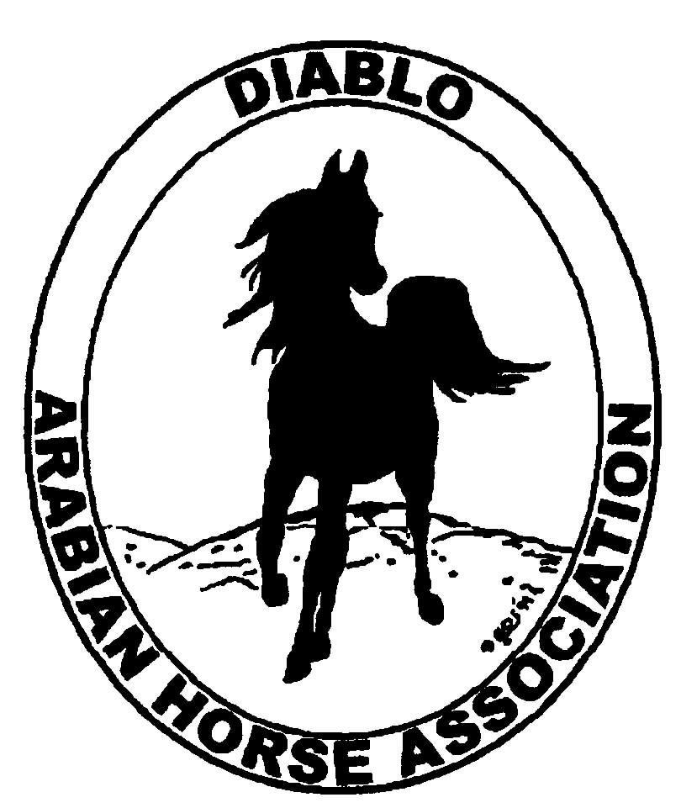
DIABLO ARABIAN HORSE ASSOCIATION
MINUTES –BOARD MEETING
May 6, 2014

Board Members Committee Members Guest

Evelyn Call Dorothy Burt Megan Jenkins
Tammy Collins Coke Swift
Debbie Compilli
Amy Edwards
Pat Hendershot
Tracey Seals
Cindy Volz

Vice President Amy Edwards called the meeting to order at 7:20 p.m. The minutes of the April board meeting were reviewed. Evelyn Call made a motion to approve the minutes, and Tracey Seals second. Motion carried.

Correspondence: Equisure sent a renewal form. Coke and Debbie will fill it out.

Calendar Review: May 15-18 – DAHA Spring Show, Brookside
July 5 – Sheik’s & Sheika’s Arabian Races, Pleasanton
Sept. 12 – Region III Meeting, Vacaville
Sept. 26-28 – Fall Show, Brookside
Oct. 24-25 – Costume Class, Grand National
Nov. 18-22 – AHA Convention, Denver
Jan. 25, 2015 – Winter Banquet, Shadelands, Walnut Creek, 5 p.m.

Treasurer’s Report: Donna Bolla was absent but emailed the Treasurer’s Report as of April 30, 2014. Total Liabilities & Equity was $99,450.49. The Profit & Loss Operating statement for April 2014 through April 2014 included Total Income of $680.00 and Total Expense of $575.00 for a net of $105.00. Donna included an updated Profit and Loss Operating Budget Performance report. She sent Check Detail for April 2014 and the Horse Show Account Reconciliation Summary and Detail for April 2014.

The April report was reviewed.

COMMITTEE REPORTS

Awards Banquet: Nothing to report at this time.

Breed Awareness/Public Relations/Horse Faire: The Walnut Creek Horse Faire was discussed. No one knew if it will be held again this year, or not.
The Horse Expo was discussed. Region III is in charge of the Arabian representation there.
Tammy Collins has been working on the TAIL program for the Spring Show. She will create a history for Whitey, the horse. There will be goodie bags for the kids. Tammy promoted our TAIL program at the Red Bluff show.

Convention: Nothing to report.

Family Outreach: Nothing to report.

High Point Program: The High Point brochure is done. 100 brochures will be available at the show.

Horse Shows: The entry numbers are down. The show budget was based on 280 horses. Coke projects the number of horses will be close to 240. Coke is still in need of a Technical Delegate for the 4th level dressage classes. She will call to see if those classes can be held without a T.D. There are 18 patrons. Jill Mitchell has lined up plenty of volunteers for the show. It was discussed and recommended that pattern books be provided to exhibitors prior to the start of the show.

Membership: Evelyn presented the DAHA Membership report with an AHA count as of May 4, 2014. Member status is as follows:
Adult (1 yr.) 81
Adult (3 yr.) 29
Adult Life 6
Voting members 116

Associates 7
Youth 34

Total members 157
Evelyn set out invitations that included flyers for the Spring Show to approximately 20 AHA members that are not affiliated with any local club.

Newsletter/Web Site: Meagan Johnson’s report is as follows: The website is up to date as of today. I updated the events page and posted the meeting minutes. A few weeks ago I posted the horse show documents to the website as well. I would like some assistance from our youth committee on updating the youth webpage. I think it’s also time to ask for some new photos to freshen up the photo album. Please let me know if there is anything that you would like me to post or update on the website.
I'm starting to come up with some ideas for the June newsletter. I plan to include an article on the DAHA Spring horse show, Horse Expo, Family Arabian program, maybe the TAIL program, High Point, DAHA Youth activities, GGF and Arabian racing. Let me know if you would like to submit an article for the newsletter.
I worked with Tracey this month on sending out an eblast on the Spring Horse show, GGF and the Castle Rock Schooling Show. I would like to put an eblast together to advertise the Family Arabian program this month. Please contact Tracey and me if you have anything you would like to have sent to the DAHA members by eblast.
A few people have asked me about the high point program. They are concerned that their points won't count for Scottsdale and Golden Gate Arabian Show since it’s been more than 30 days since those shows have ended. I propose that we update the attached reporting form and post it to the website while the booklet is still being working on so that people can at least submit the points they have. We also need to get the booklet finalized and posted and start advertising the program as soon as possible.

Racing: Evelyn and Dorothy Burt attended the Darly Awards in Hollywood on April 5—6. AHA Pres. Cynthia Richardson and AHA Vice Pres. Nancy Harvey were also in attendance. Evelyn said that it was a very elegant and well done event.
At the Alameda County Fair races, the Sheik’s race will have a $47,000 purse and the Sheika’s race will have a $40,000 purse.

Trail Rides: No trail ride is planned at this time.

Volunteer Awards: Cindy Volz reported the the deadline for nominations is July 31. Discussion about nominating a DAHA member for the Region III Volunteer award. Cindy will look into the qualifications for AHA’s Volunteer award.

Youth: Tammy reported that a Youth Directors Meeting was held at Ranch Murrieta. She got volunteers to help with the TAIL program and the Calcutta at Brookside. Tammy asked if she could have Youth T-shirts made and got the board’s approval.

Old Business: Nothing to discuss.

New Business: Nothing to discuss.

Evelyn motioned to adjourn the meeting, Cindy second. Motion carried. The meeting was adjourned at 8:50 p.m.

Respectfully submitted,

Debbie Compilli
DAHA Secretary

