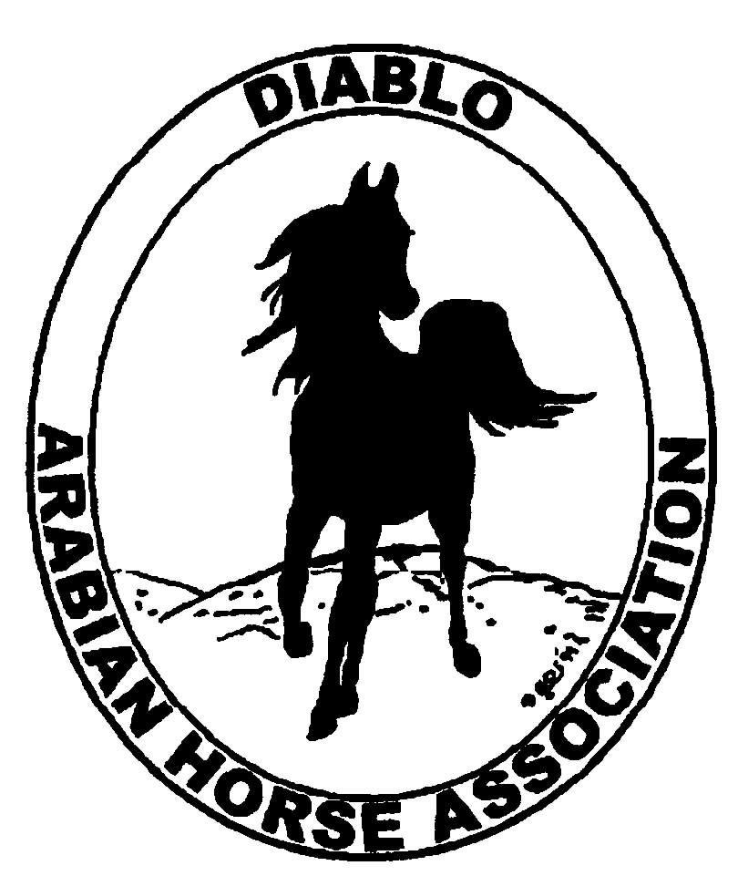
DIABLO ARABIAN HORSE ASSOCIATION
MINUTES –BOARD MEETING
May 8, 2017

Board Members Committee Members Guests
Dorothy Burt Debbie Compilli Kathy Campbell
Evelyn Call Jill Mitchell Kevallyn Paskos
Tammy Collins
Marla Melloway
Joanna Mylin
Cory Soltau

President Tammy Collins, called the meeting to order at 6:57 p.m.

Tammy asked if there were any corrections to the minutes of the April board meeting.
Dorothy made a motion to approve the April minutes. Evelyn second. Motion passed.

Correspondence: Cory received a letter from the I.R.S. granting an extension for our tax return.

Calendar Review: March, June, Sept. & Dec. – Newsletter to be posted on website
May 18-21 – DAHA Spring Show, Brookside
May 27 – Breeders’ Forum, Sherman Ranch, Pleasanton
June 4 – Work Day at Golden Gate Fields, Albany
June 10 – Open Barn, Earthquake Arabians, Clayton
July 7-12 – Region III Championship Show, Rancho Murietta
July 13 – 16 – Region III Sport Horse Championship Show, Rancho Murietta
Sept. 29 – Oct. 1 – DAHA Fall Show, Brookside

Treasurer’s Report: Meghan had emailed the treasurer’s reports for April. The Total Net Assets are $123,259.56. Total Revenues of $.03. Total Expenses of $1,593.31. The Change in Net Assets is ($1,593.28). Meghan also included the check detail for April 2017, the Statement of Activities for all accounts and the Budget-Actual Statements for both the spring and fall shows. Tammy asked if there were any questions with this month’s report. The treasurer’s report was reviewed and accepted.
Meghan had reminded the Board that the income for the Winter Banquet budget had not yet been determined. The Board discussed: income for the silent auctions is projected at $5,000. Income for the dinner is projected at $10,000. Total income for the budget is $15,000. Evelyn made a motion to add this item to the club’s annual budget. Cory second. Motion passed.
Cory proposed to raise the annual budget for the Day at the Races to $1,000. The funds will be used to promote Arabian racing throughout the year in our area and California. Cory made a motion to raise the budget for Day at the Races to $1,000. Dorothy second. Motion passed.

COMMITTEE REPORTS

Awards Banquet: The Banquet budget was discussed above. Nothing more reported.

Breed Awareness/Public Relations: DAHA will participate at the Breeders’ Forum to be held at Sherman Ranch on May 27. We will have a booth and supply water bottles with DAHA information on them. Tammy needs more volunteers to work at this event.
DAHA will work the snack bar at Golden Gate Fields on Sunday, June 4. More volunteers are always needed.
Earthquake Arabians and Kevallyn Paskos will host an Open Barn on Sat. June 10, from 10 a.m. to 3 p.m. Tammy has purchased DAHA signage which can be used at future events. Promotional material from AHA will be available for guests. Joanna volunteered to photograph the event. Tammy also needs more volunteers for this event.
DAHA will participate once again at the Grand National at the Cow Palace, Oct. 20 & 21, 2017. A new chairman is needed as both Cory and Tammy are unavailable this year.
AHA Club of the Year: Tammy wrote an article on our 2017 Winter Banquet and gave it to Dorothy. Joanna volunteered to write an article about our 2016 Fall Show. Tammy will create an article about our presentation at the 2016 Cow Palace.

Convention: Nothing to report.

Family Outreach: Nothing to report.

High Point Program: Tammy passed out the new High Point rules and entry form. They are ready to be mailed to DAHA members.

Horse Shows: Jill reported that Arabian Horse Global Network’s livestream was very well received at AHANC’s show. Jill has asked them to video the dressage and reining arenas as well as the main arena.
We have just under 200 horses entered to date. The Patron Packages are taken care of. Most of the buckles have been sponsored; only 3 or 4 more buckle sponsors are needed. The prizes and ribbons have been ordered. The volunteers are all scheduled.
We only have one photographer at this time. Tammy and Kevallyn are going to try and find a second photographer.
Discussion about reducing the number of high point awards given at our shows because it is so time intensive. Tammy suggested having printed cards ready to distribute to winners asking for their information for plaques. This would keep the trophies under our control and eliminate the problem of having the trophies returned in good condition each year.
Tammy requested that the Trainer Challenge be moved to the last class on Sat. She suggested holding a Calcutta for all trainers, with the proceeds being donated to DAHA’s Warrior Horses which will, in turn, support the Leukemia Lymphoma Society.
Jill talked to Robert Dehn, who designs the trail courses at Nationals. He charges $125 for a set of patterns. Discussion. The Board decided to use his patterns at our Fall show.

Membership: Evelyn’s report was as of May 1, 2017. Member status is as follows:

Adult 1 & 3 yrs. 95
Adult Life 10
Voting members 105

Associates 3
Youth 33
Total members 141

Newsletter: Nothing to report.

Racing: During the race meet at the Alameda County Fair, DAHA will sponsor a barn party to promote Arabian racing. DAHA will also sponsor one of the Arabian races.

Social Media/Website: Joanna reported that she has posted many articles and notices on our Facebook, Twitter and Instagram accounts. Some of the items already posted are: a flyer sized postcard for the Spring show; a flyer about the Open Barn at Earthquake Arabians on June 10; the Time to Ride program; posted on Facebook photos to Throw Back Thursday; information about Dream Pearl winning the Darby Award; and other educational articles. She will post information about our presentation at the Cow Palace in Oct. Joanna said that the number of followers is slowly increasing.
The new website has been started. Joanna said it should be completed in another month. In the Philanthropy section, she will provide information about the “Warrior Horses” and how they will help the children with leukemia and lymphoma.
Evelyn shared informative articles regarding website legal issues, protecting the website and copywriting the website.

Trail Rides: Nothing to report.

Volunteer Awards: Nothing to report.

Youth: Nothing to report.

Old Business: Nothing to report.

New Business: Evelyn presented a proposal for an Addition to DAHA Policies and Procedures. The Addition covers ownership, control and procedures regarding bank accounts and credit cards, websites and social media, account numbers, access codes and user names, PINs, and like issues. She had emailed this to all Board members on May 1, 2017, for their review. Tammy asked the Board if anyone had any questions or changes. None were presented. Evelyn made a motion to accept the new Addition to Policies and Procedures. Dorothy second. Motion passed.

Joanna made a motion to adjourn the meeting. Marla second. Motion passed. The meeting was adjourned at 8:49 p.m.

Respectfully submitted,
Debbie Compilli
DAHA Secretary

