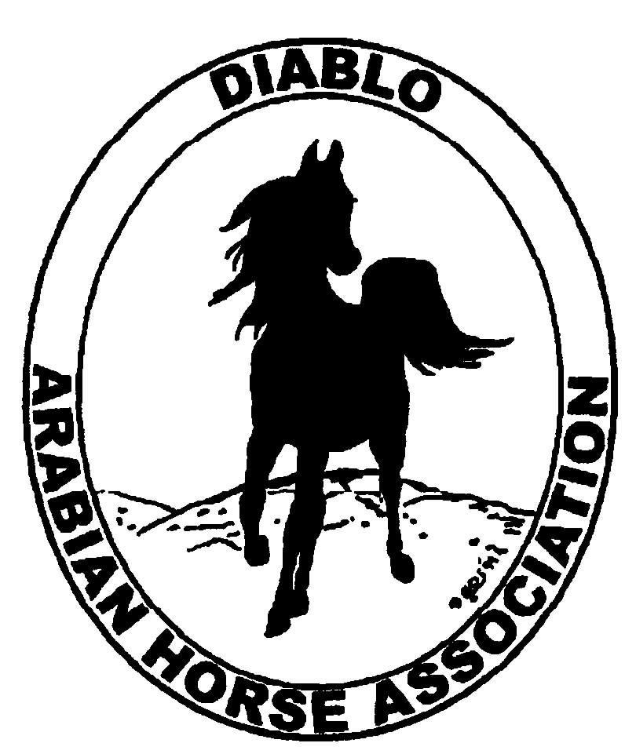
DIABLO ARABIAN HORSE ASSOCIATION
MINUTES –BOARD MEETING
June 10, 2014

Board Members Committee Members Guest

Evelyn Call Dorothy Burt
Tammy Collins Coke Swift
Debbie Compilli
Pat Hendershot
Jill Mitchell
Cory Soltau

President Jill Mitchell called the meeting to order at 7:35 p.m. The minutes of the May board meeting were reviewed. Evelyn Call saw two errors in spelling. They are corrected to: Sheikh’s and Sheikha’s. Pat made a motion to accept the minutes as corrected. Evelyn second. Motion carried.

Correspondence: There was no correspondence.

Calendar Review: July 5 – Sheikh’s & Sheikha’s Arabian Races, Pleasanton
July – Region III Meeting, during the Regional show
Sept. 12 – Region III Meeting, Vacaville
Sept. 26-28 – Fall Show, Brookside
Oct. 24-25 – Costume Class, Grand National
Nov. 18-22 – AHA Convention, Denver
Jan. 25, 2015 – Winter Banquet, Shadelands, Walnut Creek, 5 p.m.

Treasurer’s Report: Donna Bolla was absent but emailed the Treasurer’s Report as of May 30, 2014. Total Liabilities & Equity was $101,552.04. The Profit & Loss Operating statement for April 2014 through May 2014 included Total Income of $1,662.00 and Total Expense of $1,115.42 for a net of $546.58. Donna included an updated Profit and Loss Operating Budget Performance report. She sent Check Detail for May 2014 and the Horse Show Account Reconciliation Summary and Detail for May 2014.

Jill asked if there were any questions with this month’s report. The May report was reviewed.

COMMITTEE REPORTS

Awards Banquet: Nothing to report at this time.

Breed Awareness/Public Relations/Horse Faire: Tammy Collins was enthusiastic about the performance of the TAIL program at the spring show. The majority of the participants at the booth were non horsey people, which was the target audience.
Debbie reported that DAHA’s day at Golden Gate Fields was a very busy day. Total tips received were $122.

Convention: Nothing to report.

Family Outreach: Meghan Johnson wrote and Tracey Seals sent out an eblast to the general membership about the Family Arabian program.

High Point Program: The High Point brochures were delivered to the show.

Horse Shows: Coke reported that we had 238 horses entered at the spring show. 327 stalls were rented. She was able to hire a Technical Delegate for the dressage classes. Having the halter classes all on one day was well received. The new Calcutta class was a big success and a crowd pleaser. Next year, the trail classes need to be scheduled to start earlier in the morning. The Gunne Ranch donated the wine for one of the patron gifts.

Discussion of the fall show: Tammy discussed adding Academy classes to the schedule. It may be possible to hold those classes in the indoor arena. Coke is looking into adding Western Dressage classes to the schedule. Tammy suggested to add an “Octoberfest” beer tasting. Possibly with Bill providing brats for the event.

Membership: Evelyn presented the DAHA Membership report with an AHA count as of June 9, 2014. Member status is as follows:
Adult (1 yr.) 73
Adult (3 yr.) 32
Adult Life 6
Voting members 111

Associates 8
Youth 35
Total members 154

Evelyn said that she received two responses to the invitations that she sent out to the AHA members that are not affiliated with any local club. Pat will ask Debbie Fuentes if other clubs membership numbers are also decreasing.

Newsletter/Web Site: Meagan Johnson’s report is as follows: The website is up to date as of today. I added some new events to the events page, updated the horse show webpage, and posted a photo of Debbie's mom to the DAHA Hall of Fame webpage. Please let me know if you would like anything posted to the website. I'm hoping we can post the 2014 High Point Booklet soon once it’s been finalized.

I'm currently working on the June newsletter. I'm looking for articles on the Spring horse show, TAIL program, DAHA Youth activities, and Golden Gate Fields. The newsletter is a little light on content so please let me know if you have any suggestions or would like to submit an article.

I worked with Tracey to send out e-blasts in May to the DAHA members on Golden Gate Fields, the TAIL program at the DAHA Spring horse show, Native Costume at Grand National Rodeo. This week, we are going to send an e-blast about the High Point Program and the Family Arabian Recognition Program.

Racing: Dorothy Burt reported that because of the past promotional work that DAHA has done for the Arabian racing at the Fair, Jeannie Wasserman, head of racing at the Alameda County Fair, has given DAHA the sponsorship of the second race on June 21.
The Sheikh and Sheikha’s races will be on July 5.

Trail Rides: Discussion about having a ride starting at Machedo Gate in Danville and going to Barbeque Terrace.

Volunteer Awards: Nothing to report.

Youth: Tammy reported that the youth made $1,300 from the Calcutta at the spring show. The youth are planning on having a DAHA fun night during the Region III show. Tammy had 32 Youth T-shirts made and has 12 left. She will have a newly designed T-shirt ready for the fall show.
Donna Bolla notified the board that it will be necessary to set up a new checking account for the youth. Evelyn Call made a motion for the club to open a checking account for the Youth Fund. Pat Hendershot second. Motion passed.

Old Business: Debbie talked to Linda Walsh about the possibility of DAHA hosting the Pacific Slope performance classes. The 2015 shows have already been chosen. Discussion. Debbie will go back to Linda for information regarding the specifications required to host the classes.

New Business: Shady Schneider, of the Murieta Equestrian Center, emailed some of the board members asking for DAHA to consider moving our shows to their facility. Discussion. Jill will contact her and ask for a bid.

Evelyn motioned to adjourn the meeting, Tammy second. Motion carried. The meeting was adjourned at 9:00 p.m.

Respectfully submitted,

Debbie Compilli
DAHA Secretary

