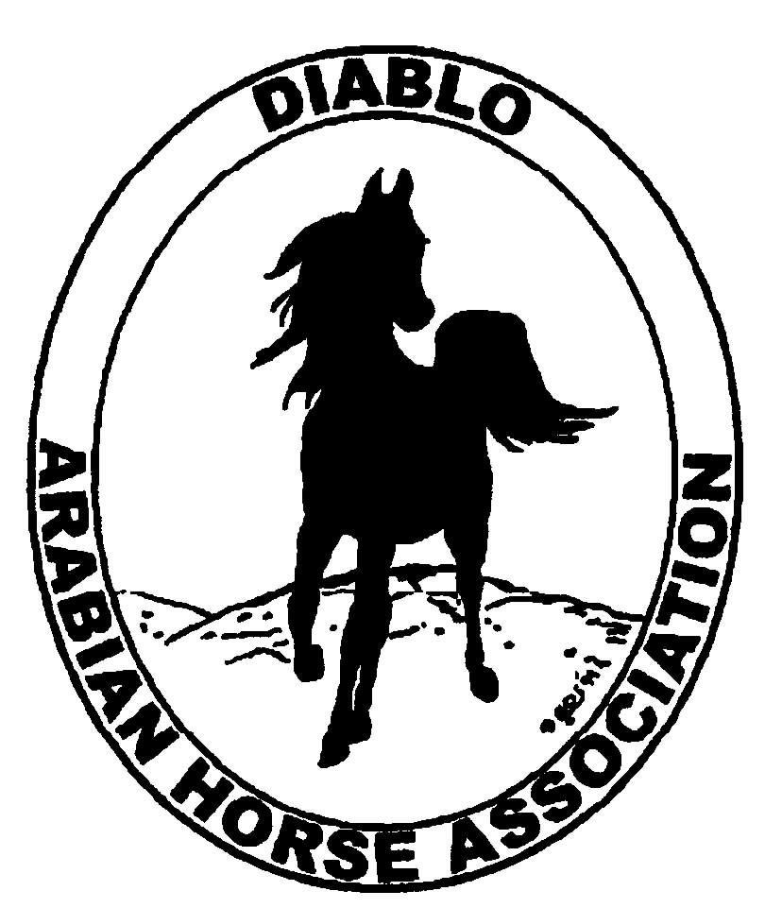
DIABLO ARABIAN HORSE ASSOCIATION
MINUTES –BOARD MEETING
June 6, 2017

Board Members Committee Members Guests
Dorothy Burt Debbie Compilli
Evelyn Call Meghan Skilling
Tammy Collins Jill Mitchell
Marla Melloway
Joanna Mylin
Leigha Perry

President Tammy Collins, called the meeting to order at 7:14 p.m.

Tammy asked if there were any corrections to the minutes of the May board meeting. Joanna had a correction on the Social Media report. It should have said: The new website has not been started yet. The site design has been delayed. Dorothy made a motion to approve as corrected, the May meeting minutes. Marla second. Motion passed.

Correspondence: Joanna received a note and a photo disc from Rob and Pam Hess regarding candid photos taken at the Spring Show.
Debbie received an email today from Linda Seigel asking for volunteers for the Horse Expo. this weekend.

Calendar Review: June 10 – Open Barn, Earthquake Arabians, Clayton
July 7-12 – Region III Championship Show, Rancho Murietta
July 13 – 16 – Region III Sport Horse Championship Show, Rancho Murietta
Sept. 29 – Oct. 1 – DAHA Fall Show, Brookside
Oct. 20 & 21 – Grand National, Cow Palace

Treasurer’s Report: Meghan had emailed the treasurer’s reports for May. The Total Net Assets are $138,393.31. Total Revenues of $97,133.84. Total Expenses of $82,000.09. The Change in Net Assets is $15,133.75. Meghan also included the check detail for May 2017, the Statement of Activities for all accounts and the Budget-Actual Statements for both the spring and fall shows. Tammy asked if there were any questions with this month’s report. The treasurer’s report was reviewed and accepted.
Meghan reported she two checks from the spring show had been returned because of insufficient funds.

COMMITTEE REPORTS

Awards Banquet: Tammy said she had asked Jill Sherman about using their ranch for our banquet. Jill was not sure if it would be available. Tammy said that we should explore other venues. The next banquet will possibly have dancing. Dorothy suggested the Pleasant Hill Community Center. Discussion about advantages in pricing if DAHA had a non-profit status. Meghan will look into applying for the 501(c)3 status.

Breed Awareness/Public Relations: Earthquake Arabians and Kevallyn Paskos Open Barn will be on Sat. June 10, from 10 a.m. to 3 p.m. Tammy said there will be horse demos. and activity stations for visitors to utilize. Tammy also needs more volunteers for this event.
AHA Club of the Year: Dorothy said that the binders are due in August. She would like to have a data gathering workshop before the next board meeting. The two binders being created are Breed Promotion and Community Development.

Convention: Nothing to report.

Family Outreach: Nothing to report.

High Point Program: Leigha has received four entries. She will send out an eblast to past participants to promote the program.

Horse Shows: Jill reported that the show went well. 211 horses entered. Marla and Kathy Campbell ran the dressage and sport horse-in hand arenas very efficiently. Riders and staff were happy with their time saving ideas. Jill would like to designate Marla and Kathy to organize the sport horse and western dressage, with Annette, at the fall show.
Suggestions for next year: Move the sport horse-riding classes to another time.
She regretted informing us that Ann Lang had recently passed away. Ann had done the typesetting of both the premium and program for the past few years. Melanni has a suggestion for a person to use in her place. The board approved using Melanni’s recommendation.
Jill recommended using Debbie Wiegmann to announce the 2nd arena, as she had done previously. The board approved.
Discussion about whether or not to use AHGN for the fall show. They charge $3.00 per horse, plus travel, hotel, food and special equipment.
It was suggested that we use a different farrier at our future shows.

Membership: Evelyn’s report was as of June 5, 2017. Member status is as follows:

Adult 1 & 3 yrs. 92
Adult Life 10
Voting members 102

Associates 2
Youth 32
Total members 136

Newsletter: Nothing to report.

Racing: Leigha is working on having a television reporter do a story on Arabian racing at the Alameda Co. Fair.

Social Media/Website: Joanna reported that she’s been promoting DAHA on Facebook, Instagram, Twitter and Vimeo. She posted both Hess’ and her own photos from the spring show. She shared posts by Arabian Horse Global Network from the show. She posted the foal presentation from the Sherman’s Breeders Forum.
Joanna created a flyer for promotion of DAHA’s participation at the Grand National in Oct.
Joanna contacted Arabian Horse Times and AHGN about creating a website for us as Arabian Synergy is no longer our website designer.
Joanna asked for clarification on our high point program’s email address.

Trail Rides: Nothing to report.

Volunteer Awards: Nothing to report.

Youth: Nothing to report.

Old Business: Nothing to report.

New Business: Nothing to report.

Leigha made a motion to adjourn the meeting. Evelyn second. Motion passed. The meeting was adjourned at 9:00 p.m.

Respectfully submitted,
Debbie Compilli
DAHA Secretary

