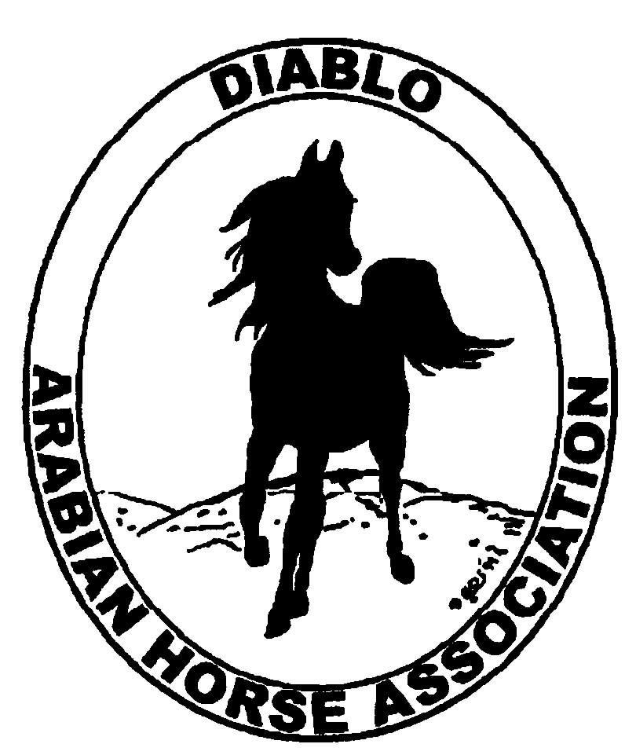
DIABLO ARABIAN HORSE ASSOCIATION
MINUTES –BOARD MEETING
July 1, 2014

Board Members Committee Members Guest

Evelyn Call Dorothy Burt
Tracey Seal Coke Swift
Evelyn Call
Pat Hendershot
Cindy Volz
Cory Soltau

Vice-President Amy Edwards called the meeting to order at 7:31 p.m. The minutes of the June board meeting were reviewed and approved.

Correspondence: Terri Moody of Vintage Horse Association sent an invitation to a show they are hosting at Ranchotel on August 10th, 2014. No response required.

Calendar Review: August 10 – Vintage Horse Association Schooling Show at Ranchotel
July – DAHA Nominate Board and Committee Members
Sept. 12 – Region III Meeting, Vacaville
Sept. 26-28 – Fall Show, Brookside
Oct. 24-25 – Costume Class, Grand National
Nov. 18-22 – AHA Convention, Denver
Jan. 25, 2015 – Winter Banquet, Shadelands, Walnut Creek, 5 p.m.

Treasurer’s Report: Donna Bolla was absent but emailed the Treasurer’s Report as of June 30, 2014.

Amy asked if there were any questions/Comments with this month’s report. Feedback from Coke Swift is that she likes the shortened version sent along with the complete version for this month. The June report was reviewed.

COMMITTEE REPORTS

Awards Banquet: Nothing to report at this time.

Breed Awareness/Public Relations/Horse Faire: The upcoming Sheik’s race at the Alameda County Fair is a focus for Dorothy Burt and Evelyn Call
- Native Costume is scheduled for July 5th with 3 horses riding.
Convention: Timing is such that Jill Mitchell should be receiving information from AHA on attendance/delegates.

Family Outreach: Nothing to report

High Point Program: Nothing to report

Horse Shows: Per Coke Swift, profit for the Spring Show is projected at $1800.00. Overall, DAHA had 41 less horses than forecasted which is 29 less than last year. Discussion that DAHA Shows are a lot of work for not much financial return . DAHA might look to ideas such as adding an “Office Fee per Horse” or “Office Fee per Owner” as a means to increase revenue. No decision nor motion made. DAHA still needs a main ring judge for Fall Fling.

Membership: Evelyn proposed put forth adding a membership “category” for Associate Member. This would need to be included in the ballot for Board of Directors as it would change DAHA By-Laws. There was a motion to add this to the next election and the motion was seconded. Motion carries.

Newsletter/Web Site:
The website is updated as of this week. I received some requests to remove some classified ads. I updated the events page, added the high point forms, new meeting minutes and the June newsletter. Please let me know if you need anything posted to the website.
I assisted Tracey with sending out a couple of e-blasts in June including an e-blast on the High Points and the June newsletter. I would like to send out another High Point e-blast after the Region III Championship show. Please let us know if you need anything sent to the DAHA members by e-blast.
I would like to request assistance from the Youth committee to update the DAHA Youth page. Please let me know their recommendations.
I plan on working on the Club Excellence project starting this month if the Board would like me to proceed with this. If so, I will need to ask assistance from the DAHA Chairs to update existing entries and create new entries. This also includes any supporting documentation like videos, photos, flyers, etc.

Racing: No updates other than Sheik and Sheika’s race on July 5th.

Trail Rides: Nothing to report

Volunteer Awards: Nothing to report.

Youth: Bank account opened by Donna Bolla for the $1300 raised at the Spring Show Calcutta. No other business to report

Old Business: Nothing to repot.

New Business: Nothing to report

Evelyn motioned to adjourn the meeting, Tracey second. Motion carried. The meeting was adjourned at 8:58 p.m.

Respectfully submitted,

Tracey Seals
Interim DAHA Secretary

