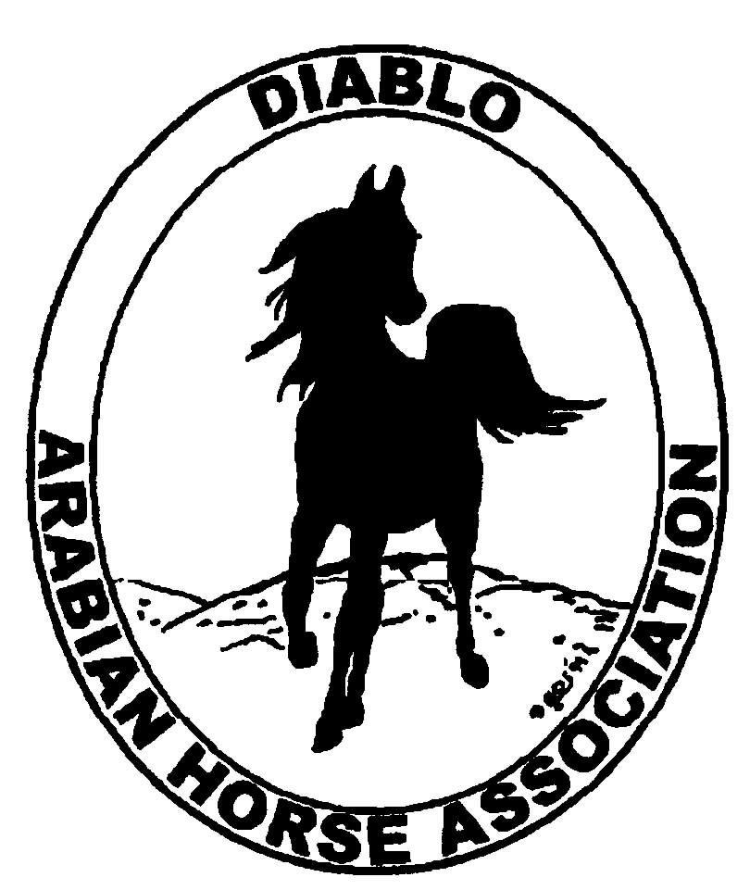
DIABLO ARABIAN HORSE ASSOCIATION
MINUTES –BOARD MEETING
July 5, 2016

Board Members Committee Members
Dorothy Burt Meghan Skilling
Evelyn Call Coke Swift
Debbie Compilli
Jill Mitchell
Cory Soltau

President Cory Soltau, called the meeting to order at 7:15 p.m.

Cory asked if there were any corrections to the minutes of the June board meeting. Jill made a motion to approve the minutes. Dorothy second. Motion passed.

Correspondence: Nothing received this month

Calendar Review: March, June, Sept. & Dec. – Newsletter to be posted on website
Sept. 30-Oct. 2 – Fall Show, Brookside
Nov. 16-19 -- AHA Convention, Denver

Treasurer’s Report: Meghan emailed the treasurer’s reports for June. The Total Net Assets are $135,538.01. Total Revenues of $31,041.04. Total Expenses of $7,812.84. The Change in Net Assets is $23,228.20. Meghan also included the check detail for June 2016, the Statement of Activities for all accounts and the Budget Actual Statements for both the spring and fall shows. Cory asked if there were any questions with this month’s report. Discussion. The report was reviewed and accepted.

COMMITTEE REPORTS

Awards Banquet: Nothing to report.

Breed Awareness/Public Relations/Horse Fair:
Grand National – The CEO of the Cow Palace contacted Cory to confirm our involvement at the October event.

Convention: The delegates need to confirm their reservations. Coke will follow up with Pat about that.

Family Outreach: Nothing to report at this time.

High Point Program: Nothing to report.

Horse Shows: Coke gave Meghan additional checks to deposit, and there are some additional expenses. The preliminary figures are showing a profit. The final accounting should be ready by the August Board meeting.
Discussion about what made this show more successful. It had been budgeted for 200 horses. We had 261 horses. Having the premium on the website sooner.
For 2017, the schedule needs to be fine-tuned. The Disney theme was very popular.
For the Fall show, the premium should be posted to our website by the end of July.

Membership: Evelyn gave the DAHA Membership report with an AHA count as of July 3, 2016. Member status is as follows:
Adult (1 yr.) 69
Adult (3 yr.) 36
Adult Life 9
Voting members 114

Associates 1
Youth 32
Total members 147

Evelyn is working on the club directory and is planning on having it out in July.

Newsletter: Nothing to report

Website: Discussion and the Board agreed that we need to create a survey and ask Tracey to eblast it to our members. Once we have responses, we can move forward with updating the website.
Items that the Board would like to have added:
Banner for Western Saddlery and other corporate sponsors
Add links to popular websites:
Region III AERC ARACA
AHA USDF CDS
USEF Discovery Farms
There should be an expiration date on classified ads.

Racing: Photos were shared of the Arabian races at the Alameda County Fair. Leigha Perry and Brittany Gordon wore native costumes for their exhibition.

Trail Rides: Nothing to report.

Volunteer Awards: Nothing to report.

Youth: Nothing to report.

Old Business: Cory will follow up with Tracey and Tammy regarding our Club of the Year entry.

New Business: Cory said that it is time to form a nominating committee for next year’s Board nominees. Dorothy, Leigha, Evelyn and Cory will remain on the Board. Debbie, Tammy, Megan, Tracey and Jill will go off.

Jill motioned to adjourn the meeting. Dorothy second. Motion carried. The meeting was adjourned at 8:38 p.m.

Respectfully submitted,

Debbie Compilli
DAHA Secretary

