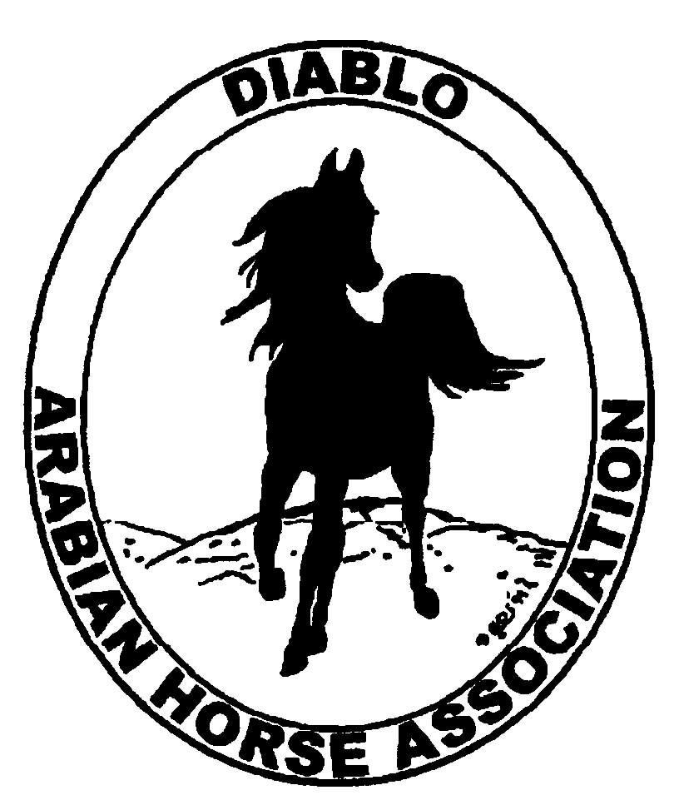
DIABLO ARABIAN HORSE ASSOCIATION
MINUTES –BOARD MEETING
August 1, 2017

Board Members Committee Members
Dorothy Burt Debbie Compilli
Evelyn Call
Marla Melloway
Joanna Mylin
Leigha Perry
Cory Soltau
Cindy Volz

Vice President Evelyn Call, called the meeting to order at 7:12 p.m.

Evelyn asked if everyone had reviewed the minutes of the July board meeting. Cory made a motion to approve the July meeting minutes. Leigha second. Motion passed.

Correspondence: Nothing received.

Calendar Review: Sept. 29 – Oct. 1 – DAHA Fall Show, Brookside
Oct. 20 & 21 – Grand National, Cow Palace

Treasurer’s Report: Meghan emailed the June treasurer’s report to all Board members on July 15. The treasurer’s report was reviewed and accepted.

COMMITTEE REPORTS

Awards Banquet: Joanna had several ideas for next year’s banquet. She thought the theme could be, “Around the World of Arabian Horses.” Each table would have a theme based on Arabian horse top breeders around the world. She can utilize YouTube videos that are available for various stallions. Joanna suggested having Rory O’Neil be our emcee and speaker for the night as he was just in France and Italy visiting Arabian horse farms. We also could have photographer Johnny Johnston talk about his history in the breed.
Locations could be Heather Farms or Earthquake Arabians in a tent; the Pleasant Hill Community Center; or Campos Winery in Byron.
Evelyn suggested emailing information on the venues to the Board during the next few weeks.

Breed Awareness/Public Relations: AHA Club of the Year: Evelyn reported that they had a good meeting preparing the binders. She has a few things to finish up and plans to mail it to AHA by Aug. 4.
Joanna said that advertisements for Grand National have already started.

Convention: Nothing to report.

Family Outreach: Nothing to report.

High Point Program: Leigha will be sending an eblast to past participants within the next week. She has 7 entries so far. Evelyn will send an eblast to the general membership to encourage participation.

Horse Shows: Debbie reported that Candace Zeier will be judging trail, reining and ranch riding. She lives in Colorado but will not charge us for her flight, as she works for an airline.
Jill is in favor of having the Live Global at the spring 2018 show. Each exhibitor paid $3.00 per horse, and they are expecting this extra service. Discussion. The Board agreed to have them again next year.
For the Fall show, Joanna suggested utilizing a Nest camera to supply live stream for the Fall show. Cost is approximately $200.00. She will investigate about whether exhibitors would be able to access it for playback at a later time.

Membership: Evelyn’s report was as of August 1, 2017. Member status is as follows:

Adult 1 & 3 yrs. 100
Adult Life 10
Voting members 110

Associates 2
Youth 31
Total members 143

Newsletter: Joanna emailed the Board on July 26, asking each Board member and committee chair to write a short paragraph about their activities so our newsletter can be active and current again.

Racing: Arabian racing will be at the Alameda Co. Fairgrounds, Pleasanton, for six days in Sept.

Social Media/Website: Joanna sent the DAHA Articles of Incorporation to Facebook to verify our account. She linked the Facebook and Instagram accounts. She contacted past President Linda Grimoldi and will be getting club archives from Linda. She covered both Reg. III and Youth Nationals and continued promoting DAHA through new posts.
Joanna continued consulting with Leah at Arabian Horse Global on the content of our new website.

Trail Rides: Nothing to report.

Volunteer Awards: Debbie will check into the deadline for nominating club members for the AHA award.

Youth: Joanna suggested putting on a clinic about desireable horse conformation for different styles of use: western, english, hunter, etc.

Old Business: Joanna looked into the fees charged by three different companies to obtain DAHA’s nonprofit 501(c)(3) status. Cory made a motion for Joanna to look into this with a maximum budget of $500. Cindy second. Motion passed.

New Business: Nominations for the Board were discussed and these people were suggested: Lisa Dillon, Kathy Campbell, Kevallyn Paskos, Amy Saunders, Katy Dubnoff, Leigha Perry, Dorothy Burt and Jill Mitchell. Marla will contact Kathy, and Leigha will call the rest to see if they are willing to run.

Dorothy made a motion to adjourn the meeting. Cindy second. Motion passed. The meeting was adjourned at 9:02 p.m.

Respectfully submitted,
Debbie Compilli
DAHA Secretary

