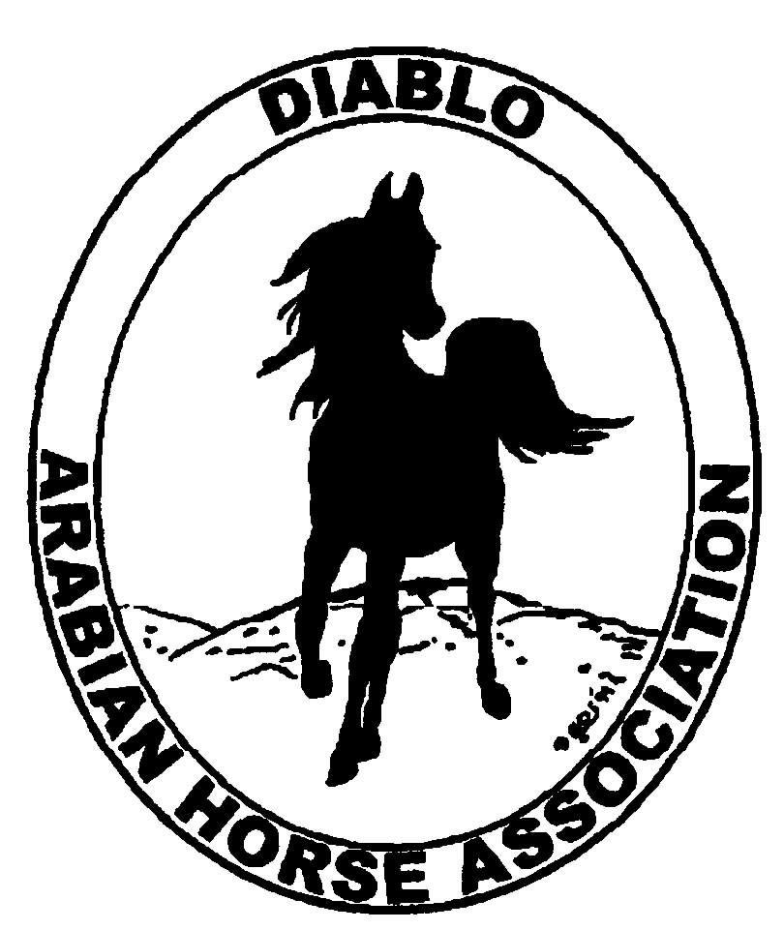
DIABLO ARABIAN HORSE ASSOCIATION
MINUTES –BOARD MEETING
August 5, 2014

Board Members Committee Members Guest
Evelyn Call Dorothy Burt Megan Jenkins
Tammy Collins
Debbie Compilli
Pat Hendershot
Cory Soltau

Board Member and past President, Pat Hendershot, called the meeting to order at 7:15 p.m. The minutes of the July board meeting were reviewed. Evelyn made a motion to approve the minutes, Cory second. Motion carried.

Correspondence: No correspondence

Calendar Review: Aug. 10 – Vintage Horse Assn. Schooling Show, Ranchotel
Aug. 24 – Brown Ranch Schooling Show, Pleasanton
Sept. 12 – Region III Meeting, Vacaville
Sept. 26-28 – Fall Show, Brookside
Oct. 24-25 – Costume Class, Grand National
Nov. 18-22 – AHA Convention, Denver
Jan. 25, 2015 – Winter Banquet, Shadelands, Walnut Creek, 5 p.m.

Treasurer’s Report: Donna Bolla was absent but emailed the Treasurer’s Report as of July 31, 2014. Total Liabilities & Equity was $97,128.41. The Profit & Loss Operating statement for April 2014 through July 2014 included Total Income of $1,787.00 and Total Expense of $2,046.86 for a net of -$259.86. Donna included an updated Profit and Loss Operating Budget Performance report. She sent Check Detail for July 2014 and the Horse Show Account Reconciliation Summary and Detail for July 2014.

Pat asked if there were any questions with this month’s report. The July report was reviewed.

COMMITTEE REPORTS

Awards Banquet: Debbie asked if we should consider having a speaker at this year’s event. Discussion. It was decided that the available time during the evening was too short. Most of the general members enjoy the opportunity to socialize. The recommendation was to not add a speaker to the schedule.

Breed Awareness/Public Relations/Horse Faire: AHA Club Excellence Entry – Meghan has asked most committee chairs to send their missing reports to her. Tammy has volunteered to gather reports from the various committee chairs, compile them and send the information on to Meghan.
Horse Expo 2015 – Tammy is on the Reg. III committee. Discussion on how DAHA can contribute to the Arabian horse experience. Megan Jenkins and Tammy volunteered to bring their Native Costume horses once again. And they will offer their assistance to Margie Polk.
Golden Gate Fields – Debbie asked where the club would like to donate the $122 in tip money from the May Day at the Races. Discussion. It was decided to give it to the Equine Hospital at U.C. Davis. She also asked about how the club wanted to use the $1,000 received from our day at the snack bar. Discussion. Decision that since the Spring Show had such a small profit, we should keep that money to be used for general expenses.

Convention: Jill has received the AHA registration packet. She will mail it to Pat for completion.
Evelyn presented her resolution that will be sponsored by DAHA. The resolution would add Youth members to the delegate count of AHA member clubs. Discussion. Evelyn made a motion that DAHA sponsor this resolution. Cory second. Motion passed.

Family Outreach: Nothing to report

High Point Program: Nothing to report

Horse Shows: Pat reported for Coke. The profit for the Spring Show may be slightly higher. The final report is not yet in. Coke is working on hiring a second judge for the Fall show. The premium book has not been completed yet. Coke would like to have a show committee meeting in August. Discussion. The board would like the premium sent out as soon as possible. Debbie will contact Coke about a show committee meeting date.

Membership: Evelyn presented the DAHA Membership report with an AHA count as of July 31, 2014. Member status is as follows:
Adult (1 yr.) 77
Adult (3 yr.) 32
Adult Life 6
Voting members 115
Associates 6
Youth 37
Total members 158

Newsletter/Web Site: Meghan sent in her report: The website is up to date as of today. I received a classified ad to post to the website by at DAHA member and photos of the recent Sheik horse racing event. I updated events page according to the July meeting minutes. I have not received any response from my last report to the board so the youth web page has not been updated and I do not plan to submit any Club Excellence entries.

Tracey and I did not send out any e-blasts in July but we will be sending out an e-blast shortly to remind members about the High Point program. If I can get a tabulation of the current high point entries, I will post it to the website. I will also try to put together another Family Arabian reminder e-blast this month.

I hope to start working on the September newsletter this month and get it out before I leave for Spain mid-September.

Racing: The remaining races for 2014 are as follows: Sonoma County Fair, Ferndale Fair, L.A. County Fair at Los Alamitos, Stockton and Fresno. For 2015, the three Sheika’s races will be in Houston, Pleasanton and Los Alamitos with a purse of $45,000 each.

Trail Rides: Nothing to report

Volunteer Awards: Nothing to report.

Youth: Megan and Tammy reported that the Region III golf cart at Youth Nationals was beautifully decorated. Tammy has sold 30 t-shirts, with proceeds going to the DAHA Youth.

Old Business: Cory reported that he is working with Sidney Simpson on the Costume Class for the Cow Palace in Oct.

New Business: Nominations for the 2015 DAHA Board of Directors for the six vacancies was discussed. Suggestions for nominees were: Evelyn Call, Tammy Collins, Debbie Compilli, Megan Jenkins, Tracey Seals, Stacey Smith and Cory Soltau. Evelyn moved that we accept the above nominees. Cory second. Motion passed. Debbie will issue a letter to the membership regarding the upcoming election.

Cory motioned to adjourn the meeting, Evelyn second. Motion carried. The meeting was adjourned at 8:55 p.m.

Respectfully submitted,

Debbie Compilli
DAHA Secretary

