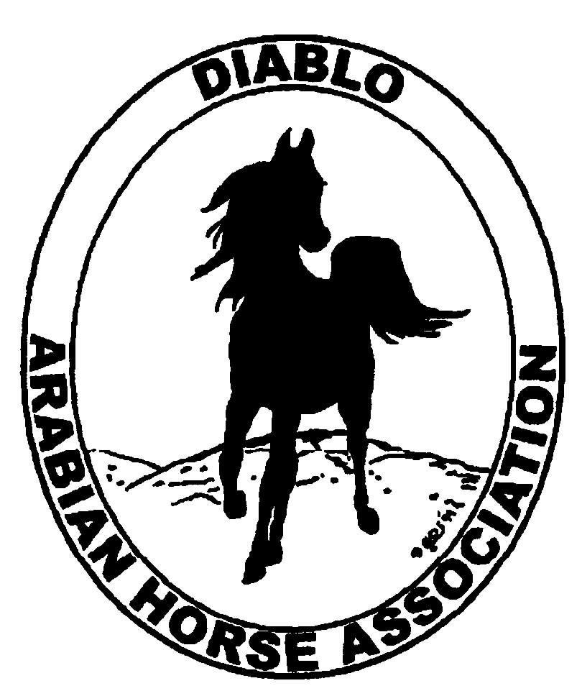

DIABLO ARABIAN HORSE ASSOCIATION
MINUTES –BOARD MEETING
September 6, 2016

Board Members Committee Members Guest
Evelyn Call Joanna Mylin
Megan Jenkins
Jill Mitchell
Leigha Perry
Cory Soltau

President Cory Soltau, called the meeting to order at 7:07 p.m.

August Meeting minutes: Cory made a motion to approve. Jill second. Minutes approved

Correspondence: Nothing new to report.

Calendar Review: March, June, Sept. & Dec. – Newsletter to be posted on website
Sept. 30-Oct. 2 – Fall Show, Brookside
Nov. 16-19 -- AHA Convention, Denver

Treasurer’s Report: Meghan emailed the treasurer’s reports for August. The Total Net Assets are $134,007.19. Total Revenues of $255.05. Total Expenses of $797.35. The Change in Net Assets is ($542.30). Meghan also included the check detail for August 2016, the Statement of Activities for all accounts and the Budget Actual Statements for both the spring and fall shows. Cory asked if there were any questions with this month’s report. The treasurer’s report was reviewed and accepted.

COMMITTEE REPORTS

Awards Banquet: Cory is interviewing 3 caterers. Tracey Seals is going to contact Lisa Dillon re silent auction head. Discussed asking Debbie Bartman. Scott Trees is confirmed for a presentation.

Breed Awareness/Public Relations/Horse Fair:
Grand National – Tammy Collins is spearheading. Brooke Fike-Carlson will be helping her. Cow Palace needs our contract. Cory to speak with Tammy on this. Cory will ask Mike Cheatwood to judge. Rounding up horses.

Convention: Cory reports that AHA has not received any forms from us. Evelyn will call on 9/7/16 to find out what forms need to be sent in. Our delegates are Cory, Megan and Tracey. Cory is going to ask Pat Hendershot to take his place. Convention has moved back to Tulsa this year. Megan reports that prices from SFO and OAK range from 4 to 5 hundred dollars.

Family Outreach: Nothing new to report

High Point Program: Nothing new to report

Horse Shows: All in agreement to extend the post entry deadline to 9/13/16. Still in need of 3 ring stewards. Kathi Daniels has committed to helping in the show office.

Membership: Evelyn reports there were 2 youth renewals in August.

Newsletter and Website: Joanna Mylin has offered to take on our website and social media.

Racing: Evelyn reports races in Los Alamitos 9/7 through 9/27. These are the 3rd jewel races of the Sheik’s races. In Alameda 9/21 through 10/4. In Fresno in October.
Cory reports that we need to promote the arabian racing and encourage everyone to attend in Pleasanton to help keep Arabian Racing local. Joanna will put on the website as well as work with Tracey to get an eblast out. Cory would like the youth to attend on 9/24. Set up a barn tour meet the trainers and horses.

Trail Rides: Nothing new to report.

Volunteer Awards: Nothing new to report.

Youth: Megan has reached out to Gene LaCroix to see if we can have him out for a clinic or an evening with him as a speaker.

Old Business: New directories have been sent out.

New Business: Region 3 meeting on 9/9. Jill is attending. Will find out if Red Bluff show is moving to January and will bring information on racing to the meeting.

Evelyn made a motion to adjourn Jill second. Motion carried.

Meeting ended at 8:01pm

Respectfully submitted,

Leigha Perry
Acting DAHA Secretary

