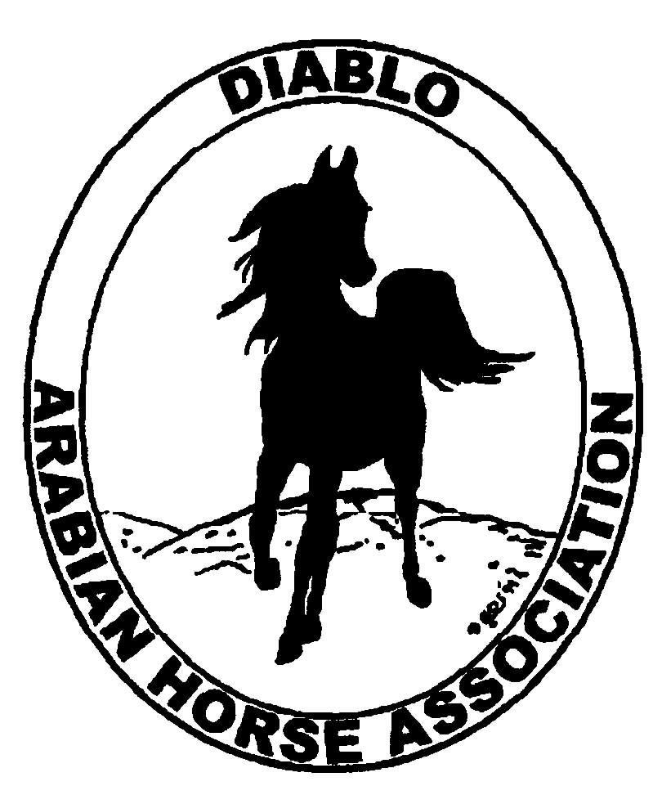
DIABLO ARABIAN HORSE ASSOCIATION
MINUTES –BOARD MEETING
October 7, 2014

Board Members Committee Members Guest
Evelyn Call Dorothy Burt Megan Jenkins
Tammy Collins Coke Swift
Debbie Compilli
Amy Edwards
Pat Hendershot
Cory Soltau
Tracey Seals

Vice President Amy Edwards, called the meeting to order at 7:15 p.m. The minutes of the September board meeting were reviewed. Coke noted a correction: Meagan Johnson should be added for working on the Club Excellence entries. Evelyn made a motion to approve the minutes with the noted correction. Tracey second. Motion carried.

Correspondence: No correspondence

Calendar Review: Oct. 24-25 – Costume Class, Grand National
Nov. 18-22 – AHA Convention, Denver
Jan. 25, 2015 – Winter Banquet, Shadelands, Walnut Creek, 5 p.m.

Treasurer’s Report: Donna Bolla was absent but emailed the Treasurer’s Report as of September 30, 2014. Total Liabilities & Equity was $89,089.02. The Profit & Loss Operating statement for April 2014 through September 2014 included Total Income of $3,297.00 and Total Expense of $3,931.76 for a net of -$634.76. Donna included an updated Profit and Loss Operating Budget Performance report. She sent Check Detail for September 2014, the Profit & Loss Statement for the Juniors, the Horse Show Account Reconciliation Summary and Detail for April thru September 2014.

Amy asked if there were any questions with this month’s report. The September report was reviewed.

The budget meeting that was held on Sept. 21, 2014, at Donna Bolla’s home, was reviewed. At that meeting, ideas were discussed about other ways that DAHA can produce income. The Convention expense is the largest expense in our operating budget.

The meeting concentrated on the two horse shows, as these are DAHA’s main source of income. The budgets, actuals and the Brookside Park invoices for the past two years were reviewed. Virtually every item on the spring and fall show budgets was reviewed for ways to trim the expenses. Suggestions were:

Reduce the amount spent on prizes and ribbons
Eliminate buckles as prizes
For Thurs. of the spring show have only 1 judge
For the entire Fall show have only 1 main ring judge
Add to the judge’s contract that they must book their flight at least 30 days prior to the show in order to take advantage of lower flight rates.

COMMITTEE REPORTS

Awards Banquet: Discussion about new features to draw more people to the banquet. Debbie will check with Shadelands for the maximum number of people that we can have. Tammy suggested adding fun things for the Juniors to do; such as a photo booth. Megan Jenkins said that Kasey and Katie Kreske will take pictures at the banquet.

Breed Awareness/Public Relations/Horse Faire: Grand National Rodeo - Cory reported that there will be at least 13 riders. The riders will be involved in the opening ceremony. Katie and Kasey Kreske will video again.

Convention: Evelyn led the discussion about the presentation of DAHA’s resolution. She will ask that the resolution be considered for “Extraordinary” status. That would make the resolution effective on June 30, 2015, instead of December 31, 2015.

Family Outreach: Tracey was asked to send out an eblast to remind DAHA’s members to turn in their nominations.

High Point Program: Tracey will post the standings to the newsletter and website. The Top Ten presentation and ribbons last year were a hit and will be continued. The committee will meet to plan out the awards presentation.

Horse Shows: Coke reported that we had 138 horses at the fall show, down from 193 last year. The Sport Horse Nationals were on the same weekend. But Amy pointed out that we probably didn’t lose 55 horses to that event. There were 15 patrons. Western Dressage was cancelled due to no entries. Discussion about the future: Plan for fewer horses at both shows.
Coke has two judges lined up for the spring show. A show committee meeting will be at Cory’s home on Nov. 6, at 6:30.

Membership: Evelyn presented the DAHA Membership report with an AHA count as of October 6, 2014. Member status is as follows:
Adult (1 yr.) 69
Adult (3 yr.) 32
Adult Life 6
Voting members 107
Associates 5
Youth 38
Total members 150
Evelyn recently sent out reminders to several people whose memberships had expired since July.

Newsletter/Web Site: Meghan’s report: The website is updated as of today. She updated the events page, added the fall horse show premium to the high point webpage, new meeting minutes, information about the BOD election, added some fall photos and the September newsletter. Please let her know if anything needs to be posted to the website.
She assisted Tracey with sending out a couple of e-blasts in September including an e-blast on the High Points and the September newsletter. She would like to send out another High Point e-blast and Grand National Rodeo e-blast. Please let she or Tracey know if anything should be sent to the DAHA members by e-blast.
Meghan would like to request assistance from the Youth committee to update the DAHA Youth page. Please let her know their recommendations. It would be also great to get some updated photos for the photo album.

Racing: Dorothy reported that the last races of the year are currently running at Fresno.

Trail Rides: Cory said that the San Ramon Valley Horsemen will be holding a moonlight ride and dinner at Diablo Ranch on Nov. 8th at 6 p.m. Those interested can contact Denise Boucher at 925-820-0843.

Volunteer Awards: Cindy still needs nominations for Friends of DAHA nominees. Cindy needs them by December 1st.

Youth: Tammy reported that the Youth have a meeting planned for Fri., Oct 10.

Old Business: Evelyn reported on the Region III meeting. The Regional show made $27,000. The performance futurity is doing well. The Regional Sport Horse show made $3,500. Region III needs more youth officers. The Horse Expo had a higher attendance. Sweepstakes needs to revise their program due to a reduction in entries. AHANC’s 2015 show will qualify for Regions 2 & 3.

New Business: Megan Jenkins told us about Alex Shveyda, a long time club member. She has been diagnosed with kidney disease and is in need of a kidney transplant. Megan, Leigha Perry and others are working on raising funds for her treatment. Any interested in donating can do so at www.gofundme.com/alexshveyda. Discussion about possible fund raisers for her. Our Jan. banquet would be our next opportunity. Megan will work on that.

Cory motioned to adjourn the meeting, Evelyn second. Motion carried. The meeting was adjourned at 9:05 p.m.

Respectfully submitted,

Debbie Compilli
DAHA Secretary

