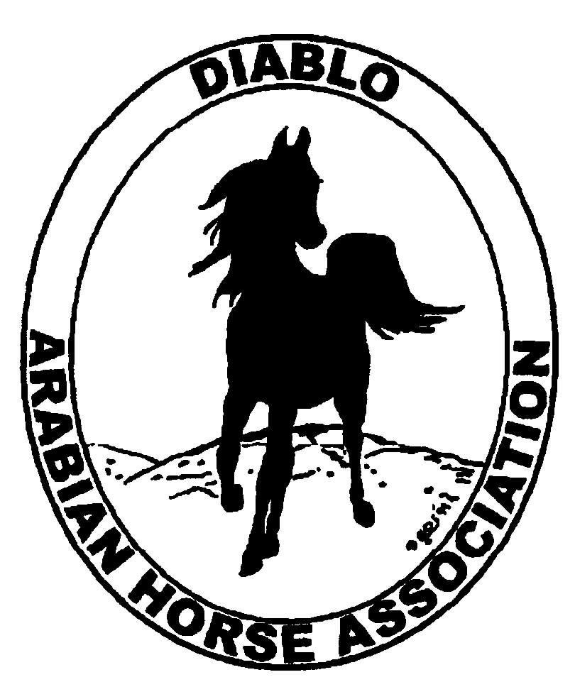
DIABLO ARABIAN HORSE ASSOCIATION
MINUTES –BOARD MEETING
November 4, 2014

Board Members Committee Members Guest
Evelyn Call Dorothy Burt Jamie Seals
Debbie Compilli Coke Swift
Amy Edwards
Jill Mitchell
Tracey Seals
Cory Soltau

President Jill Mitchell, called the meeting to order at 7:10 p.m. The minutes of the October board meeting were reviewed. Evelyn made a motion to approve the minutes. Tracey second. Motion carried.

Correspondence: Region III Director, Pam Bingham, asked each delegate to bring a door prize to Convention.

Calendar Review: Nov. 18-22 – AHA Convention, Denver
Jan. 25, 2015 – Winter Banquet, Shadelands, Walnut Creek, 5 p.m.

Treasurer’s Report: Donna Bolla was absent but emailed the Treasurer’s Report as of October 31, 2014. Total Liabilities & Equity was $90,242.83. The Profit & Loss Operating statement for April 2014 through October 2014 included Total Income of $4,137.25 and Total Expense of $4,932.51 for a net of -$795.26. Donna included an updated Profit and Loss Operating Budget Performance report. She sent Check Detail for October 2014, the Profit & Loss Statement for the Juniors, the Horse Show Account Reconciliation Summary and Detail for April thru October 2014.

Jill asked if there were any questions with this month’s report. The October report was reviewed and accepted.

Coke noted that there is still more income coming in for the Fall show. The Spring show accounting is final.

COMMITTEE REPORTS

Awards Banquet: Debbie talked to Tom McKillop of Classic Catering. The price of each dinner will have to be increased by $.50. In 2014, the adult dinner was $21. and $13.50 for 17 & under. We charged $35 for adult and $22 for youth dinners. Amy volunteered, once again, to put together a slide show for the evening.

Breed Awareness/Public Relations/Horse Faire: Grand National Rodeo - Cory reported that there were 9 riders on Fri. and 8 riders on Sat. nights. Lots of spectators came through the stall area to see the horses and the native costumes. For the opening ceremony, Cory and Trevor Miller presented an Arabian gelding, mare and foal in hand. He said that they received an enthusiastic response from the audience. Frank Wipfli, of Western Saddlery, gave DAHA a $1,500 sponsorship for the weekend’s events. Debbie will send him a thank you note.

Convention: Evelyn created a FAQ sheet regarding the DAHA resolution that will be distributed at Convention. Since Pat Hendershot is injured, Evelyn will take her place and will present the resolution at Convention. There was discussion about possible co-presentors. Nancy Harvey, Deb Johnson and Pam Bingham were all suggested as good candidates.
Discussion followed about some of the other resolutions that will be voted on at Convention.

Family Outreach: Tracey sent out an eblast to remind DAHA’s members to turn in their nominations. So far no one has responded.

High Point Program: Tracey reported that she has 16 open and 28 youth entrants. She posted the standings to the newsletter and website. A representative of Noble Outfitters contacted Jill about DAHA using them as a resource for the club’s awards. Tracey will contact them to get information about their products.

Horse Shows: Coke will email an agenda for the show committee meeting that will be at Cory’s home on Nov. 6, at 6:30. The show budgets will have to be reviewed and revised for a fewer number of horses expected. B.J. LeMaster will be the trail and reining judge. Coke is looking for two local dressage judges.

Membership: Evelyn presented the DAHA Membership report with an AHA count as of October 6, 2014. Member status is as follows:
Adult (1 yr.) 69
Adult (3 yr.) 32
Adult Life 6
Voting members 107
Associates 6
Youth 41
Total members 154

Newsletter/Web Site: Meghan’s report: I updated the website this month. I posted the high points standings. I also worked w/ Tracey to send eblasts regarding high points, family Arabian and Grand National Rodeo. I plan to start working on the Dec. newsletter soon. Please send me anything you want to post to the website, newsletter or send to our members via eblast.

Racing: The races are over for 2014.

Trail Rides: Nothing to report.

Volunteer Awards: Cindy still needs nominations for Friends of DAHA nominees. Cindy needs them by December 1st.

Youth: Jamie Seals reported on the last Youth meeting. They want to have a Youth day at DeLaRosa Ranch in Tracy and visit an area Arabian ranch. They recently developed a DAHA Youth Facebook page. They would like to offer ideas for the High Point awards. The Youth discussed putting on a tack sale----either a live sale or online. Jill suggested they could put on a ranch sorting and BarBQ.

Old Business: No old business to follow up on.

New Business: The ballots were counted. The new board members will be: Evelyn Call, Tammy Collins, Debbie Compilli, Megan Jenkins, Tracey Seals and Cory Soltau.
Remaining on the board for their second year will be: Jill Mitchell, Pat Hendershot and Cindy Volz.

The proposed amendments to the By-Laws were approved. Evelyn made a motion that the board confirm the vote to be effective November 4. Amy second the motion. Motion passed.

Tracey shared that the Day of the Horse is Sat., Dec. 13. She said that in past years, the Equestrian Center at Heather Farms put on an event. She will inquire whether they will be holding another celebration this year and report back.

Amy motioned to adjourn the meeting, Tracey second. Motion carried. The meeting was adjourned at 8:45 p.m.

Respectfully submitted,

Debbie Compilli
DAHA Secretary

