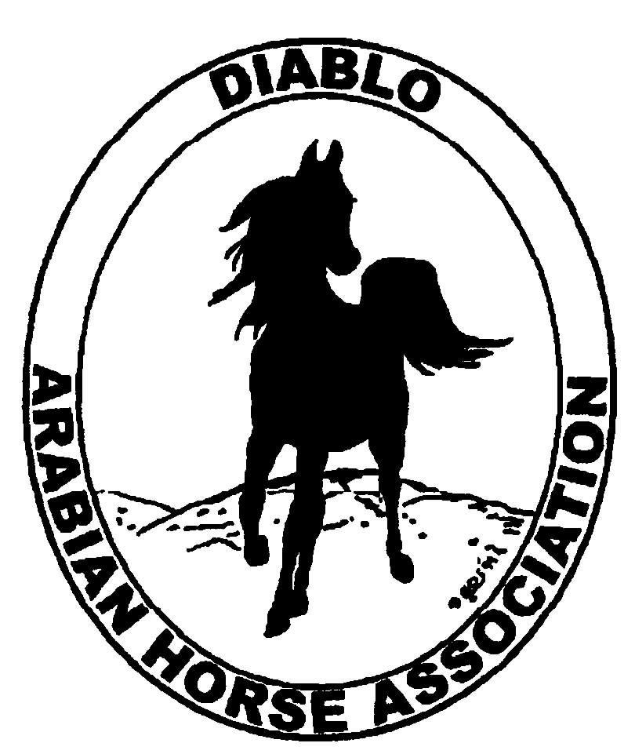
DIABLO ARABIAN HORSE ASSOCIATION
MINUTES –BOARD MEETING
December 2, 2014

Board Members Committee Members Guest
Debbie Compilli Dorothy Burt Jamie Seals
Amy Edwards Coke Swift
Pat Hendershot
Jill Mitchell
Tracey Seals

President Jill Mitchell, called the meeting to order at 7:15 p.m. The minutes of the November board meeting were reviewed. Amy made a motion to approve the minutes. Pat second. Motion carried.

Correspondence: Markel Insurance sent a letter asking for our business.

Calendar Review: Jan. 25, 2015 – Winter Banquet, Shadelands, Walnut Creek, 5 p.m.
Jan. 30, 2015 – Region III Meeting, Vacaville
March 27-29, 2015 – Golden Gate Show, Santa Rosa
April 9-12, 2015 – AHANC Show, Rancho Murietta

Treasurer’s Report: Donna Bolla was absent but emailed the Treasurer’s Report as of November 30, 2014. Total Assets was $89,051.25. The Profit & Loss Operating statement for April 2014 through November 2014 included Total Income of $4,337.25 and Total Expense of $6,313.19 for a net of -$1,975.94. Donna included an updated Profit and Loss Operating Budget Performance report. She sent Check Detail for November 2014, the Profit & Loss Statement for the Show Account and the Juniors Balance Sheet.
Pat had a question about the number of hotel rooms for our delegates at Convention. In past years, the delegates shared rooms to help lower the cost to DAHA. This year they did not. It was suggested that the delegates share rooms in the future.
Pat recommended that the email list Donna uses for the reports should be updated.
Jill asked if there were any questions with this month’s report. The November report was reviewed and accepted.

COMMITTEE REPORTS

Awards Banquet: Debbie presented the Board with the 2015 budget, proposed menu and the catering cost of the 2014 dinner. Discussion regarding the price of the dinner tickets. The Board agreed to raise the prices to $40 for adults and $25 for children. Nancy & Debbie Bartman will again chair the silent auction and raffle committee. All members are asked to contribute items. Tracey Seals volunteered to create the program for the evening.

Breed Awareness/Public Relations/Horse Faire: DAHA won the Breed Promotion/Community Involvement award of $500 at Convention.

Convention: Evelyn presented DAHA’s resolution to add youth members to a club’s delegate count. After discussion, the resolution was withdrawn. The resolution will be revised for next year for the adult member count to be lowered from 50 members to 35 members for each delegate.

Family Outreach: Tracey sent out an eblast to remind DAHA’s members to turn in their nominations. So far no one has responded.

High Point Program: Tracey reported that she will accept points up to Dec. 30, 2014. She will contact the representative of Noble Outfitters concerning awards. Tracey will meet with Megan Jenkins and Tammy Collins regarding the awards and the awards presentation.

Horse Shows: Coke announced there will be major changes for next May’s show. It will be shortened to 3 days, and there will only be one main arena judge and one dressage judge. Christie Hart has agreed to be the main arena judge. The Working Hunter and Jumping divisions will be eliminated. To follow AHA’s guidelines, the categories of Select, Choice and Elite will be used for the Amateur classes. Thus, eliminating the age divisions that were previously used.
The committee will get together to revise the class schedule.

Membership: No report.

Newsletter/Web Site: Meghan’s report: I have updated the website as of today and I'm also working on the December newsletter. Can someone send me a short paragraph or two on the AHA convention and the Grand National Rodeo? If anyone has any photos from those events, I would love them. I would like to send out the newsletter the week of the 15th. Please let me know if you have any articles to submit to the newsletter

This month I worked with Tracey on eblasts regarding high point and family Arabian. Please let Tracey or I know if you have something to eblast.

I was happy to hear that DAHA was the 2014 winner of the AHA club excellence award for Breed Promotion/Community Involvement and a finalist in Club Projects. What a wonderful achievement! On that high note, I would like to step down from the website/newsletter chair effective December 31, 2014. I am happy to transition the position to someone else who can bring new ideas and life to the website, newsletter and hopefully the club excellence project.

Racing: No report.

Trail Rides: Nothing to report.

Volunteer Awards: Cindy volunteered to work on this in 2015.

Youth: Jamie Seals reported that Tammy has arranged for the juniors to tour Sherman Ranch in Pleasanton.

Old Business: No old business to follow up on.

New Business: Cindy Volz has asked to resign as a board member because of family illness. Jill asked the Board to email her with suggestions for a new board member.
The 2015 Board shall elect the President and Vice President at the January 6, 2015, Board meeting.

Amy motioned to adjourn the meeting, Tracey second. Motion carried. The meeting was adjourned at 8:30 p.m.

Respectfully submitted,

Debbie Compilli
DAHA Secretary

