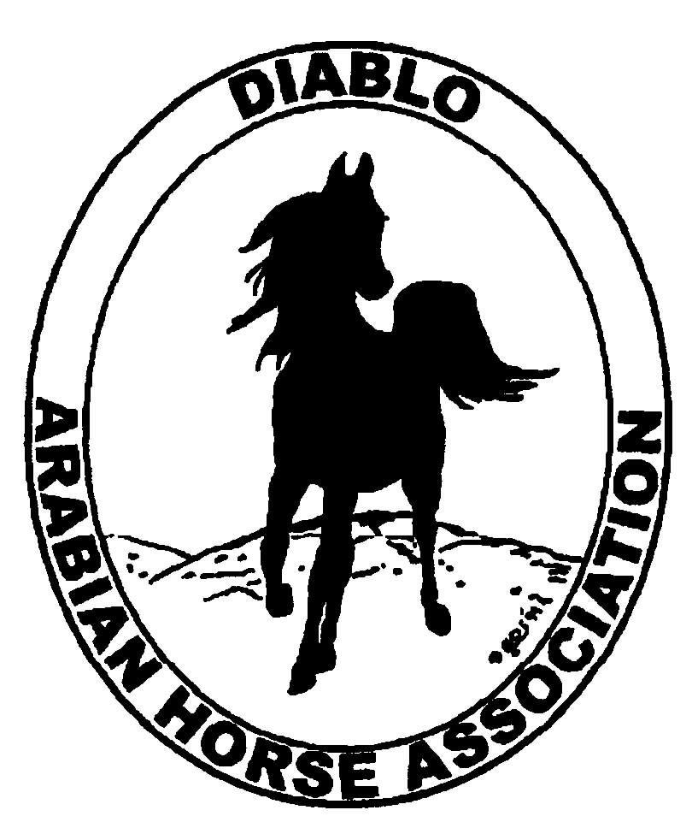
DIABLO ARABIAN HORSE ASSOCIATION
MINUTES –BOARD MEETING
September 2, 2014

Board Members Committee Members Guest
Evelyn Call Dorothy Burt Megan Jenkins
Amy Edwards Coke Swift
Cindy Volz
Jill Mitchell
Cory Soltau
Tracey Seals

President, Jill Mitchell, called the meeting to order at 7:15 p.m. The minutes of the August board meeting were reviewed. Amy made a motion to approve the minutes, Cory second. Motion carried.

Correspondence: No correspondence

Calendar Review: Sept. 12 – Region III Meeting, Vacaville
Sept. 26-28 – Fall Show, Brookside
Oct. 24-25 – Costume Class, Grand National
Nov. 18-22 – AHA Convention, Denver
Jan. 25, 2015 – Winter Banquet, Shadelands, Walnut Creek, 5 p.m.

Treasurer’s Report: Donna Bolla was absent but emailed the Treasurer’s Report as of August 31, 2014. Total Liabilities & Equity was $93,383.14. The Profit & Loss Operating statement for April 2014 through August 2014 included Total Income of $2,257.00 and Total Expense of $2,971.76 for a net of -$714.76. Donna included an updated Profit and Loss Operating Budget Performance report. She sent Check Detail for August 2014 and the Horse Show Account Reconciliation Summary and Detail for August 2014.

Jill asked if there were any questions with this month’s report. The August report was reviewed.

COMMITTEE REPORTS

Awards Banquet: Jill said the hall is reserved. Amy will put together the slide show. An eblast will be sent to members requesting photos for the slide show. Megan Jenkins will ask Kasey and Katie Kreske to take pictures at the banquet, at the request of the board.

Breed Awareness/Public Relations/Horse Faire: AHA Club Excellence Entry – Tammy pulled together the club excellence entry and turned it in on time.

70th Annual AHASC Horse Show- Jill reported that the Santa Barbara show had a good turn out.
Horse Expo- Megan and Tammy will reach out to Margie Pope in hopes of getting more horses and new ideas involved at the faire.

Grand National Rodeo- Cory is meeting with Sid, George, and Ed about the Cow Palace event. Ed said he was willing to help with filming and pictures. Megan Jenkins will ask Kasey and Katie Kreske to take pictures and video again, at the request of the board. Earthquake Arabians will try to bring three horses. Seth, the head of the program, said we can have more time, banners, longer presentations, and wants us to do an opening ceremony presentation. Members will be contacted to ride and participate.

Convention: Reservations for delegates are being sent it. The change was made that Evelyn will be the first alternate instead of Megan J. Megan J is second alternate. Evelyn submitted the resolution S-14 to AHA, who suggested some changes. One change was from “Extraordinary” to “Standard”. Evelyn will ask for an effective date of June 30,2015, instead of December 31, 2015. Evelyn will write up arguments and Q & As to present to other delegates at Convention. Positive responses were received from Cynthia Richardson and Nancy Harvey regarding the resolution. Cory suggested putting an editorial in Modern Arabian Horse “Letters to the Editor” column. The purpose of the resolution was discussed. Jill recommended contacting Deborah Johnson to gain Extraordinary status, and Shauna Strickland to garner support.

Family Outreach: Nothing to report

High Point Program: Tracey will do tabulation to include in the next newsletter. Tracey confirmed the website is up to date.

Horse Shows: Coke presented Jill with the Calcutta winner check. Coke sent out trainer packets. Michael Wilihan and Lorne Robertson are judging main ring. Creeky Routson will judge western dressage. Sporthorse and trail are TBA. There will be no programs, but daily sheets will be available in the office. Volunteers are needed. Championship awards have not yet been decided. The spring show budget was discussed.

Membership: Evelyn presented the DAHA Membership report with an AHA count as of September 1, 2014. Member status is as follows:
Adult (1 yr.) 72
Adult (3 yr.) 32
Adult Life 6
Voting members 110
Associates 6
Youth 36
Total members 152

Newsletter/Web Site: Tracey said the newsletter and website is up to date. AOL members do not receive eblasts or newsletters.

Racing: The remaining races for 2014 are as follows: Los Alamitos, Stockton and Fresno. Dorothy shared that the season is winding down. The race in Pomona was moved to Los Alamitos. A $40k race was added as part of the Big Sheikas Races. Also, The Breeder’s Cup will run an Arabian race again.

Trail Rides: Jill asked Cory how the Tevis went. He said they had a high completion rate of 59% this year. It was considered a great year, and very safe. A fifteen year old rider won the “Best Condition” award. “French Open”, a French bred ex-racehorse with 87 race starts won the Tevis.

Volunteer Awards: Cindy has awards ready to go to AHA. There are plenty of AHA club volunteer nominees. We currently have no Friends of DAHA nominees. Cindy needs them by December 1st.

Youth: Nothing to report

Old Business: Tracey reported the youth convention vote was overwhelmingly in support of keeping the 13 & under and 14-18 age divisions.

New Business: Evelyn will email the bylaw change to Debbie before the club ballots go out. Jill suggested a budget meeting to discuss concerns on the current budget. Cory encouraged the board to review the budget and bring to current.

Cory motioned to adjourn the meeting, Cindy second. Motion carried. The meeting was adjourned at 9:00 p.m.

Respectfully submitted,

Megan Jenkins

